

Fake News Detection Using Machine Learning, Deep Learning, and Online Fact Verification
Submitted in Partial Fulfilment of the Requirements for the MSc in Advanced Computer Science A dissertation submitted in partial fulfilment of the requirements for the degree of Master of Science (MSc Computer Science)

Name: Chappidi Vamsi Krishna
Name of School: CST Cardiff School of Technology
Name of University: Cardiff Metropolitan University
Date: August 2026

Declaration
I hereby declare that this dissertation entitled “Fake News Detection Using Machine Learning, Deep Learning, and Online Fact Verification” entirely my own work and it has never been submitted nor is it currently being submitted for any other degree.

Student Name: Chappidi Vamsi Krishna
Signature:
Date:

Dissertation Supervisor: Muhammad Rahman
Signature:
Date:

Abstract
The rapid spread of fake news through online platforms and social media has created significant challenges for individuals, organisations, and governments, highlighting the need for accurate and automated detection systems. This research designed a fake news detection system based on Artificial Intelligence (AI) and Natural Language Processing (NLP), machine learning, deep learning, and online fact verification. For this, a balanced data set of 4460 news articles were prepared by merging authentic news from BBC News, The Hindu and The Indian Express with fake news from ISOT Fake News Dataset. The data were preprocessed and used to develop and compare Logistic Regression, Support Vector Machine (SVM), XGBoost, LSTM, BiLSTM, and DistilBERT models. Various metrics such as accuracy, precision, recall, f1 score and ROC-AUC were used to assess the performance. The DistilBERT model achieved the best classification performance with an accuracy of 99.78% and was chosen to be deployed. The trained model was applied to a web application using Flask and a NewsAPI to retrieve additional articles from reliable news websites to verify the information. The proposed system demonstrates that combining transformer-based classification with real-time online verification improves fake news detection accuracy, transparency, usability, and user confidence in evaluating online news credibility.

Acknowledgement
I would like to express my sincere gratitude to my dissertation supervisor for their continuous guidance, constructive feedback, and valuable support throughout this research project. It is their guidance and encouragement that have been crucial in the completion of this dissertation. Finally, I would like to express my gratitude to the School of Technologies at Cardiff Metropolitan University for its support and provision of academic resources and a learning environment in which I could carry out this research. Thanks to all the developers and maintainers of the open-source libraries, datasets, and software tools utilised for this study, such as Python, Flask, PyTorch, Hugging Face Transformers, and NewsAPI. Lastly, I would like to thank my family and friends for their encouragement, patience and support over the years during my postgraduate studies.

Table of Contents
Declaration 2
Abstract 3
Acknowledgement 4
Chapter1: Introduction 11
1.1 Background 11
1.2 Problem Statement 11
1.3 Research Aim and Objectives 12
1.4 Research Questions 12
1.5 Scope and Significance of the Project 13
1.6 Structure of the Report 13
Chapter 2: Literature Review 14
2.1 Introduction 14
2.2 Fake News Detection: Background and Current Challenges 14
2.3 Natural Language Processing for Fake News Detection 14
2.4 Machine Learning Techniques for Fake News Detection 16
2.5 Deep Learning and Transformer-Based Models 16
2.6 Online Fact Verification and Research Gap 18
2.7 Conceptual Framework 19
2.8 Literature Summary 20
2.9 Chapter Summary 21
Chapter 3: Methodology 22
3.1 Introduction 22
3.2 Research Design 22
3.3 Research Approach 23
3.4 Dataset Collection and Description 24
3.5 Exploratory Data Analysis (EDA) 25
3.6 Data Preprocessing 26
3.7 Model Evaluation 26
3.8 Flask Application Development 27
3.9 Online News Verification Module 27
3.10 Ethical Considerations 28
Chapter 4: Implementation and Results 29
4.1 Introduction 29
4.2 Web Scraping and Dataset Creation 29
4.3 Dataset Loading and Initial Exploration 31
4.4 Exploratory Data Analysis 35
4.5 Data Preparation and Preprocessing 39
4.6 Feature Engineering 40
4.7 Train-Test Split and Feature Representation 42
4.8 Machine Learning Model Development and Evaluation 44
4.9 Deep Learning Model Development and Evaluation 48
4.10 Flask-Based Fake News Detection System and Online Verification 54
Chapter 5: Conclusion and Future Work 58
5.1 Summary of Research 58
5.2 Achievement of Objectives 58
5.3 Limitations 59
5.4 Future Work 59
5.5 Chapter Summary 60
Chapter 6: References 61
Chapter 7: Appendix 63
Appendix- A 63
Appendix - B 77
Appendix -C 137

List of Figures
Figure 1 : Natural Language Processing Pipeline 15
Figure 2 : Architecture of BERT and DistilBERT Models 17
Figure 3 : Automated Fact Verification Workflow 18
Figure 4 : Conceptual Framework of the Proposed Fake News Detection System 19
Figure 5 : Overall System Architecture 23
Figure 6 : Research Methodology Workflow 24
Figure 7 : Importing the required libraries for web scraping 30
Figure 8 : Web scraping process for collecting news articles 31
Figure 9 : Integration of the scraped real news dataset with the ISOT fake news dataset 31
Figure 10 : Creation of the final balanced news dataset (balanced_news_dataset.csv) 31
Figure 11 : Preview of the first, last, and randomly selected records from the balanced news dataset 32
Figure 12 : Dataset dimensions showing the total number of rows and columns 33
Figure 13 : Dataset information and attribute data types 33
Figure 14 : Missing value analysis of the balanced news dataset 34
Figure 15 : Summary of duplicate record analysis for the balanced news dataset 35
Figure 16 : Distribution of real and fake news articles 36
Figure 17 : Distribution of news articles by source 37
Figure 18 : Distribution of news title lengths 37
Figure 19 : Top 20 most frequent words in the news dataset 38
Figure 20 : Word cloud generated from real news articles 39
Figure 21 : Word cloud generated from fake news article 39
Figure 22 : Verification of the dataset and creation of the clean_text column before preprocessing 40
Figure 23 : Comparison of the original news article and the cleaned text after preprocessing 40
Figure 24 : Preview of the final processed dataset (cleaned text and tokenised representation) 40
Figure 25 : Verification of the processed dataset and duplicate analysis after feature engineering 41
Figure 26 : Selection of the input feature (processed_text) and target variable (label) for model development 42
Figure 27 : Train-test split showing the training and testing dataset distribution 43
Figure 28 : TF-IDF Feature Extraction 43
Figure 29 : Elbow method 44
Figure 30 : K-Means cluster visualisation used for exploratory analysis. 44
Figure 31 : Performance evaluation of the Logistic Regression model 45
Figure 32 : Performance evaluation of the Support Vector Machine 45
Figure 33 : XGBoost feature importance analysis. 46
Figure 34 : Comparison of machine learning model performance 46
Figure 35 : ROC-AUC comparison of the Logistic Regression, SVM and XGBoost models 47
Figure 36 : LSTM training process showing training and validation accuracy, loss curves, and model performance 49
Figure 37 : Confusion matrix and classification performance of the LSTM model. 50
Figure 38 : BiLSTM Training Accuracy Performance 51
Figure 39 : BiLSTM Training Loss Performance. 51
Figure 40 : Confusion matrix and classification performance of the BiLSTM model 52
Figure 41 : DistilBERT confusion matrix and classification performance 53
Figure 42 : Overall comparison of all ML and DL ROC-AUC models 54
Figure 43 : Flask-based fake news detection system interface 55
Figure 44 : Successful fake news prediction with supporting articles 56
Figure 45 : Prediction Result Showing "Likely Fake News 57

List of Tables
Table 1: Summary Table 20
Table 2: Final Dataset Summary 25

Chapter1: Introduction

1.1 Background
With the growth of digital communication platforms like online news outlets, social media, blogs and forums, information is now being produced, shared and consumed almost in real-time, reaching millions of people. This has raised awareness and increased the speed of information diffusion, but it has also allowed the proliferation of fake news: false and manipulated information meant to appear like valid reporting to deceive readers or to be used for political and economic benefit. It creates significant problems for governments, media organizations and technology firms because of its impact on public trust, democracy, decisions regarding healthcare and social stability.
The traditional approach to fact-checking is done manually by journalists and experts. This method is reliable, but slow and hard to scale up to the vast number of news articles published every day. So researchers have resorted to artificial intelligence (AI) and Natural Language Processing (NLP) to automate detection. The models that rely on machine learning have also performed well, learning by recognising linguistic patterns in labelled data, and transformer-based language models have additionally enhanced understanding of context in texts. In this study, an AI-powered fake news detection system is proposed that combines several machine learning and deep learning algorithms such as Logistic Regression, SVM, XGBoost, LSTM, Bi-LSTM and DistilBERT. It contains an online verification module as well, utilising the NewsAPI to cross-check the headlines sent with trusted sources. Built as a Flask web application, the system combines automated classification with real-time verification to offer a practical, accessible tool for identifying potentially misleading news online.

1.2 Problem Statement
With the rising amount of news content appearing online via websites and social media platforms, it has become challenging for users to filter out reliable from the unreliable. Fake news can spread rapidly, influencing public opinion, creating social unrest, and negatively affecting decisions related to politics, public health, and the economy. The manual fact-checking process is reliable but time-intensive and too slow to meet the volume and pace of digitally created and disseminated information. While there are established automated fake news detection systems with good performance, few of them have evidence from trusted news sources. Therefore, there is a need for an intelligent system that not only classifies news articles accurately using advanced NLP techniques but also performs online verification against reliable news sources to improve user confidence in the prediction results.

1.3 Research Aim and Objectives
Aim
This research aims to create an Artificial Intelligence (AI) based fake news detection system which will be based on Natural Language Processing (NLP) techniques. The main classification model used is DistilBERT, with an online news verification module to enhance the reliability and credibility of identifying fake news.
Research Objectives
The objectives of this research are:
- To collect and prepare a balanced dataset by combining real news articles from trusted news sources with fake news articles from the ISOT Fake News Dataset.
- To preprocess the collected news data using text cleaning, duplicate removal, label encoding, and tokenisation techniques to improve data quality.
- To develop and compare multiple machine learning and deep learning models, including Logistic Regression, Support Vector Machine (SVM), XGBoost, LSTM, Bi-LSTM, and DistilBERT, for fake news classification.
- To evaluate the performance of the developed models using standard classification metrics, including accuracy, precision, recall, and F1-score, to identify the most effective approach.
- To design and implement a Flask-based web application that enables users to classify news articles and perform online verification using trusted news sources through NewsAPI.

1.4 Research Questions
This research seeks to answer the following research questions:
- How effectively can machine learning and deep learning models detect fake news from textual content?
- Which classification model provides the best performance for fake news detection among Logistic Regression, SVM, XGBoost, LSTM, Bi-LSTM, and DistilBERT?
- How does integrating an online verification module using trusted news sources improve the reliability and usability of the fake news detection system?
- Can a Flask-based web application provide an effective and user-friendly platform for real-time fake news classification and online verification?

1.5 Scope and Significance of the Project
The project involves creating a fake news detection system to classify English language news articles based on Artificial Intelligence (AI) and Natural Language Processing (NLP), with no reference to images or videos. A custom dataset is created by using a real news from trusted sources along with fake news from the ISOT dataset. Various ML and DL models are tested and DistilBERT is deployed for the task. The system is realised as a web application with Flask, and online verification will also be performed using NewsAPI to get the articles relating to the system. It plays a key role in further developing reliable AI-powered news verification tools, with its ability to automatically classify and provide evidence-based verification of misleading news.

1.6 Structure of the Report
This dissertation has five chapters.
- Chapter 1 presents the background of the study, problem statement, aim, objectives, scope and structure of the report.
- Chapter 2 reviews the literature on fake news detection, NLP, machine learning, deep learning, transformer models and online verification, and specifies the gap in the literature.
- Chapter 3 focuses on methodology including data collection, pre-processing, exploratory analysis, model development, evaluation, Flask application design, verification module, and ethical considerations.
- Chapter 4 provides details on implementation and experimental results, showing the performance of models and the functionality of the application.
- Chapter 5 concludes with key findings, contributions, limitations, and recommendations for future research and system improvements.

Chapter 2: Literature Review

2.1 Introduction
The rapid growth and development of online news sources and social media have not only increased the speed of information distribution but also led to increased distribution of fake news and misinformation, posing substantial societal, political, and economic issues. Conventional fact-checking processes are becoming less efficient with the amount and pace of online information, and AI-based detection systems are essential. Recent developments in Natural Language Processing (NLP), Machine Learning (ML), Deep Learning (DL) and online fact verification have improved the capabilities of automated detection, but issues with model generalisation and explainability still exist. This chapter critically assesses these methods, ongoing research gaps, and preludes the suggested hybrid fake news detection framework (Alshuwaier & Alsulaiman, 2025).

2.2 Fake News Detection: Background and Current Challenges
Fake news are messages that are false but circulated as news reports, misinformation are messages that are false but are accidently shared as news reports and disinformation are messages that are false and are willfully produced. As digital media has increased, so has the occurrence of these information disorders, with consequences on political choices, health, the economy, and social trust (D'Ulizia et al., 2021; Harris et al., 2024). AI-based fact-checking is necessary to handle the vast amount of content in the modern era, which manual methods cannot handle (Khan et al., 2021). While there are promising advancements, there are also hurdles to address, such as shifting trends in misinformation, uneven data distribution, cross-domain generalisation issues, and the lack of transparency in predictions.

2.3 Natural Language Processing for Fake News Detection
One of the most important components of fake news detection is Natural Language Processing (NLP), which helps machines to analyse and interpret the textual information effectively. Preprocessing methods, such as text cleaning, tokenisation, stop-word removal, and lemmatisation, standardise text data by eliminating noise and maintaining meaningful linguistic properties. More classical approaches to feature extraction, including Term Frequency-Inverse Document Frequency (TF-IDF), also convert textual data into quantifiable forms that can be used in machine learning algorithms (Khan et al., 2021).
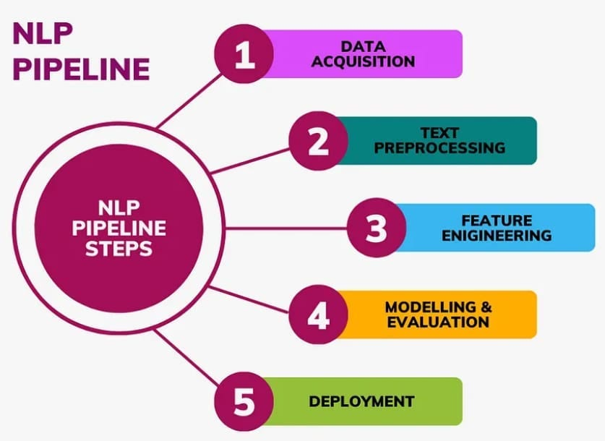
Figure 1: Natural Language Processing Pipeline
(Source: Khan et al., 2021)
The figure shows the overall Natural Language Processing (NLP) pipeline that emphasises the steps of data acquisition, text preprocessing, feature engineering, model development, evaluation, and deployment to perform text classification tasks.
Traditional NLP versus Transformer-Based Representations
Even though traditional NLP methods are both computationally efficient and useful in baseline classification models, they do not tend to represent contextual semantics and long-range word relationships, limiting these methods when dealing with complex or ambiguous news content. Conversely, language models based on transformers form contextual embeddings that maintain semantic relationships and help to comprehend subtle language, resulting in better classification results (Raza & Ding, 2022; Chen & Yin, 2025). However, compared to traditional methods, transformer models demand significantly more computational resources and training data. It, therefore, depends on the choice of an NLP strategy in balancing between computational efficiency and understanding of context. In general, effective NLP preprocessing boosts the quality of the features, which facilitates a better and more confident classification of fake news, especially when combined with sophisticated transformer structures (Rini Anggrainingsih et al., 2025).

2.4 Machine Learning Techniques for Fake News Detection
Supervised machine learning algorithms have largely been developed for detecting fake news using pattern learning from labeled data, with Logistic Regression (LR), Support Vector Machine (SVM), and XGBoost being frequently applied algorithms for textual classification, each with a different advantage for fake news detection (Khan et al., 2021). Logistic Regression is a commonly used baseline because of its simplicity, fast computation, and interpretability, but it has a linear decision boundary making it less capable of capturing the complexity of the relationships in the news content. SVM performs well with high-dimensional, sparse text data by identifying optimal decision boundaries, often outperforming Logistic Regression despite higher computational costs for large datasets (Alghamdi et al., 2022). The gradient-boosted decision trees add further predictive power to XGBoost via capturing nonlinear feature interactions, improving classification accuracy, and regularising to prevent overfitting (El-Mageed et al., 2024). Although XGBoost is more accurate and requires more parameters tuning and computational power, in comparison with LR and SVM, it is better at generalisation but less interpretable, and model selection depends on the interpretability-efficiency-accuracy trade-off (Khan et al., 2021; Alghamdi et al., 2022; El-Mageed et al., 2024).

2.5 Deep Learning and Transformer-Based Models
2.5.1 Deep Learning for Fake News Detection
Deep learning has greatly enhanced the detection of fake news by automatically discovering complicated linguistic patterns among textual information without heavy feature engineering. Especially effective with sequential analysis of texts are recurrent architectures like Long Short-Term Memory (LSTM) and Bidirectional Long Short-Term Memory (Bi-LSTM). Long-term contextual dependencies are learned by LSTM, whereas Bi-LSTM considers information in both directions, which allows a better understanding of the structure of the sentence and its semantics (Roumeliotis et al., 2025; Raza et al., 2025).
2.5.2 Transformer-Based Models
Recent developments in the architecture of transformers, such as BERT, DistilBERT, and Large Language Models (LLMs), have additionally boosted fake news detection with self-attention mechanisms and contextual embeddings. In contrast to recurrent networks, all the words are processed in transformers at the same time, allowing for the modelling of long-range dependencies effectively and enhancing semantic comprehension.
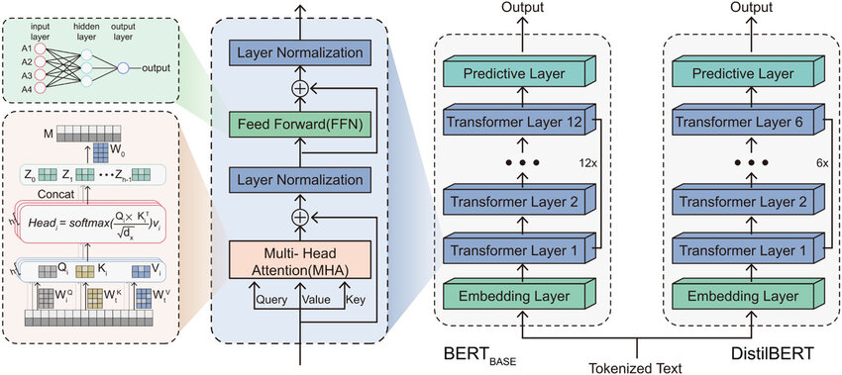
Figure 2: Architecture of BERT and DistilBERT Models
(Source: Chen & Yin, 2025)
The figure shows the architecture of BERT and DistilBERT that illustrates the transformer encoder, multi-head self-attention mechanism and the reduced-layer design of DistilBERT that represents the contextual language efficiently.
DistilBERT maintains the majority of predictive performance of BERT and has a smaller model and lower inference time, thus being suitable in real-time settings with few computational resources (Chen & Yin, 2025; Suresh, 2025). The transformer-based models have shown enhanced resilience through a combination of contextual learning and transfer learning and graph-based representations (Alqadi et al., 2025; Rama Moorthy et al., 2025; Lu & Yao, 2025).
2.5.3 Critical Comparison
Deep learning models offer better contextual insight as compared to traditional machine learning models, at the cost of larger datasets and increased computation resources. Transformer-based models are always superior to classical machine learning and recurrent neural networks in their capacity to classify and represent semantics; however, with the cost of training and computation being higher (Rini Anggrainingsih et al., 2025). Therefore, the DistilBERT provides a good tradeoff between prediction accuracy and inference efficiency, which is why it is a suitable option in the proposed fake news detector system, where the accuracy of classification and real-time inference are equally relevant (Karthik et al., 2025; Roumeliotis et al., 2025).

2.6 Online Fact Verification and Research Gap
2.6.1 Online Fact Verification
The majority of the current fake news detection systems are more classification-oriented and offer predictions without evidence, which restricts transparency and trust to the users. Moreover, their use of static datasets also limits their capacity to identify new misinformation. To overcome these limitations, automated fact verification is the approach that retrieves evidence provided by trusted news sources so that the user can validate the prediction results and enhance decision-making confidence (Guo et al., 2022).
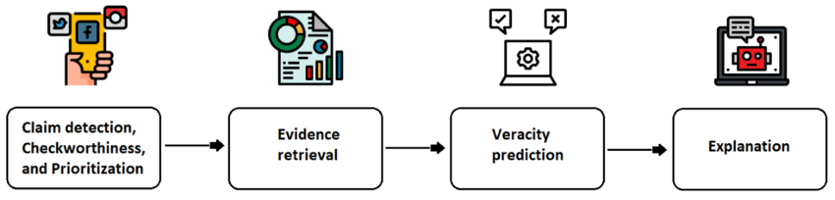
Figure 3: Automated Fact Verification Workflow
(Source: Guo et al., 2022)
The figure demonstrates the automated process of fact verification: this consists of claim detection, evidence retrieval, veracity prediction and generation of explanations to enhance the transparency and credibility of fake news detection.
2.6.2 Research Gap
Natural Language Processing, Machine Learning, Deep Learning, and evidence retrieval are hardly combined in a single study, and hybrid datasets and real-world usage are still scarce (Soveatin Kuntur et al., 2026). The suggested framework, a combination of comparative AI models and fact verification online, justifies these gaps by enhancing both the detection accuracy and explainability of the predictions (Harris et al., 2024; D'Ulizia et al., 2021).

2.7 Conceptual Framework
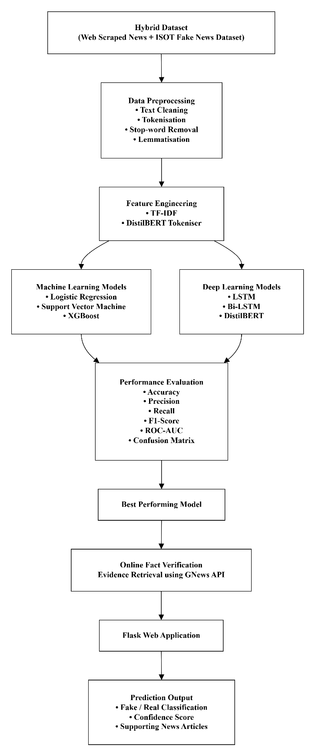
Figure 4: Conceptual Framework of the Proposed Fake News Detection System
(Source: Self-Made)
The figure represents the proposed fake news detector, which is intelligent. It comprises web-scraped real news in combination with the ISOT Fake News Dataset and preprocessing and feature engineering of the data via TF-IDF and DistilBERT tokenisation. Machine learning (Logistic Regression, Support Vector Machine and XGBoost) and deep learning (LSTM, Bi-LSTM and DistilBERT) models are compared to determine the most effective model. The selected model is integrated with an online fact verification module using the GNews API, and integrated into a Flask web application to generate fake or real news predictions, confidence scores and news articles supporting them, thereby enhancing the accuracy of the prediction and its explainability.

2.8 Literature Summary
Table 1: Summary Table
Author(s) | Focus | Methodology | Key Findings
Khan et al. (2021) | ML detection | Logistic Regression, SVM | Reliable baseline for text classification
Alghamdi et al. (2022) | ML vs DL | Comparative analysis | DL outperforms traditional ML models
Chen & Yin (2025) | Transformer detection | DistilBERT, CNN-LSTM | Improves contextual accuracy
El-Mageed et al. (2024) | XGBoost detection | Xgb-Tree | High accuracy, strong generalisation
Guo et al. (2022) | Fact verification | Survey | Evidence retrieval boosts trust
Raza et al. (2025) | Transformer DL | Transformer models | Outperforms conventional models
Roumeliotis et al. (2025) | AI comparison | CNN, NLP, LLMs | Transformers show highest performance
Transformer-based models consistently outperform traditional ML in fake news detection, yet explainability and evidence verification remain limited—justifying this study's combined approach of comparative AI models with online fact-checking integration.

2.9 Chapter Summary
The current literature regarding the detection of fake news was critically analysed in this chapter, including Natural Language Processing, machine learning, deep learning, transformer-based models, and online fact verification. The review confirmed that the transformer models have better contextual insights and classification performance, but issues of explainability, fixed datasets, and evidence-based validation are still unresolved. These restrictions underscore the necessity to use a combined framework that involves both comparative machine learning and deep learning models and online fact verification. The reviewed literature, therefore, has a solid theoretical basis and has a clear justification for the methodology taken in the current study.

Chapter 3: Methodology

3.1 Introduction
The chapter outlines the methodology used in the research process for designing, developing and evaluating the proposed fake news detection system using artificial intelligence. It states the philosophy, approach and strategy used for the research during the study, and then the processes involved in collecting the datasets, pre-processing the data, exploratory data analysis, and developing the model. The chapter also provides information on the metrics used to evaluate the model's performance, building the web application with Flask, adding the online news verification module with the NewsAPI, and ethical issues involved in the research. The methodology offers a systematic approach for the implementation and validation of the proposed system.

3.2 Research Design
An experimental design is utilised in this research to develop and test an AI system for fake news detection, allowing the training, testing, and comparison of various models on a standardised dataset and evaluation framework. The process consists of data collection, data pre-processing, exploratory data analysis, model development, model evaluation, system implementation, and online verification. The balanced dataset was created by merging real news from reputable news sources (BBC News, The Hindu, The Indian Express) with fake news from the ISOT news collection. The data were cleaned, duplicates removed, labeled, and tokenized prior to splitting into training and testing sets. The standard metrics were used to develop and evaluate 6 models, which are Logistic Regression, SVM, XGBoost, LSTM, Bi-LSTM, and DistilBERT. DistilBERT has been chosen as the end model, and has been built into a Flask-based web app with an associated online verification module to pull down related, trusted articles using news API.
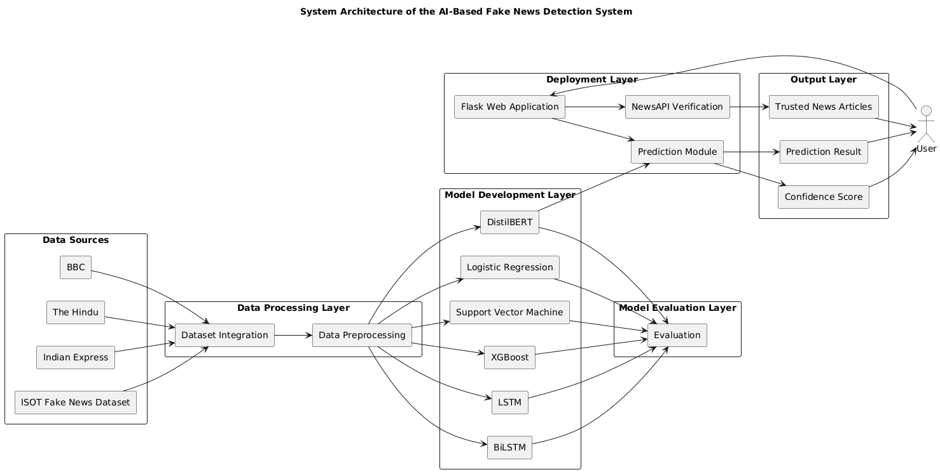
Figure 5: Overall System Architecture
Figure 5 presents the overall architecture of the proposed fake news detection system. The architecture consists of multiple interconnected components, including dataset collection, data preprocessing, feature extraction, machine learning and deep learning model training, prediction generation, and online verification. User-submitted news articles are first processed using the trained DistilBERT model to determine whether the content is real or fake. The prediction is then validated using trusted online news sources through NewsAPI before the final results are presented to the user. The figure clearly demonstrates the interaction between the AI model, verification module, and Flask web application, illustrating the end-to-end implementation of the proposed framework

3.3 Research Approach
This research adopts a quantitative experimental research approach to develop and evaluate an AI-based fake news detection system. A quantitative approach was chosen because the effectiveness of the proposed models is assessed numerically with accuracy, precision, recall and F1-score as indicators of model performance. Multiple machine learning and deep learning models were implemented, trained and tested with the same set of data in the same manner. The research entailed data collection and preprocessing of the news articles, building the classification models, testing them and choosing the most successful model for deployment. Finally, the chosen DistilBERT models were incorporated into a web application built using Flask and an online news verification module using NewsAPI to assess the proposed system in a real-world setting.
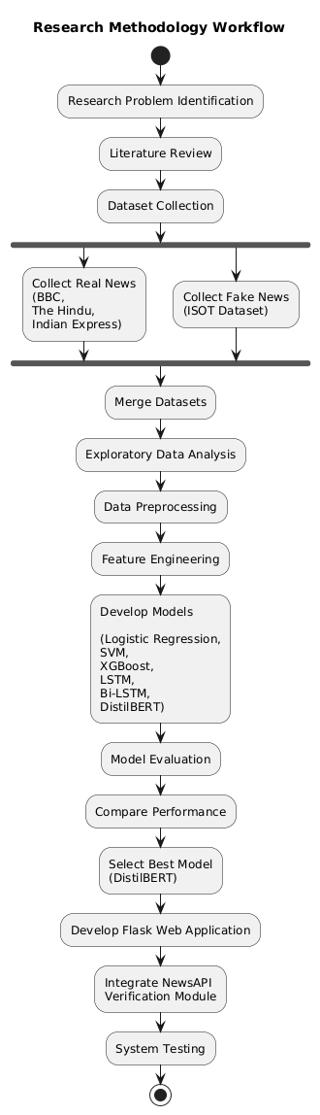
Figure 6: Research Methodology Workflow
Figure 6 illustrates the complete research methodology adopted in this study. The workflow begins with identifying the research problem and collecting balanced datasets from reliable news sources and the ISOT fake news dataset. After preprocessing and exploratory data analysis, feature engineering techniques are applied before training several machine learning and deep learning models. Model evaluation is performed using standard classification metrics, and the best-performing model is integrated into a Flask web application with an online verification module. The workflow demonstrates the systematic and experimental research process followed throughout the development and evaluation of the fake news detection system.

3.4 Dataset Collection and Description
The dataset used in this research was created by combining authentic news articles collected through web scraping with fake news articles obtained from the ISOT Fake News Dataset. Real news articles were collected from three trusted news organisations—BBC News, The Hindu, and The Indian Express—using RSS feeds and web scraping techniques. For each article, the headline, full article content, publication date, source, and URL were extracted. Fake news articles were obtained from the publicly available ISOT Fake News Dataset, which contains labelled news articles collected from unreliable news websites and is widely used for fake news detection research.
After combining the two sources, the dataset was balanced to eliminate class imbalance and improve model learning. The final dataset consisted of 4,460 news articles, including 2,230 real news articles and 2,230 fake news articles. Each record contained six attributes: title, content, source, publication date, URL, and class label, where 0 represents Real News and 1 represents Fake News.
Before model development, the dataset underwent quality assessment to identify missing values, duplicate records, and inconsistencies. The textual data were then preprocessed using lowercasing, HTML tag removal, punctuation and special character removal, tokenisation, stop-word removal, and feature engineering to produce cleaned text suitable for Natural Language Processing (NLP). The processed dataset was subsequently used for exploratory data analysis, feature extraction, machine learning model development, deep learning model training, and performance evaluation.
For the DistilBERT model, which achieved the highest classification performance, only the article content and the corresponding class label were used. Missing values and duplicate articles were removed, and the cleaned dataset was divided into 80% training and 20% testing subsets using stratified sampling to preserve the balanced class distribution. The news articles were tokenised using the DistilBERT tokenizer, with a maximum sequence length of 256 tokens, before fine-tuning the pre-trained transformer model for binary classification.
Table 2: Final Dataset Summary

Dataset Summary Table
Attribute | Description
Dataset Name | Balanced Fake News Dataset
Total Articles | 4,460
Real News Articles | 2,230
Fake News Articles | 2,230
Real News Sources | BBC News, The Hindu, The Indian Express
Fake News Source | ISOT Fake News Dataset
Language | English
Features | Title, Content, Source, Published Date, URL, Label
Target Variable | Label (0 = Real News, 1 = Fake News)
Dataset Type | Balanced Binary Text Classification Dataset

3.5 Exploratory Data Analysis (EDA)
Exploratory Data Analysis (EDA) was performed to understand the characteristics of the collected dataset before model development. This phase was designed to explore the structure, quality and distribution of data to see if it's suitable for the classification of fake news. Analysis consisted of examining the class distribution of real news versus fake news for the dataset to ensure a balanced dataset for binary classification. In addition, the textual content was explored to identify common linguistic patterns, analyse article length variations, and detect potential inconsistencies within the dataset. The data set was also analyzed for missing data, duplicate data, and other data quality problems that would impact the performance of the model. The findings from the exploratory analysis guided the choice of suitable preprocessing methods and verified that the data set is suitable for training and testing the machine learning and deep learning models used in this study. This is detailed in chapter 4 in the process of exploratory data analysis (EDA), with the results presented in visualisations.

3.6 Data Preprocessing
Data preprocessing was performed to improve the quality and consistency of the collected dataset before model development. The data was collected from various news sources, so it was necessary to preprocess the data to normalize inconsistent text and convert it into a format suitable for machine learning and deep learning models. Balanced dataset of real news and fake news was prepared and checked for missing and duplicate data, and these were excluded from the learning process to avoid the effect of repeated information. All text content was copied to a new processing field to keep the text intact. A series of text cleaning steps was performed: All text was lowercased for consistency, HTML Tags, email addresses, numerical values, punctuation, special characters, and all unnecessary whitespace were removed to keep meaningful information. This helped to decrease noise and enhance features. Cleaned articles were then tokenized using the NLTK library where each article was broken into individual words. Common English stopwords were filtered out and the remaining tokens were then re-combined to form a cleaned form of each article for model training. Finally, duplicated processed articles were again filtered out to insure uniqueness. The data was divided into a 80:20 training and testing sets to provide independent sets for model development and evaluation. This pipeline allowed for the textual data to be clean, consistent and appropriate for the training of the proposed detection models.

3.7 Model Evaluation
The developed models were tested to assess their usefulness in discriminating between real and fake news articles. All models were tested with the same testing data set and evaluated under the same experimental conditions for a fair comparison. The metrics used for model evaluation were conventional: accuracy, precision, recall, and F1-score. The overall correctness of the classification of articles was measured by accuracy, and the correctness of the fake news predictions was measured by precision. Fake news identification was assessed by recall and the F1-Score was used to identify a good balance between precision and recall. Besides these metrics, confusion matrices were created to analyze the classification results of each model. The comparative evaluation helped to identify the best model, and this model was chosen for the deployment in the proposed fake news detection system.

3.8 Flask Application Development
A web-based application was developed using the Flask framework to provide an interactive interface for the proposed fake news detection system. Flask was selected because of its lightweight architecture, ease of integration with machine learning models, and suitability for deploying Python-based applications. The application was created to allow users to upload a news headline and news article with ease through a simplified web interface. The backend was designed to take in the user input, use the trained DistilBERT model to classify the news article and then return the prediction and a confidence score. Furthermore, the application included an online verification module which retrieved a set of articles on the provided headline from trusted news portals via the NewsAPI service. The prediction results, confidence score and corresponding news articles were then displayed on a results page, to provide automated classification and supporting information for verification. This implementation translated the developed model into a real and easy-to-use application for detection of fake news.

3.9 Online News Verification Module
To enhance the reliability of the fake news detection system, an online news verification module was integrated into the Flask application. The DistilBERT model's job is to determine whether a news article is genuine or fake while the verification module supplements this prediction with extra supporting evidence to search for related news articles published by trusted media organizations. This will allow the users to compare what they submitted news with information from credible sources. The verification module has been created with the NewsAPI service. Once the user enters a news headline and an article, the news headline is used to get relevant news articles from trusted news publishers. The resulting articles are then compared to the submitted headline using the similarity mechanism based on the keyword. When an article meets the predefined similarity criteria, it will be shown to the user along with the source article, the publication year, description, and a direct link to the original article. If no relevant article was found, the application will let the user know that no trusted news sources were found. This verification process complements the prediction generated by the DistilBERT model and improves the overall transparency and usability of the proposed system.

3.10 Ethical Considerations
This research was conducted in accordance with ethical principles related to data collection, privacy, and responsible use of artificial intelligence. Real news articles for the study were gathered from publicly accessible news websites and RSS feeds and fake news articles from the publicly available ISOT Fake News Dataset. During the research no personal, confidential or sensitive information was gathered or processed. The designed fake news detection system is not meant to replace professional journalists and fact-checking organisations, but instead to help their users with automated predictions and supporting verification results. The system's predictions should therefore be viewed as information for decision making and not as a definite call to action. In addition, all data and software libraries and external services utilized in this research is properly cited, and following the principles of academic honesty and responsible research practices.

Chapter 4: Implementation and Results

4.1 Introduction
The chapter discusses implementation and experimental results of the proposed fake news detection system based on Artificial Intelligence. It outlines the hands-on application of the system starting from loading the data sets, exploratory data analysis, data preprocessing, feature engineering and train-test data splitting. It then goes on to describe the implementation of the machine learning and deep learning models Logistic Regression, Support Vector Machine (SVM), XGBoost, LSTM, Bi-LSTM, DistilBERT and their evaluation. Finally, the implementation of the Flask-based web application and the online news verification module using NewsAPI is presented, demonstrating the practical functionality and effectiveness of the proposed fake news detection system.

4.2 Web Scraping and Dataset Creation
A reliable and diverse dataset is essential for developing an effective fake news detection system. This work did not only use publicly available benchmark datasets, but also scraped real news articles from reliable websites with a web scraping pipeline. News articles were automatically collected from the BBC news, The Hindu and Indian Express RSS feeds using the python based libraries Requests, Feedparser, BeautifulSoup and Newspaper3k. These libraries allowed for retrieval of article titles, full text, year of publication, source data, and URLs, and filtered out articles not found, or incomplete articles. This automated approach reduced manual effort and ensured collected data reflected recent news from reputable organisations. After the data were collected, the data from the three sources were merged into one. Articles and incomplete records were duplicated and removed to enhance data quality and consistency. The real news data was cleaned and then the clean real news data was merged with ISOT Fake News data to generate a labelled fake news data. Both datasets were standardised with consistent column names and appropriate class labels for real and fake news. The final step was to balance the data set so that it had an equal number of real and fake articles in it before it was exported as balanced_news_dataset.csv. This balanced dataset was used as input to the subsequent exploratory data analysis, dataset preprocessing, feature engineering, machine learning and deep learning model development, and system evaluation.
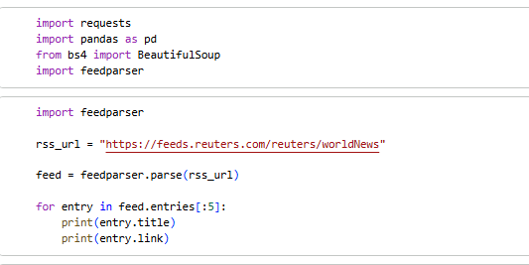
Figure 7: Importing the required libraries for web scraping
Figure 7 shows the Python libraries imported for collecting real news articles through web scraping. The implementation includes libraries such as Requests for sending HTTP requests, Feedparser for reading RSS feeds, BeautifulSoup for HTML parsing, Newspaper3k for extracting article content, and Pandas for data manipulation. These libraries work together to automate the collection of news articles from trusted publishers, reducing manual effort and ensuring efficient acquisition of reliable textual data. The figure demonstrates the initial implementation stage of building the dataset used throughout the research.

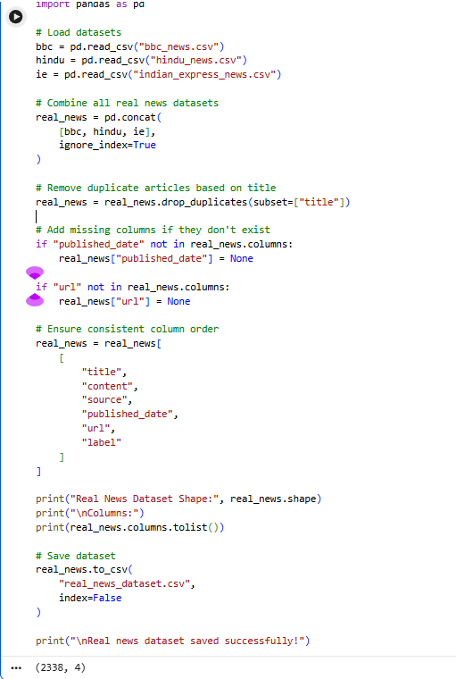
Figure 8: Web scraping process for collecting news articles
Figure 8 illustrates the automated web scraping process used to collect authentic news articles from trusted online news websites. The workflow begins by accessing RSS feeds from BBC News, The Hindu, and The Indian Express. Individual news articles are downloaded, parsed, and cleaned before extracting important information such as the headline, article content, publication date, source, and URL. Invalid or incomplete articles are automatically discarded to maintain data quality. This automated process ensures that the collected dataset contains reliable and up-to-date news articles suitable for training the fake news detection models.
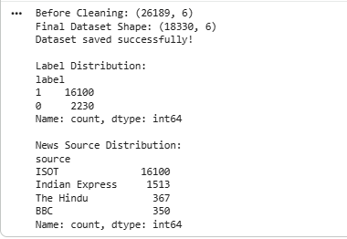
Figure 9: Integration of the scraped real news dataset with the ISOT fake news dataset
Figure 9 illustrates the integration process used to combine authentic news articles collected through web scraping with fake news articles obtained from the publicly available ISOT Fake News Dataset. Before merging, both datasets are standardised by ensuring consistent column names, data formats, and class labels. Duplicate and incomplete records are removed to improve data quality and maintain consistency across both datasets. This integration creates a unified dataset containing both real and fake news articles, providing a balanced and reliable dataset for model development and evaluation.

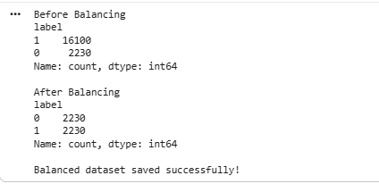
Figure 10: Creation of the final balanced news dataset (balanced_news_dataset.csv)
Figure 10 presents the final stage of dataset preparation in which the merged news dataset is balanced and exported as balanced_news_dataset.csv. Equal numbers of real and fake news articles are maintained to eliminate class imbalance, which could otherwise bias the classification models during training. The figure demonstrates the successful preparation of a clean and balanced dataset consisting of 4,460 labelled news articles that are subsequently used for exploratory data analysis, feature engineering, model training, testing, and performance evaluation. Creating a balanced dataset ensures fair model learning and improves the reliability of the experimental results reported in this research.

4.3 Dataset Loading and Initial Exploration
4.3.1 Loading and Previewing the Dataset
Pandas library was used to load the final balanced dataset, balanced_news_dataset.csv, into the Python environment. The consistency of the number of records in the dataset throughout the file and whether it was successfully imported was checked by using the head(), tail(), and sample() functions. The preview was valid, with each news article having attributes such as the title of the article, the article content, the source, class label, the publication date, and a URL. Examining the first, last, and randomly selected records provided confidence that both real and fake news articles were correctly represented and that the dataset was ready for further analysis.

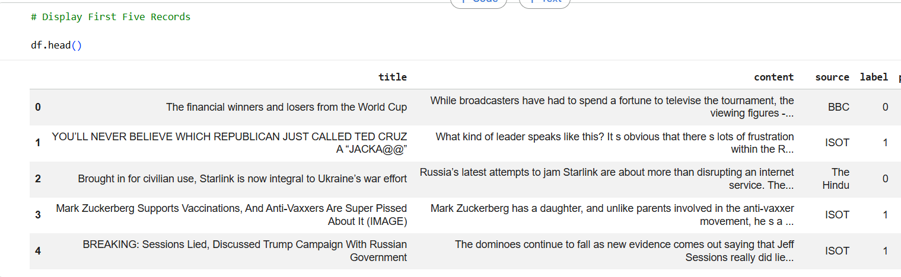

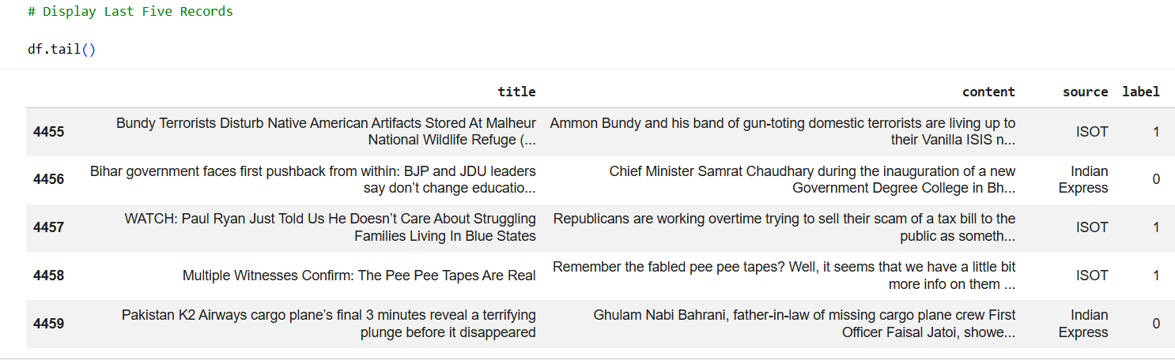

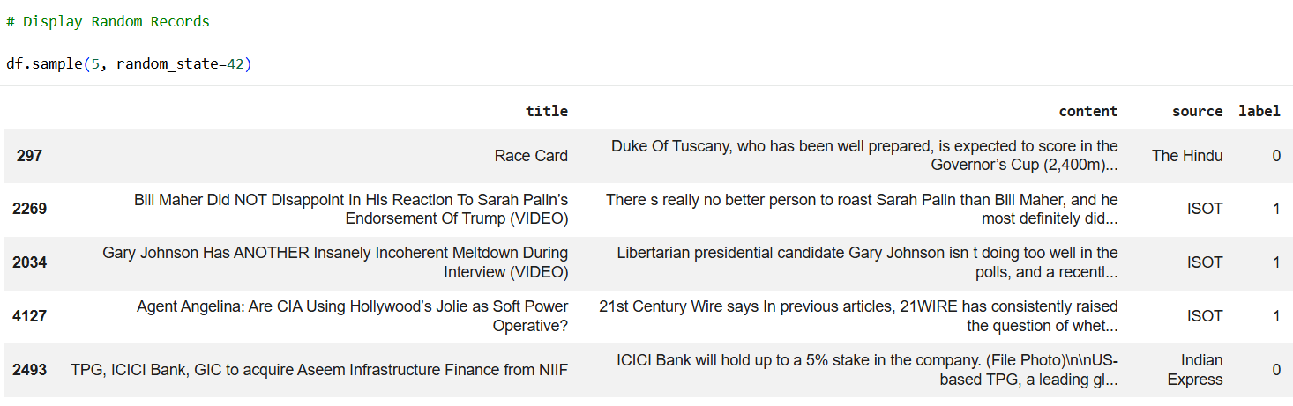
Figure 11: Preview of the first, last, and randomly selected records from the balanced news dataset
Figure 11 presents a preview of the balanced news dataset after it was successfully loaded into the Python environment. The figure displays the first few records, the last few records, and a random sample of news articles using the head(), tail(), and sample() functions. This verification step confirms that the dataset was imported correctly and that each record contains the required attributes, including the news title, article content, source, publication date, URL, and class label. Examining records from different sections of the dataset also verifies that both real and fake news articles are correctly represented before further preprocessing and model development. This inspection provides confidence in the quality and consistency of the collected dataset.

4.3.2 Dataset Structure and Information
The overall structure of the dataset was examined by determining the number of rows and columns, followed by analysing the dataset information using the info() function. There are 6 attributes of each news article in the dataset: title, content, source, label, publication date, and URL. The inspection also verified what type of data was placed on each attribute. For example, the text elements (title, content, source, and publication date) were represented as object data types, and the class label was stored as an integer for binary classification. Checking the details of the dataset made sure that the data was imported properly and gave an idea of the amount of memory needed before preprocessing.
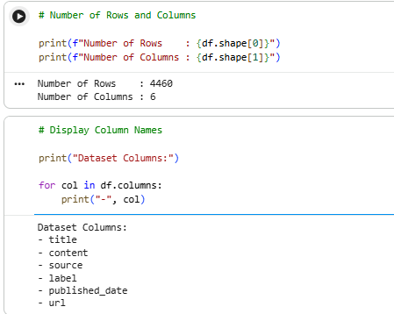
Figure 12: Dataset dimensions showing the total number of rows and columns
Figure 12 illustrates the dimensions of the balanced news dataset by displaying the total number of rows and columns. The dataset contains 4,460 news articles distributed across 6 primary attributes, representing both real and fake news samples. Determining the dataset dimensions is an important validation step because it confirms that all records have been successfully imported into the analysis environment without data loss. This information also provides an understanding of the dataset size before preprocessing, feature engineering, and model training. The figure demonstrates that the dataset is sufficiently large for conducting reliable machine learning and deep learning experiments.
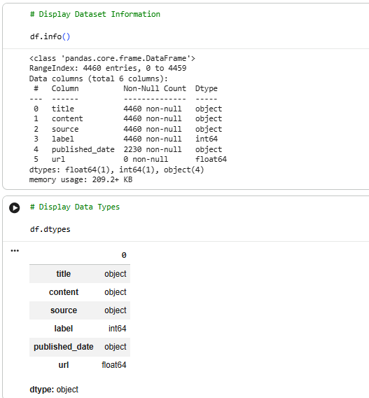
Figure 13: Dataset information and attribute data types
Figure 13 presents detailed information about the dataset using the info() function. The figure identifies each attribute, its corresponding data type, and the number of non-null values present in every column. Textual fields such as the title, content, source, publication date, and URL are stored as object data types, whereas the class label is stored as an integer for binary classification. Examining the dataset structure helps verify that each variable has been imported correctly and is stored in an appropriate format. This validation step ensures that the dataset is suitable for subsequent preprocessing and machine learning operations.
4.3.3 Missing Value Analysis
The missing values in the data set were analysed by using a missing value analysis, prior to pre-processing. The results indicated that all the columns in the dataset were complete without any missing values, such as the title, content, source, or label, suggesting that the necessary attributes for fake news classification were present. Only published_date and URL columns had missing values; these are the value that were unavailable for some news articles collected. However, since these attributes were not used for modeling, the absence of some of these attributes did not impact classification. This analysis confirmed that the dataset was suitable for the subsequent preprocessing and feature engineering stages.
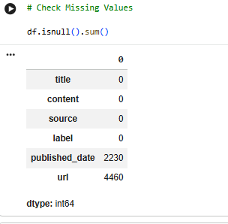
Figure 14: Missing value analysis of the balanced news dataset
Figure 14 illustrates the analysis of missing values within the balanced news dataset. The figure demonstrates that the essential attributes required for fake news classification, including the news title, article content, source, and class label, contain no missing values. Only a small number of missing entries appear in the publication date and URL fields, which are not directly used for model training. This analysis confirms that the dataset possesses a high level of completeness and that no significant data cleaning is required before preprocessing. Performing missing value analysis helps ensure that incomplete records do not negatively affect model performance during training and evaluation.
4.3.4 Duplicate Record Analysis
A duplicate record analysis was conducted as another assessment of the quality of the data. Duplicate news articles can cause bias in the model training process as it can give the classification models more samples to memorize than to learn meaningful textual patterns. The analysis added up the numbers of records, duplicate records, and duplicate percentage. There were no duplicate articles and a 0% duplicate percentage as seen in Figure. This indicates that there were no redundant data records and that the data could be used for further exploratory data analysis, data preprocessing, and machine learning model development.
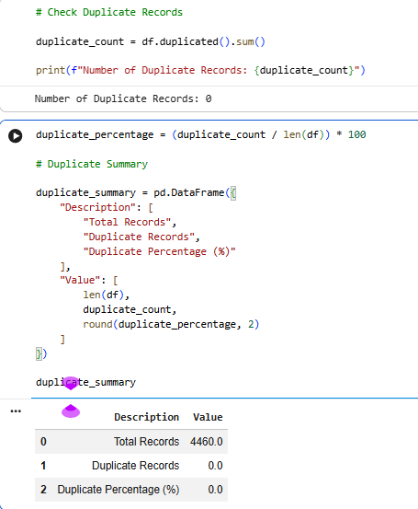
Figure 15: Summary of duplicate record analysis for the balanced news dataset
Figure 15 presents the duplicate record analysis performed to assess dataset quality. Duplicate news articles can introduce bias into machine learning models because repeated observations may encourage memorisation rather than genuine pattern learning. The analysis calculates the total number of duplicate records and their corresponding percentage within the dataset. The results indicate that no duplicate records were identified, producing a duplicate percentage of 0%. This confirms that every article in the dataset is unique and suitable for reliable model training and evaluation. Removing duplicate records contributes to improving the generalisation capability of the developed classification models.

4.4 Exploratory Data Analysis
Exploratory Data Analysis (EDA) was conducted to gain a comprehensive understanding of the balanced news dataset before applying data preprocessing and machine learning techniques. The analysis was conducted on examining the distribution of news classes, the contribution of news sources, the analysis of the textual features and the commonly occurring words among the news articles. The visualisations were useful to gain insights into the quality and composition of the dataset and to verify its appropriateness to classify fake news. Other exploratory visualisations produced in the analysis are provided in Appendix A.
4.4.1 Distribution of Real and Fake News
To assess if the data had a balanced distribution of real and fake news articles, the class distribution was analysed. The data set is perfectly balanced with 2230 real news articles matched with 2230 fake news articles as shown in Figure. Maintaining equal class representation is important because it prevents classification models from becoming biased towards one class and enables a more reliable evaluation of model performance.
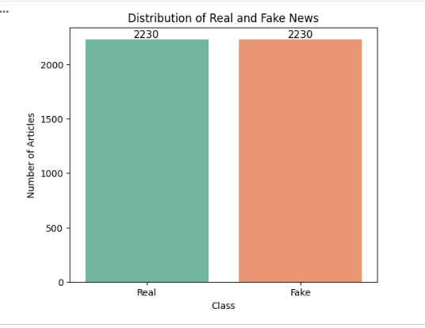
Figure 16: Distribution of real and fake news articles
Figure 16 illustrates the class distribution of the balanced news dataset. The visualization shows that the dataset contains 2,230 real news articles and 2,230 fake news articles, resulting in a perfectly balanced binary classification dataset. Maintaining equal representation of both classes is essential because it prevents machine learning models from becoming biased towards the majority class and allows more reliable performance evaluation. The balanced distribution improves the fairness of model training and enables meaningful comparison between different classification algorithms used in this research.
4.4.2 Distribution of News Sources
The composition of collected data source was examined by analysing distribution of news articles in various sources. As shown in Figure, fake news articles were obtained from the ISOT dataset, while real news articles were collected through web scraping from BBC, The Hindu, and Indian Express. Indian Express contributed the largest proportion of real news articles, whereas BBC and The Hindu provided additional diversity. Having several trusted news organisations together gave more diversity in writing style and patterns of reporting to use for training the models.
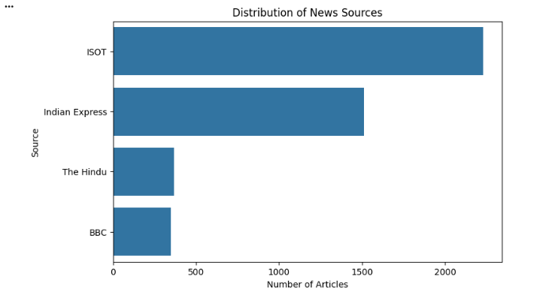
Figure 17: Distribution of news articles by source
Figure 17 presents the distribution of news articles collected from different sources. Real news articles were obtained through web scraping from BBC News, The Hindu, and The Indian Express, whereas fake news articles originated from the ISOT Fake News Dataset. The figure illustrates the contribution of each source to the final dataset, showing that Indian Express provided the largest proportion of authentic news articles while BBC News and The Hindu contributed additional diversity. Using multiple trusted publishers enhances the variety of writing styles, vocabulary, and reporting patterns, thereby improving the robustness and generalisation capability of the classification models
4.4.3 Analysis of Title Length Distribution
The distribution of the length of news titles was analysed to gain insight into the textual features of the collected news articles. The Figure shows that most news headlines contain between 60 and 100 characters, with the highest concentration occurring around 75–85 characters. There are also a few shorter and longer titles that are not typical, which reflects natural differences between news publishers. Understanding title length helps identify the diversity of textual inputs that the classification models must process.
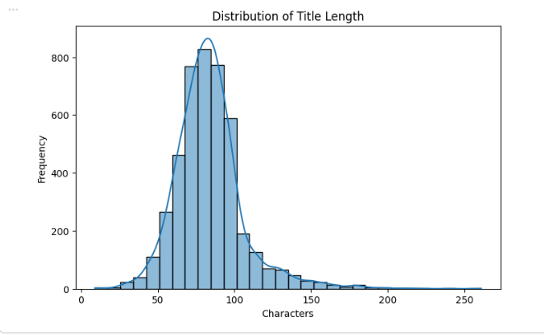
Figure 18: Distribution of news title lengths
Figure 18 illustrates the distribution of news headline lengths within the collected dataset. The histogram indicates that most headlines contain between 60 and 100 characters, with the highest concentration occurring around 75–85 characters. Although a few shorter and longer headlines exist, the majority fall within a consistent range, reflecting common headline-writing practices among news publishers. Analysing title length provides useful insight into the diversity of textual inputs that the machine learning models must process and helps verify that the dataset represents realistic news content collected from multiple sources.
4.4.4 Most Frequent Words
A frequency distribution of words used in the news articles was done to see which words are used the most. As illustrated in Figure, common English words such as the, to, and, and of appear most frequently because the analysis was performed before text preprocessing. These observations indicated that a large number of high-frequency stop words exist in the text, which necessitated the next preprocessing steps of removing stop words and cleaning the text before the feature extraction.
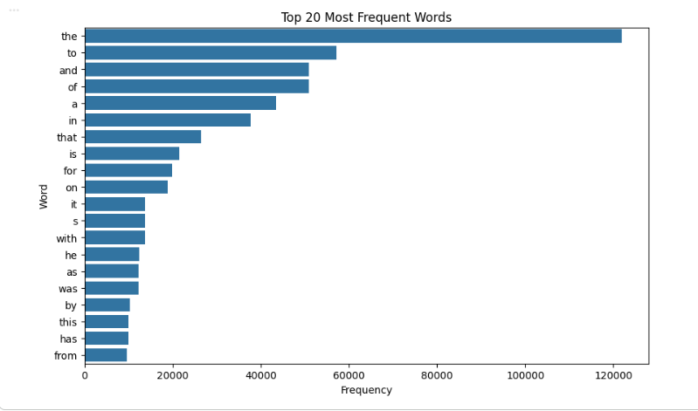
Figure 19: Top 20 most frequent words in the news dataset
Figure 19 presents the twenty most frequently occurring words within the collected news articles before preprocessing. Common English words such as the, to, and, and of appear with the highest frequencies because stop-word removal had not yet been applied. The figure demonstrates that raw textual data contains many high-frequency words that contribute little semantic meaning to classification tasks. Consequently, preprocessing techniques such as stop-word removal, text cleaning, and tokenisation are required to eliminate irrelevant words and improve feature quality before machine learning and deep learning model development. This analysis justifies the preprocessing techniques applied later in the research.
4.4.5 Word Cloud Analysis
Word clouds were generated separately for real and fake news articles to visualise the dominant terms within each class. The cloud of real news words, as shown in first figure, shows that words that have appeared with governments, public institutions, countries, education and current events are featured because they all relate to legitimate news reporting. In comparison, the second figure reveals that fake news articles have several politically oriented terms such as the mentions of political figures, elections, and sensational topics. These visual differences demonstrate that the vocabulary used in real and fake news differs considerably, supporting the use of Natural Language Processing techniques for classification.
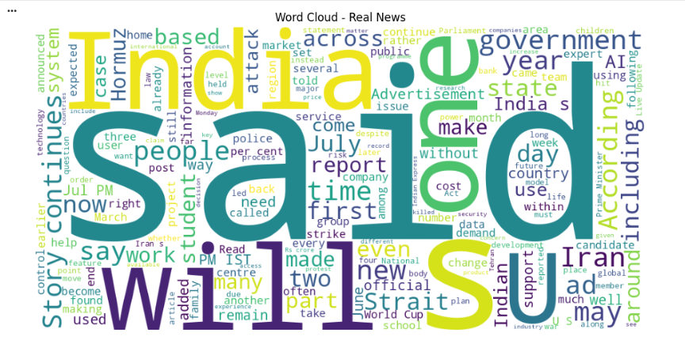
Figure 20: Word cloud generated from real news articles
Figure 20 displays a word cloud generated from the real news articles contained in the balanced dataset. The size of each word represents its frequency of occurrence, with larger words appearing more frequently across authentic news reports. The visualization highlights terms commonly associated with governments, public institutions, international affairs, education, healthcare, and current events, reflecting the factual reporting style of reputable news organisations. This word cloud provides a visual summary of the dominant vocabulary used in authentic news articles and demonstrates the linguistic patterns that distinguish genuine news from fake news. These observations support the application of Natural Language Processing techniques for identifying meaningful textual differences during fake news classification.
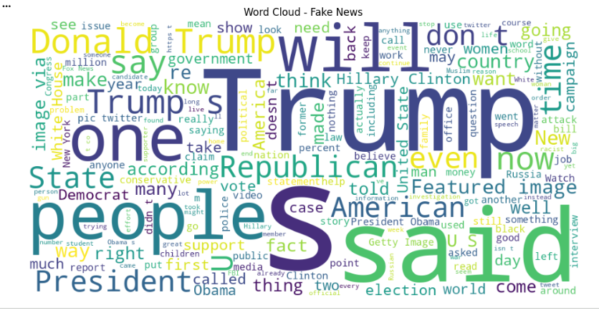
Figure 21: Word cloud generated from fake news article
Figure 21 presents a word cloud generated from the fake news articles contained in the balanced dataset. The size of each word represents its frequency within fake news content, allowing commonly occurring terms to be identified visually. Unlike the word cloud for real news, this figure contains a higher concentration of politically related terms, references to well-known public figures, elections, and sensational topics that frequently appear in misinformation. The noticeable difference in vocabulary between real and fake news demonstrates that fake news articles often employ distinctive linguistic patterns. These differences provide valuable features for Natural Language Processing models and support the effectiveness of AI-based fake news classification.

4.5 Data Preparation and Preprocessing
The news articles were preprocessed in order to enhance the quality and uniformity of texts before the feature extraction and model training process. The dataset has been preprocessed for uniformity using several techniques for cleaning textual data collected from the websites and the public data sets that were used in this project to collect the data. Initially, required columns were verified, and news content was inspected to ensure no missing values existed in the primary text field. Original content was stored on a new clean_text column for independent preprocessing. The initial step of the pipeline involved lowercasing the text so that words with different capitalisation were considered the same. The excessive amount of HTML tags, numerical values, punctuation, special characters, and whitelines were cleaned using regular expressions, which improved the consistency of the data and reduced noise. Effectiveness was verified by comparing original and cleaned samples, confirming irrelevant formatting was removed while semantic meaning was preserved. Once the articles were cleaned, they were tokenised using the NLTK library to break each article down into word tokens for more efficient feature extraction and representation for subsequent NLP tasks. Additionally, frequently occurring website boilerplate terms associated with news sites and social media were identified and removed to minimise irrelevant information. Finally, the fully processed dataset was saved as a new CSV file, providing a clean, structured dataset for feature engineering and model development.
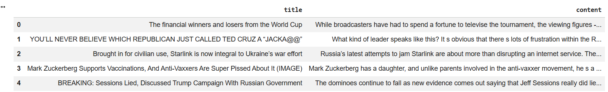

Figure 22: Verification of the dataset and creation of the clean_text column before preprocessing
Figure 22 illustrates the initial stage of the preprocessing pipeline in which the dataset is verified and a new clean_text column is created. Instead of modifying the original article content, the text is copied into a separate processing field to preserve the raw dataset. This approach enables all cleaning operations—including lowercasing, removal of punctuation, special characters, numbers, HTML tags, and unnecessary whitespace—to be performed without affecting the original data. The figure demonstrates good data management practices by maintaining both the original and processed versions of each news article for comparison and validation.
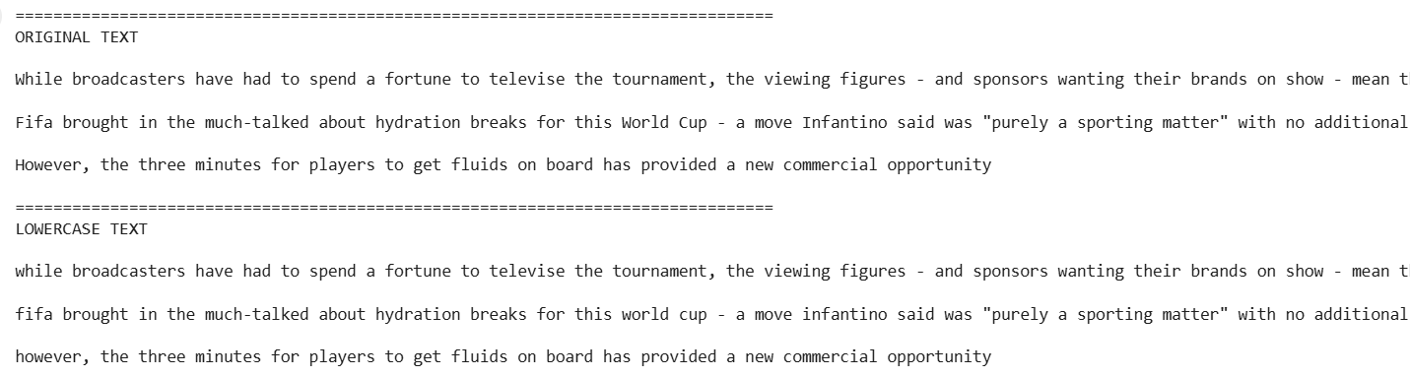
Figure 23: Comparison of the original news article and the cleaned text after preprocessing
Figure 23 compares a sample news article before and after preprocessing. The original article contains uppercase letters, punctuation marks, numbers, special characters, and formatting elements that introduce unnecessary noise into the dataset. After preprocessing, the cleaned version retains only meaningful textual information while removing irrelevant symbols and formatting. This comparison demonstrates that the preprocessing pipeline successfully standardises textual content while preserving its semantic meaning. The figure validates the effectiveness of the text cleaning process and confirms that the processed data are suitable for feature extraction and machine learning model development.

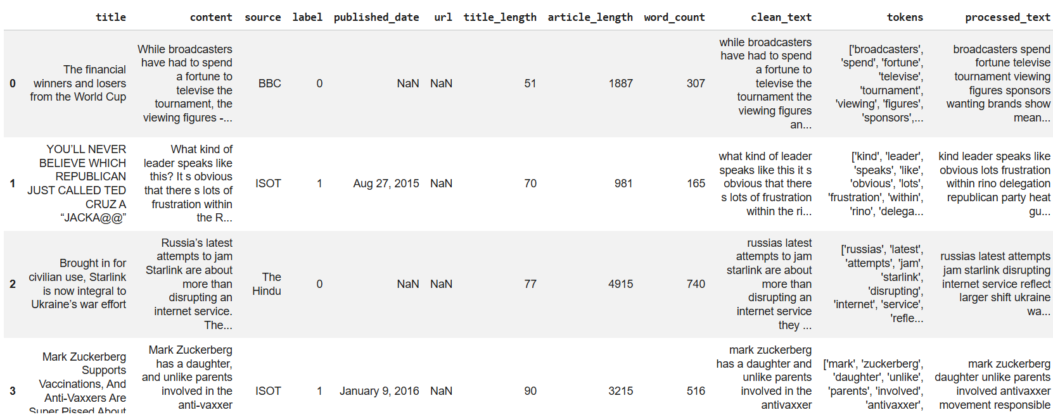

Figure 24: Preview of the final processed dataset (cleaned text and tokenised representation)
Figure 24 presents a preview of the final processed dataset after completing the preprocessing stage. The figure shows the cleaned textual content alongside its tokenised representation, where each news article has been converted into a sequence of meaningful words suitable for Natural Language Processing tasks. Tokenisation divides continuous text into individual tokens, allowing machine learning and deep learning algorithms to analyse linguistic patterns more effectively. The figure confirms that the preprocessing pipeline has successfully transformed the raw dataset into a structured format ready for feature engineering and model training.

4.6 Feature Engineering
After data preprocessing, feature engineering approach was applied to make sure that the cleaned text data is properly represented for machine learning and deep learning model development. The main goal of this stage was to build an adequate feature set which would be able to accurately capture these news articles without sacrificing the semantic information. The processed_text column, which was obtained by cleaning the text, was chosen as the feature, while the label column representing the actual (binary) value of real (0) or fake (1) news was selected as the class target for classification. Processed data set was then validated prior to selecting final features to confirm that all features were available and no duplicate processed articles were found after processing. The verification found that there were 4,460 news articles and 12 attributes in the dataset, and duplicate analysis found that there was no duplicate processed text in the dataset. This ensured that the training data contained unique textual samples and reduced the possibility of introducing bias during model learning. The cleaned articles were represented by the feature matrix (X) and the class labels were represented by the target vector (y). A small example of the preprocessed text was also investigated to ensure that the preprocessing pipeline was successfully processing the original news articles and creating a clean textual representation to be used in the subsequent vectorisation, tokenisation, and training of the classification model.
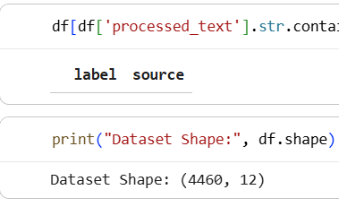
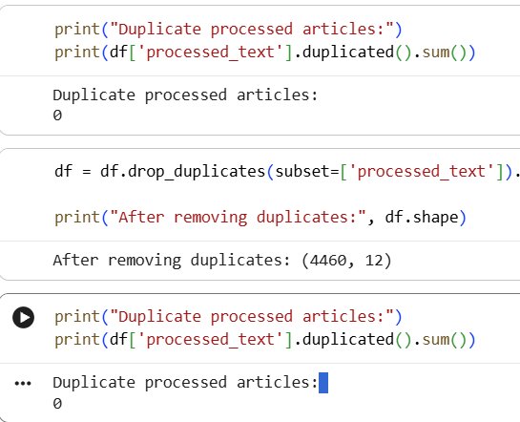
Figure 25: Verification of the processed dataset and duplicate analysis after feature engineering
Figure 25 verifies the processed dataset after feature engineering has been completed. The figure confirms that the dataset contains 4,460 processed news articles and 12 attributes, demonstrating that the preprocessing and feature engineering stages have preserved all required information. An additional duplicate analysis performed on the processed text indicates that no duplicate articles remain within the dataset. This validation ensures that every training sample is unique, reducing the likelihood of bias and improving the ability of machine learning models to generalise when analysing previously unseen news articles.
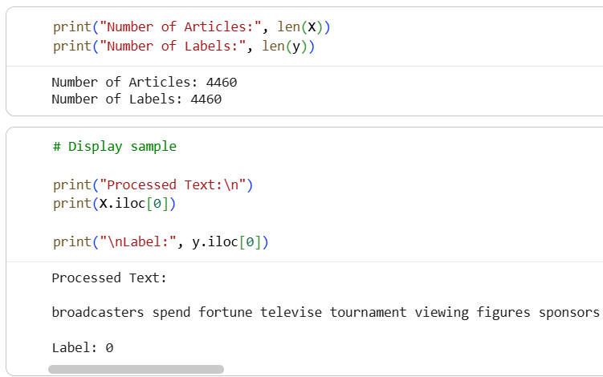
Figure 26: Selection of the input feature (processed_text) and target variable (label) for model development
Figure 26 illustrates the selection of variables used for machine learning and deep learning model development. The processed_text column, containing the cleaned news articles, is selected as the input feature (X), while the label column serves as the target variable (y) for binary classification. The labels are encoded such that 0 represents real news and 1 represents fake news. Clearly separating the predictor variables from the target variable is a fundamental step in supervised learning and ensures that the classification models are trained using meaningful textual information while learning the correct output labels.

4.7 Train-Test Split and Feature Representation
Before training the classification models, the processed dataset was divided into separate training and testing subsets to enable an unbiased evaluation of model performance. The column processed_text was the input feature (X) and the column label was the target variable (y), with a value of 0 for a real news and a value of 1 for a fake news. We used the train_test_split() function to get an 80:20 split, which yielded 3,568 training articles and 892 testing articles. The distribution of the classes in both subsets was even, with an equal number of genuine and fake news articles. Additionally, a blind test was conducted to see if any articles overlapped between the training and testing sets, with no articles found to cause any data leakage when evaluating the model. The data was converted into numerical representation using the Term Frequency–Inverse Document Frequency (TF-IDF) vectorisation process to make it suitable for the machine learning algorithms. The TF-IDF vectoriser created a vocabulary of 10,000 features, with uni-grams, bi-grams, and tri-grams, that results in sparse numerical matrices for the training and testing sets. Also, an exploratory analysis was conducted using the K-Means clustering method to study the natural clustering of news articles in the feature space. The number of clusters was estimated using the Elbow Method prior to visualisation of the resulting clusters by Principal Component Analysis (PCA).
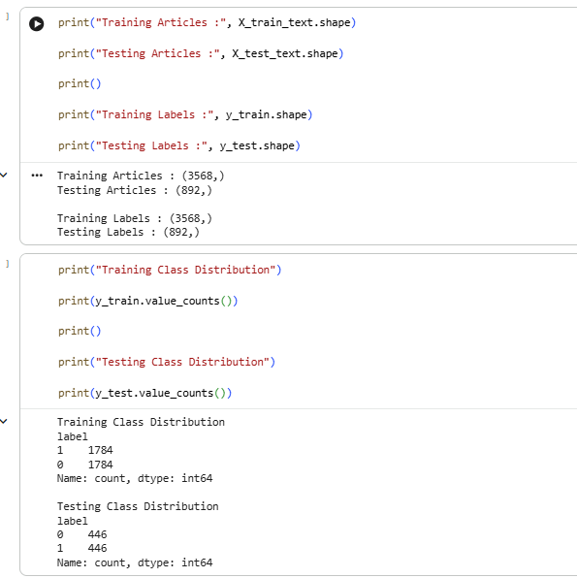
Figure 27: Train-test split showing the training and testing dataset distribution
Figure 27 illustrates the division of the processed dataset into separate training and testing subsets. The dataset is split using an 80:20 ratio, producing 3,568 training articles and 892 testing articles. The figure also confirms that both subsets maintain an equal distribution of real and fake news articles, preserving class balance throughout the experiment. Maintaining separate training and testing datasets allows the developed models to be evaluated on previously unseen data, providing an unbiased assessment of their predictive performance and generalisation capability.
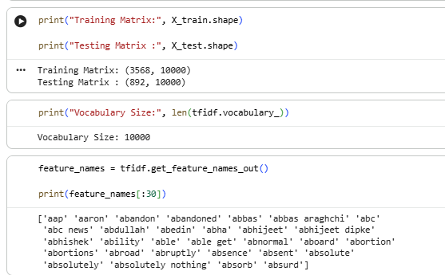
Figure 28: TF-IDF Feature Extraction
Figure 28 demonstrates the application of the Term Frequency–Inverse Document Frequency (TF-IDF) feature extraction technique. TF-IDF converts cleaned textual data into numerical feature vectors that machine learning algorithms can process. Frequently occurring words within a document receive higher weights, whereas words appearing commonly across many documents receive lower weights because they contribute less discriminatory information. In this research, TF-IDF generates a vocabulary consisting of approximately 10,000 textual features, including unigrams, bigrams, and trigrams. The resulting numerical representation preserves important linguistic information while enabling traditional machine learning algorithms to classify news articles effectively.
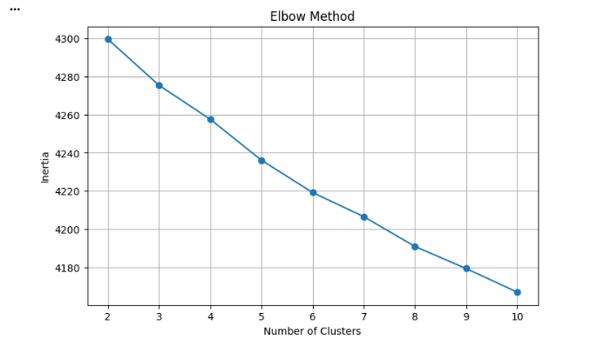
Figure 29: Elbow method
Figure 29 presents the Elbow Method used to determine the optimal number of clusters for exploratory data analysis. The graph plots the within-cluster sum of squared errors against different numbers of clusters. As the number of clusters increases, the clustering error decreases until reaching a point where additional clusters produce only marginal improvement. This point, known as the "elbow," indicates the most appropriate number of clusters for representing the dataset. The Elbow Method assists in understanding the underlying structure of the news articles before visualising them using clustering techniques such as K-Means
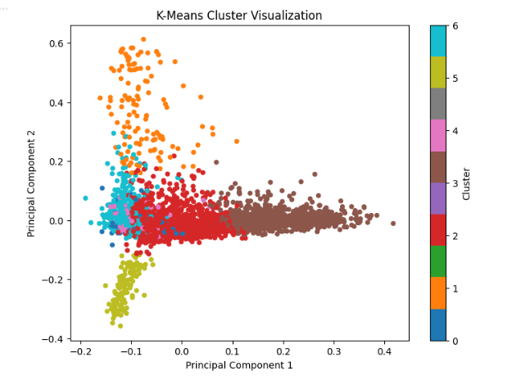
Figure 30: K-Means cluster visualisation used for exploratory analysis.
Figure 30 illustrates the results of applying the K-Means clustering algorithm to the TF-IDF feature space. The high-dimensional textual features are first reduced using Principal Component Analysis (PCA) to enable two-dimensional visualisation. Each point in the figure represents a news article, while different colours indicate the cluster assigned by the K-Means algorithm. Although clustering is not used directly for classification, it provides valuable insight into the natural grouping of news articles based on their textual similarity. The figure demonstrates that articles with similar linguistic characteristics tend to form distinct clusters, supporting the suitability of the extracted features for subsequent machine learning and deep learning model development.

4.8 Machine Learning Model Development and Evaluation
Three classic machine learning classification algorithms, namely Logistic Regression, Support Vector Machine (SVM), and Extreme Gradient Boosting (XGBoost) were thus implemented as a baseline to see how well they can perform the classification task of fake news detection. TF-IDF feature vectors were extracted from processed news articles and all models were trained on these using the testing set and their performance was measured in terms of accuracy, precision, recall, F1-score, and ROC-AUC. These metrics were used to comprehensively evaluate the performance of each model in separating true and false news articles. The Logistic Regression model demonstrated good classification accuracy of 98.32%, precision 99.31%, recall 97.31%, F1-score 98.30%, and ROC-AUC 99.86%. Both real news and fake news classes were well classified in terms of precision and recall values, indicating Logistic Regression has a good baseline performance for text classification based on TF-IDF features.
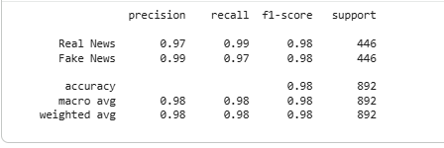
Figure 31: Performance evaluation of the Logistic Regression model
Figure 31 presents the performance evaluation results of the Logistic Regression model for fake news classification. The figure includes the confusion matrix and classification report, illustrating the model's ability to distinguish between real and fake news articles. The Logistic Regression model achieved an accuracy of 98.32%, precision of 99.31%, recall of 97.31%, F1-score of 98.30%, and ROC-AUC of 99.86%. These results indicate that the model provides a strong baseline for text classification by correctly identifying the majority of news articles while maintaining high precision and recall for both classes. The figure demonstrates that even a relatively simple machine learning algorithm can achieve excellent performance when combined with appropriate text preprocessing and TF-IDF feature extraction.

The Support Vector Machine (SVM) had the greatest overall accuracy for the traditional machine learning models. The model obtained an accuracy of 99.22%, precision of 99.33%, recall of 99.10%, F1-score of 99.21%, and ROC-AUC of 99.90%. The classification report displays excellent generalisation and a well-balanced classification performance with consistently high scores for both classes. The results show that SVM is an effective method for separating high-dimensional textual data with the TF-IDF representation.
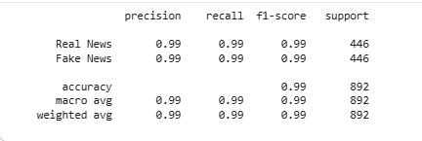
Figure 32: Performance evaluation of the Support Vector Machine
Figure 32 illustrates the performance of the Support Vector Machine (SVM) classifier on the balanced fake news dataset. The confusion matrix and classification report demonstrate that the model correctly classified almost all news articles. The SVM achieved an accuracy of 99.22%, precision of 99.33%, recall of 99.10%, F1-score of 99.21%, and ROC-AUC of 99.90%. These outstanding results indicate that SVM effectively separates high-dimensional textual data represented by TF-IDF vectors. Among the traditional machine learning algorithms evaluated in this research, SVM achieved the highest overall classification performance and served as the strongest baseline for comparison with deep learning models.
The XGBoost classifier also achieved competitive performance with an accuracy of 96.97%, precision of 98.16%, recall of 95.74%, F1 score of 96.94% and ROC-AUC of 99.57%. Despite this, XGBoost was still slightly less accurate than Logistic Regression and SVM; it managed to distinguish the key textual features that played a role in classification. The feature importance analysis shown in Figure highlights influential terms such as political names and frequently occurring news-related words that significantly contributed to distinguishing fake news from legitimate news articles.
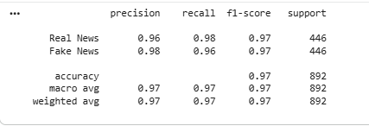
Figure 33: XGBoost feature importance analysis.
Figure 33 presents the feature importance analysis generated by the XGBoost classifier. The visualization ranks the textual features according to their contribution to the classification process, allowing the most influential words and phrases to be identified. Features associated with political topics, frequently occurring news-related terminology, and distinctive linguistic patterns receive the highest importance scores because they contribute significantly to distinguishing fake news from genuine news. Although XGBoost achieved slightly lower classification accuracy than Logistic Regression and SVM, the feature importance analysis provides valuable insight into how the model makes classification decisions and highlights the most discriminative textual features within the dataset.

For the comparison of the performance of all the traditional machine learning models, the comparative bar charts were plotted using the evaluation metrics. SVM performed best in nearly all of the measures of evaluation, with Logistic Regression coming in next and XGBoost had relatively low accuracy but high ROC-AUC value as seen in Figure. The accuracy comparison further shows that SVM performed best in the overall performance having compared the three machine learning models used in this research.
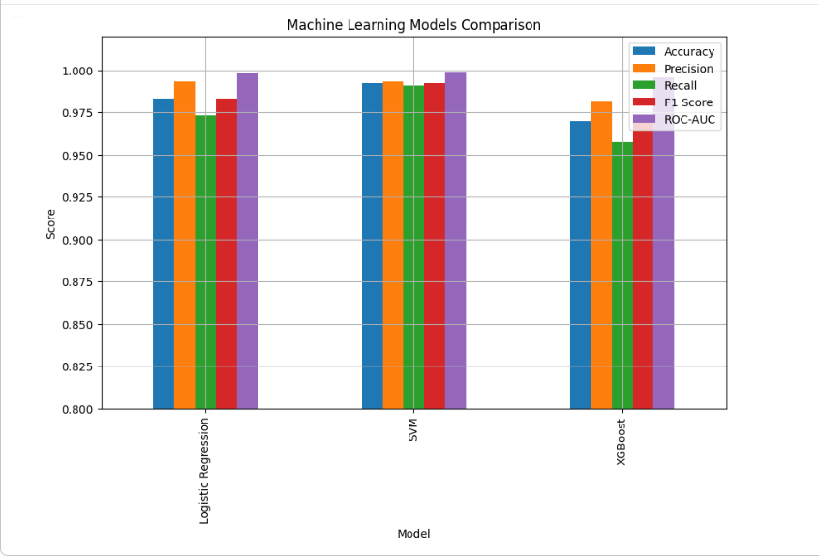
Figure 34: Comparison of machine learning model performance
Figure 34 compares the performance of the three traditional machine learning algorithms evaluated in this study: Logistic Regression, Support Vector Machine (SVM), and XGBoost. The comparison includes multiple evaluation metrics, including accuracy, precision, recall, F1-score, and ROC-AUC. The results demonstrate that SVM achieved the highest overall performance across nearly all evaluation metrics, followed closely by Logistic Regression, while XGBoost produced slightly lower classification accuracy despite maintaining a high ROC-AUC score. This comparative analysis enables objective assessment of each algorithm and supports the selection of SVM as the strongest traditional machine learning baseline before introducing deep learning models.
The experimental results show that all three machine learning models achieved good accuracy for the balanced fake news set, with all values being greater than 96%. Of these, the Support Vector Machine (SVM) was the most successful traditional machine learning approach and was used as a baseline to compare to the deep learning approaches discussed later.
The comparison of the Receiver Operating Characteristic (ROC) and Area Under the Curve (ROC-AUC) scores of the three machine learning models is shown in the figure. The ROC-AUC value for all models was very close to 1.0, which showed high performance in distinguishing real news articles from fake or pseudo-articles. The model with the best ROC-AUC score was Support Vector Machine (SVM) with a score of 0.9990, followed by a Logistic Regression score of 0.9986 and an XGBoost score of 0.9957. The results again validate the excellent classification ability of the SVM model, although the differences between the models are comparatively low. The consistently high ROC-AUC scores demonstrate that the proposed machine learning models were highly effective in separating the two news categories and exhibited strong generalisation performance on unseen test data.
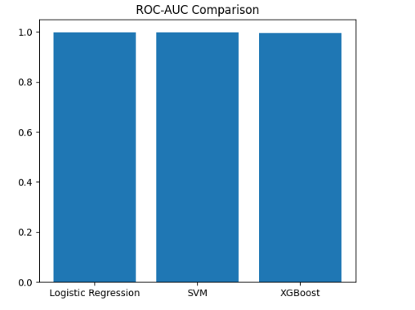
Figure 35: ROC-AUC comparison of the Logistic Regression, SVM and XGBoost models
Figure 35 compares the Receiver Operating Characteristic (ROC) curves and Area Under the Curve (ROC-AUC) values for the three machine learning classifiers. The ROC curve illustrates the trade-off between the true positive rate and false positive rate across different classification thresholds. All three models achieved ROC-AUC values close to 1.0, indicating excellent discrimination between real and fake news articles. The SVM model achieved the highest ROC-AUC value (0.9990), followed by Logistic Regression (0.9986) and XGBoost (0.9957). These results confirm that all three algorithms possess excellent classification capability, with SVM providing the strongest overall performance among the traditional machine learning approaches.

4.9 Deep Learning Model Development and Evaluation
4.9.1 Long Short-Term Memory (LSTM) Model
The Long Short-Term Memory (LSTM) model was implemented as the first deep learning approach for fake news classification. LSTM networks are well suited for NLP applications because they have the ability to model the long-range dependencies in a text sequence. The model was constructed using an embedding layer to transform tokenised words into dense vector representations, followed by an LSTM layer to learn contextual relationships between words. The dropout layer was used to prevent overfitting and the dense output layer was used to classify the results into two classes with a sigmoid activation function. The Adam optimiser and binary cross-entropy loss function were used to train the model for 10 epochs.
The training and validation accuracy increased steadily and the loss values decreased, showing successful learning of textual patterns in the dataset during the training process. As shown in the figure, the training process converged successfully, achieving stable performance after several epochs. The training and validation accuracy lines, alongside the loss lines, show that the model did not overfit significantly and that it was able to learn meaningful feature representations. The accuracy, precision, recall, F1-score and ROC-AUC of the trained LSTM model on the testing set were 92.15%, 93.52%, 90.58%, 92.03% and 94.58% respectively. The classification report shows that the performance is similar between the real news class and the fake news class. In addition, the confusion matrix in the figure indicates that most news articles were correctly classified, and there was a small number of false positives and false negatives. In summary, the LSTM model achieved good classification accuracy and served as a fundamental deep learning framework for the comparison with the more sophisticated Bi-LSTM and DistilBERT models detailed in the subsequent sections.
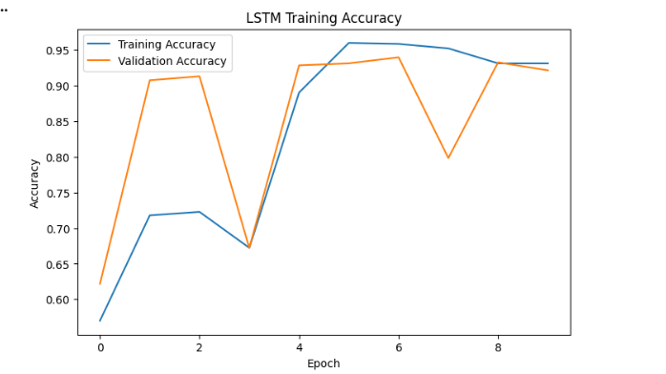
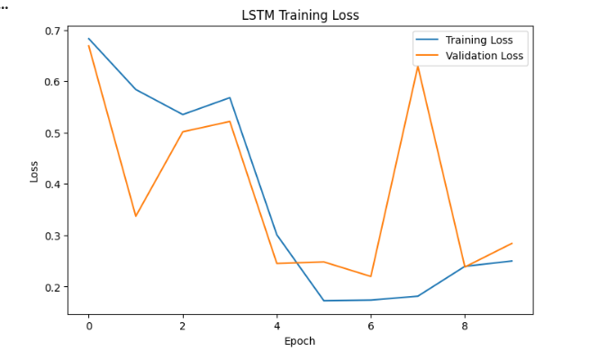
Figure 36: LSTM training process showing training and validation accuracy, loss curves, and model performance
Figure 36 illustrates the training process of the Long Short-Term Memory (LSTM) model. The figure displays both the training and validation accuracy curves together with their corresponding loss curves over multiple training epochs. The increasing accuracy and decreasing loss values indicate that the model successfully learned meaningful textual representations from the training dataset. The close alignment between training and validation curves suggests that the model experienced minimal overfitting while maintaining good generalisation performance. The final LSTM model achieved an accuracy of 92.15%, demonstrating that recurrent neural networks are capable of learning sequential language patterns for fake news classification, although their performance remained lower than the transformer-based DistilBERT model.
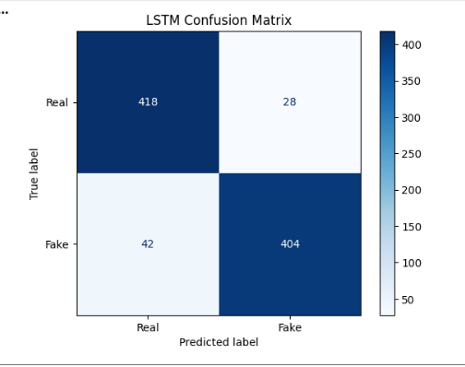
Figure 37: Confusion matrix and classification performance of the LSTM model.
Figure 37 presents the confusion matrix and classification report for the LSTM model. The confusion matrix shows the number of correctly and incorrectly classified real and fake news articles, while the classification report summarises the model's precision, recall, and F1-score. The results indicate that the LSTM classifier successfully identified the majority of news articles, with relatively few false positive and false negative predictions. The balanced performance across both classes demonstrates that the model effectively captures sequential contextual information within textual data. This figure confirms that LSTM provides a reliable deep learning baseline for comparison with more advanced architectures such as BiLSTM and DistilBERT.
4.9.2 Bidirectional Long Short-Term Memory (BiLSTM) Model
A Bidirectional Long Short-Term Memory (BiLSTM) network was used to further enhance the sequential learning capability of the deep-learning model. Unlike the traditional LSTM, the BiLSTM reads the text sequence in forward and backward directions, and as a result, it can also be used to retain the information related to the previous words in a sentence and the next words. The bi-directional learning mechanism enables the model to create more semantic representations, which is very beneficial for complex tasks like fake news detection in Natural Language Processing. The BiLSTM model was also similar in structure to the LSTM model, featuring an embedding layer, bidirectional LSTM layer, dropout regularisation, and a dense output layer that used sigmoid activation. The model was trained for 10 epochs with the Adam optimiser and using the binary cross-entropy loss function.
The training process showed good convergence: the accuracy of the training and the validation were always high during training. The two graphs in Figure 4.31 show that the training accuracy was close to 100% and the validation accuracy was around 97% which means that the model learns meaningful representations of text. The model showed a slight increase in the loss for the validation data with the successive epochs, but it still had a proper validation accuracy which means it was a good generaliser.
The BiLSTM model achieved an accuracy of 97.31%, precision of 96.27%, recall of 98.43%, F1-score of 97.34%, and ROC-AUC of 99.81% on the testing dataset. The balanced classification report confirms the performance of both the real and fake news classes and the confusion matrix presented in Figure 4.32 reveals that only few articles were misclassified. The overall performance of the BiLSTM model is significantly better than the baseline LSTM model, with higher classification accuracy and recall, which indicates that the bidirectional learning of sequences is more suitable for representing textual information in fake news classification.
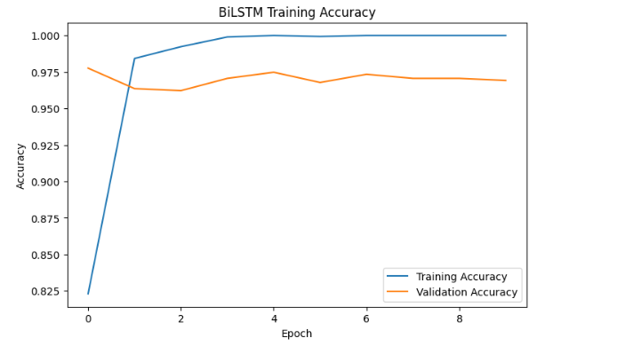
Figure 38: BiLSTM Training Accuracy Performance
Figure 38 illustrates the training and validation accuracy achieved by the Bidirectional Long Short-Term Memory (BiLSTM) model during training. The graph demonstrates a steady increase in both training and validation accuracy as learning progresses through successive epochs. The BiLSTM architecture processes text in both forward and backward directions, enabling the model to capture richer contextual relationships than the standard LSTM model. The consistently high validation accuracy indicates that the model learned meaningful semantic representations while maintaining good generalisation performance. The figure demonstrates the advantage of bidirectional sequence learning for complex Natural Language Processing tasks such as fake news detection.
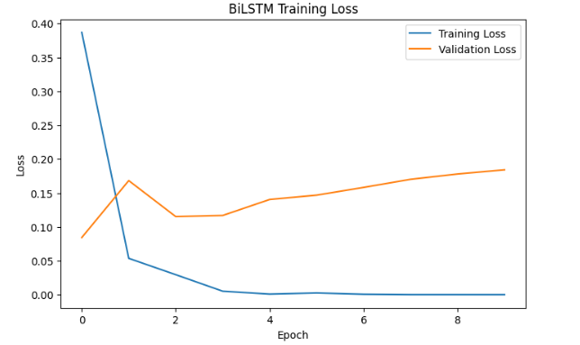
Figure 39: BiLSTM Training Loss Performance.
Figure 39 presents the training and validation loss curves obtained during BiLSTM model training. Both curves decrease steadily throughout the training process, indicating continuous optimisation of the model parameters. Although a slight increase in validation loss is observed during later epochs, the validation accuracy remains consistently high, suggesting only minor overfitting and good generalisation capability. The decreasing loss values demonstrate successful convergence of the optimisation algorithm and confirm that the BiLSTM model effectively learns complex sequential patterns within news articles. These observations support the superior performance of BiLSTM compared with the conventional LSTM architecture.
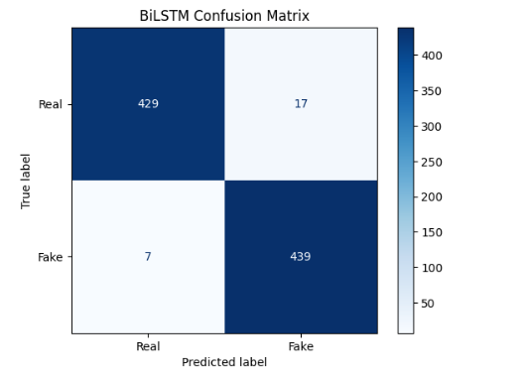
Figure 40: Confusion matrix and classification performance of the BiLSTM model
Figure 40 presents the confusion matrix and classification report for the BiLSTM model. The confusion matrix demonstrates that only a small number of news articles were incorrectly classified, reflecting the model's strong predictive capability. The BiLSTM achieved an accuracy of 97.31%, precision of 96.27%, recall of 98.43%, F1-score of 97.34%, and ROC-AUC of 99.81%. These results represent a substantial improvement over the standard LSTM model and highlight the effectiveness of bidirectional sequence learning for fake news detection. The figure confirms that BiLSTM captures contextual information more effectively than traditional recurrent neural networks, making it one of the strongest deep learning models evaluated before the final DistilBERT implementation.

4.9.3 DistilBERT Model

Dataset Used for DistilBERT Analysis
The DistilBERT model was trained and evaluated using the processed fake news dataset created during the data preprocessing stage. The dataset originally consisted of 4,460 labelled news articles, equally balanced between 2,230 real news articles and 2,230 fake news articles. Real news articles were collected through web scraping from trusted news sources including BBC News, The Hindu, and The Indian Express, while fake news articles were obtained from the ISOT Fake News Dataset.
For the DistilBERT implementation, only the article content and the corresponding class label were used as input features. Records containing missing values were removed, duplicate articles were eliminated, and the dataset index was reset to ensure data consistency before model training. The class labels were encoded as 0 (Real News) and 1 (Fake News) for binary classification.
The cleaned dataset was then divided into 80% training data and 20% testing data using a stratified train-test split to preserve the balanced distribution of both classes. The training dataset was used to fine-tune the pre-trained DistilBERT-base-uncased model, while the testing dataset was reserved for evaluating the model's performance on previously unseen news articles.
Finally, the news articles were tokenised using the DistilBERT tokenizer, with each article converted into input IDs and attention masks. A maximum sequence length of 256 tokens was applied to ensure consistent input size during transformer model training.
DistilBERT, which uses a transformer based language model with fewer computational resources, is the final deep learning model used in this research. Unlike LSTM and BiLSTM models that process text sequentially, DistilBERT uses a self-attention mechanism to recognize the relationship among words in the text without considering their position in the text. This helps the model to grasp the significant semantic patterns and long-range dependencies, making it particularly well suited for fake news detection. The articles were tokenized using the pre-trained DistilBERT tokenizer and each article was converted into input IDs and attention masks. The dataset was split into 80% training and 20% testing data before fine-tuning the pre-trained DistilBERT-base-uncased model for three epochs with the Hugging Face Transformers framework. During training, the AdamW optimiser and an adaptive learning rate were used to tune the model parameters while maintaining the acquired language knowledge from pre-training. Predictions were then made on the test set after the training and assessed with common classification metrics.
The experimental results showed that DistilBERT model outperforms all of the machine learning models and deep learning models that were evaluated. The model achieved a precision of 100%, a recall of 100% and an F1 score of 100% for Real News and Fake News classes on the testing dataset as indicated in the classification report. The confusion matrix shown in Figure further illustrates the model's superb classification performance, with just two misclassified articles from 892 testing samples (445 articles correctly classified per class and only 1 misclassified article per class). In addition, DistilBERT demonstrated a close to perfect ROC-AUC value in Figure compared to Logistic Regression, SVM, XGBoost, LSTM and BiLSTM. These findings indicate that the transformer-based architecture provides superior contextual understanding and generalisation capability, making DistilBERT the most effective model for the proposed AI-based fake news detection system.

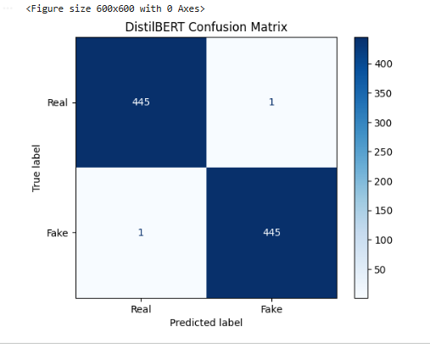
Figure 41: DistilBERT confusion matrix and classification performance
Figure 41 presents the confusion matrix and classification report for the DistilBERT model. The figure demonstrates exceptional classification performance, with only two misclassified articles out of 892 testing samples. The classification report shows almost perfect precision, recall, and F1-score for both real and fake news categories. The transformer-based architecture successfully captures complex contextual relationships within textual data through its self-attention mechanism, allowing it to outperform all other machine learning and deep learning models evaluated in this research. The figure confirms that DistilBERT is the most effective classification model for the proposed fake news detection system.
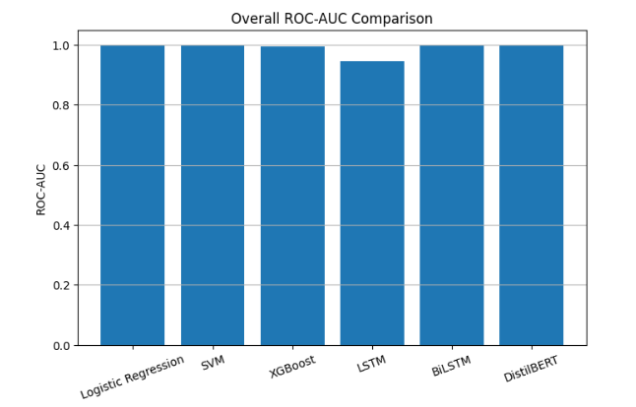
Figure 42: Overall comparison of all ML and DL ROC-AUC models
Figure 42 compares the ROC-AUC performance of all six classification models developed in this research, including Logistic Regression, Support Vector Machine, XGBoost, LSTM, BiLSTM, and DistilBERT. The comparison demonstrates that DistilBERT achieved the highest overall classification performance with an accuracy of 99.78% and a ROC-AUC score of 0.99996, outperforming both traditional machine learning and recurrent neural network models. The figure provides a comprehensive visual comparison of model performance and clearly justifies the selection of DistilBERT as the final model deployed within the Flask-based fake news detection application.

All developed models were compared with each other in terms of their performance and the best one was selected for fake news detection. The overall accuracy of the best performing model, DistilBERT, was 99.78% with the same precision, recall, and F1-score values of 99.78%, and an excellent ROC-AUC score of 0.99996. The results show that the transformer-based architecture outperforms all other models in terms of contextual understanding and classification. After selecting the model, the trained model and the TF-IDF vectorizer were saved using the Joblib library to make the model usable to be deployed and used again in the developed Flask-based fake news detection application.

4.10 Flask-Based Fake News Detection System and Online Verification
To demonstrate the practical applicability of the proposed fake news detection framework, a web-based application was developed using the Flask framework. The application combines the trained DistilBERT classification model and an online news verification module which allows users to analyse news articles using a simple and interactive web interface. The system can give automatic prediction of fake news and some information from trusted online news sources, which can enhance the transparency and reliability of fake news classification results. The homepage of the application is shown in Figure 4.35. Users are free to type in a news headline and then paste the full news article into the input form of the interface. Once the "Detect News" button is clicked, the submitted article goes through the same pre-processing steps as during model training followed by the classification using the trained DistilBERT model. This user-friendly interface enables non-technical users to perform fake news analysis without requiring any knowledge of machine learning algorithms.

Figure 43: Flask-based fake news detection system interface
Figure 43 presents the graphical user interface of the Flask-based fake news detection system developed in this research. The interface allows users to enter a news headline and paste the corresponding news article into a simple web form. After clicking the "Detect News" button, the submitted article undergoes preprocessing before being analysed by the trained DistilBERT model. The intuitive interface enables users with little or no technical knowledge to perform fake news analysis through a user-friendly web application. This figure demonstrates the successful deployment of the trained artificial intelligence model into a practical decision-support system.

After classification, the classification result is presented with the prediction confidence score (model confidence score). The system will also undertake an online verification process where it searches trusted news publishers based on the classification output, in addition to the classification output. When related articles are identified, information regarding the titles, sources, dates published, summaries of the articles, and links to the original news release are displayed and the user can compare the submitted article with the verified information available from the reputable publishers. An example of successful online verification is presented in Figure 4.36, where the system predicts the news as Real News with a confidence score of 99.96% and retrieves matching articles from trusted news sources.

Figure 44: Successful real news prediction with supporting articles
Figure 44 illustrates an example of successful prediction and online verification within the developed Flask application. In this example, the submitted news article is classified as Real News with a high confidence score of approximately 99.96%. After generating the prediction, the NewsAPI verification module retrieves related articles from trusted news publishers and displays their titles, publication dates, summaries, and direct links. These supporting articles allow users to compare the submitted content with information from credible sources, thereby increasing transparency, user confidence, and trust in the prediction generated by the AI model.

If no articles from trusted news publishers are found that are closely related, the application will clearly state in the results that supporting evidence was not found. The DistilBERT model predicted the given article to be Fake News with a confidence value of 99.95%, as shown in the figure. The system failed to find any related articles on credible news websites, so the verification status is set to "Likely Fake News".
In addition, the application provides users with "No Supporting Evidence Found" message, if none of the closely matching articles from trusted publishers were available for analysis at the time of the analysis. The system is clear, though, that if supporting articles are not present, it doesn't necessarily mean that the news submitted is false. This can happen if the article is about breaking news, community events, a recent publication or a subject which hasn't yet been covered by a reputable news source included in the verification service.
Overall, the developed Flask application was able to successfully combine a DistilBERT-based fake news detection model with a real time NewsAPI verification to create an AI assisted decision support system. The primary classification is done by the transformer model, while the online verification module fetches supporting evidence from trusted publishers, if available. By providing the AI prediction alongside any supporting evidence that is available, this integrated approach enhances transparency, and allows users to make informed judgments on the credibility of online news articles.

Figure 45: Prediction Result Showing "Likely Fake News
Figure 45 demonstrates the behaviour of the fake news detection system when no supporting evidence can be found from trusted news publishers. In this example, the DistilBERT model predicts the submitted article as Fake News with a confidence score of approximately 99.95%. The NewsAPI verification module is unable to retrieve closely matching articles from reputable news organisations, resulting in the message "No Supporting Evidence Found" and the verification status "Likely Fake News." The figure highlights the complementary roles of AI-based classification and online fact verification, emphasising that the absence of supporting evidence strengthens the suspicion of misinformation while also informing users that newly emerging events may not yet appear in trusted news databases. This integrated approach improves transparency and supports informed decision-making when evaluating online news credibility.

Chapter 5: Conclusion and Future Work

5.1 Summary of Research
This research presented the design and implementation of an AI-based fake news detection system that combines transformer-based natural language processing with real-time online news verification. The study tackled the emerging problem of misinformation, creating a system to identify factual or fake news for users on online news articles and to offer them evidence from trusted news outlets. A comprehensive dataset was created by merging the authentic news articles gathered from BBC news, The Hindu, and Indian Express with fake news articles from publicly available datasets. Data cleaning and data preprocessing were done and exploratory data analysis was carried out to get insight into the nature and distribution of data collected before the development of the model. A number of machine learning methods were tested for their ability to classify the most appropriate classification model. After testing, DistilBERT was chosen as the end deployment as it had the best classification performance among all the algorithms. The trained model has been incorporated into a web application using Flask which enables users to enter a headline and body text in a news article and get an automated answer. The application also introduces a NewsAPI-powered verification module, which fetches relevant news articles from reputable publishers when necessary, enhancing transparency and user trust. The final system shows the possibility of integrating AI and online verification services to help users evaluate the veracity of online news content using a user-friendly and practical online tool.

5.2 Achievement of Objectives
The proposed fake news detection framework was developed and tested to meet the research objectives. The first objective, which involved collecting and preparing an appropriate dataset, was accomplished by combining real news articles from reputable publishers with publicly available fake news datasets. Data preprocessing techniques, including duplicate removal, text cleaning, missing value handling, and label encoding, ensured that the dataset was suitable for machine learning. The second objective was to build and compete several machine learning models. The traditional machine learning algorithms were implemented and evaluated along with the DistilBERT transformer model to check the performance of them. DistilBERT always achieved the best classification accuracy and was chosen as the final model.
The third objective of developing an intelligent web application was achieved through the implementation of a Flask-based interface that enables users to submit news articles and receive immediate AI predictions together with confidence scores. Finally, the objective of improving prediction transparency was addressed through the integration of NewsAPI, which retrieves supporting articles from trusted news publishers whenever similar reports are available. In conclusion, the proposed system was able to fulfill the research goals effectively by integrating advanced NLP techniques and evidence-based verification, creating a robust fake news detection system.

5.3 Limitations
Although the proposed system achieved excellent performance on the evaluation dataset, several limitations should be acknowledged. The main constraint is to do with the composition of the training data set. As DistilBERT is trained by filter of authentic and fake news articles, it is best suited to news articles that are similar to those it has been trained on. There was some extent of generalisation to new forms of misinformation, as fake news from previously unknown sources or laden with new styles was not always correctly classified. Another constraint relates to the verification process online. NewsAPI only returns articles from publishers supported by the API, meaning newly published articles, local news, or articles from publishers not indexed may not have supporting evidence, even if they are authentic. Moreover, the app only analyzes textual content, not images, videos, manipulated multimedia or patterns of social media interaction that are prevalent in today's misinformation. These limitations indicate the application should be considered an AI-assisted decision support system rather than a replacement for professional fact-checking or human verification.
5.4 Research Questions Addressed
Research Question 1: How effectively can machine learning and deep learning models detect fake news from textual content?
Outcome:
The experimental results demonstrate that both machine learning and deep learning models effectively detect fake news. Logistic Regression, SVM, XGBoost, LSTM, BiLSTM, and DistilBERT all achieved high classification performance, with accuracies above 92%. This confirms that AI-based Natural Language Processing techniques are highly effective for fake news detection. DistilBERT achieved the highest accuracy of 99.78%, demonstrating superior contextual understanding compared with traditional approaches.
Research Question 2: Which classification model provides the best performance among Logistic Regression, SVM, XGBoost, LSTM, BiLSTM, and DistilBERT?
Outcome:
The comparative evaluation shows that DistilBERT outperformed all other models, achieving 99.78% accuracy and an almost perfect ROC-AUC score. Its transformer-based architecture captured contextual relationships more effectively than both traditional machine learning models and recurrent neural networks, making it the most suitable model for deployment.
Research Question 3: How does integrating an online verification module improve the reliability and usability of the fake news detection system?
Outcome:
The integration of the NewsAPI verification module enhanced transparency by retrieving supporting articles from trusted publishers whenever relevant information was available. This evidence-based verification allows users to compare AI predictions with credible news sources, increasing confidence in the system's decisions and improving usability.
Research Question 4: Can a Flask-based web application provide an effective and user-friendly platform for real-time fake news classification and online verification?
Outcome:
The Flask application successfully deployed the trained DistilBERT model and provided a simple interface where users could submit news articles for classification. The system returned prediction results, confidence scores, and supporting evidence from trusted news publishers, demonstrating that the proposed application is practical, user-friendly, and suitable for real-time fake news detection.

5.5 Future Work
There are a number of possibilities for improving the proposed system. The most important improvement is the addition of fake news articles from various reputable sources, such as PolitiFact, LIAR, FakeNewsNet, and others known to host fake news content, to the training set, thus enhancing the generalisation of the training set in terms of the writing style and the type of fake news. Larger transformer models like RoBERTa, DeBERTa, or domain-specific transformer models are worth exploring in the future to enhance the classification accuracy. Multimodal detection could also be explored by combining textual analysis with image verification, video analysis, and metadata examination to identify manipulated multimedia. The verification component might be improved by using more than one fact-checking API and trusted knowledge bases instead of just one API. Lastly, it would be desirable to provide user authentication, prediction history, feedback mechanisms, multilingual support, and continuous model updating using newly verified articles, which would enhance its accuracy, usability, and adaptability to changing online misinformation.

5.6 Chapter Summary
This chapter presented the overall conclusions of the research and evaluated the extent to which the proposed objectives were achieved. The study showed that using transformer-based NLP is an effective method for fake news detection via an automated system, when the dataset is carefully prepared and the preprocessing technique is applicable. DistilBERT has been evaluated against a number of models and was found to have the highest classification accuracy and was successfully deployed in a Flask web app that can process user-submitted news articles. A NewsAPI-based verification module was also added to the system, ensuring transparency by adding supporting articles from trusted publishers if they are available. The research also identified several practical limitations related to dataset diversity, generalisation to previously unseen fake news, and dependence on external verification services. The findings underscore ongoing challenges around automatic detection of misinformation and the critical need for the integration of AI with human expertise and trusted sources of information. There are several promising directions for future research, such as leveraging more extensive and varied data sets, more sophisticated transformer structures, multimodal analysis, and extending verification methods. Overall, this dissertation successfully achieved its aim of developing an AI-assisted fake news detection system and demonstrated the practical application of transformer-based deep learning techniques for supporting users in evaluating the credibility of online news content.

Chapter 6: References
Alghamdi, J., Lin, Y. and Luo, S. (2022). A comparative study of Machine learning and deep learning techniques for Fake news detection. Information, 13(12), p.576. https://doi.org/10.3390/info13120576
Alqadi, B.S., Alsuhibany, S.A., Samia Nawaz Yousafzai, Sharf Alzu’bi, Deema Mohammed Alsekait and Diaa Salama AbdElminaam (2025). Transfer learning driven fake news detection and classification using large language models. Scientific reports, [online] 15(1). https://doi.org/10.1038/s41598-025-10670-2
Alshuwaier, F.A. and Alsulaiman, F.A. (2025). Fake news detection using machine learning and deep learning algorithms: A comprehensive review and future perspectives. Computers, [online] 14(9), pp.394–394. https://doi.org/10.3390/computers14090394
Chen, Y. and Yin, B. (2025). Transformer-Based fake news classification: Evaluation of DistilBERT with cnn-lstm and GloVe embedding. Informatica, [online] 49(25). https://doi.org/10.31449/inf.v49i25.7710
D’Ulizia, A., Caschera, M.C., Ferri, F. and Grifoni, P. (2021). Fake news detection: A survey of evaluation datasets. PeerJ computer science, 7, p.e518. https://doi.org/10.7717/peerj-cs.518
El-Mageed, A.A.A., Abohany, A.A., Ali, A.H. and Hosny, K.M. (2024). An adaptive hybrid african vultures-aquila optimizer with Xgb-Tree algorithm for fake news detection. Journal of Big data, 11(1). https://doi.org/10.1186/s40537-024-00895-9
Guo, Z., Schlichtkrull, M. and Vlachos, A. (2022). A survey on automated Fact-Checking. Transactions of the association for Computational linguistics, [online] 10, pp.178–206. https://doi.org/10.1162/tacl_a_00454
Harris, S., Hadi, H.J., Ahmad, N. and Alshara, M.A. (2024). Fake news detection revisited: An extensive review of Theoretical frameworks, dataset assessments, model constraints, and Forward-Looking research agendas. Technologies, [online] 12(11), pp.222–222. https://doi.org/10.3390/technologies12110222
Karthik, M.G., Ahmad, K.S.F., Pamidimukkala, S.G., Sathe, A.P., Sirisha G.N.V.G, Ram M, S. and Ch, K. (2025). Hybrid optimization driven fake news detection using reinforced transformer models. Scientific reports, 15(1), pp.14782–14782. https://doi.org/10.1038/s41598-025-99936-3
Khan, J.Y., Khondaker, Md.T.I., Afroz, S., Uddin, G. and Iqbal, A. (2021). A benchmark study of machine learning models for online fake news detection. Machine learning with applications, 4, p.100032. https://doi.org/10.1016/j.mlwa.2021.100032
Lu, Y. and Yao, N. (2025). A fake news detection model using the integration of multimodal attention mechanism and residual convolutional network. Scientific reports, [online] 15(1). https://doi.org/10.1038/s41598-025-05702-w
Rama Moorthy, H., Avinash, N.J., Krishnaraj Rao, N.S., Raghunandan, K.R., Dodmane, R., Blum, J.J. and Gabralla, L.A. (2025). Dual stream graph augmented transformer model integrating BERT and GNNs for context aware fake news detection. Scientific reports, [online] 15(1). https://doi.org/10.1038/s41598-025-05586-w
Raza, N., Abdulkadir, S.J., Abid, Y.A., Albouq, S.S., Ayed Alwadain, Rehman, A.U., Ebrahim Hamid Sumiea and Farhan, M. (2025). Enhancing fake news detection with transformer-based deep learning: A multidisciplinary approach. PLoS one, 20(9), pp.e0330954-e0330954. https://doi.org/10.1371/journal.pone.0330954
Raza, S. and Ding, C. (2022). Fake news detection based on news content and social contexts: A transformer-based approach. International journal of Data science and analytics, [online] 13(4). https://doi.org/10.1007/s41060-021-00302-z
Rini Anggrainingsih, Hassan, G.M. and Datta, A. (2025). Evaluating BERT-based language models for detecting misinformation. Neural computing and applications. https://doi.org/10.1007/s00521-025-11101-z
Roumeliotis, K.I., Tselikas, N.D. and Nasiopoulos, D.K. (2025). Fake news detection and classification: A comparative study of Convolutional neural networks, large language models, and natural language processing models. Future internet, 17(1), p.28. https://doi.org/10.3390/fi17010028
Soveatin Kuntur, Wróblewska, A., Ganzha, M., Marcin Paprzycki and Sachdeva, S. (2026). Fake news detection: It’s all in the data! Applied sciences, 16(3), pp.1585–1585. https://doi.org/10.3390/app16031585
Suresh, S. (2025). Transforming fake news detection: Leveraging DistilBERT models for Enhanced accuracy. Procedia computer science, [online] 260, pp.283–290. https://doi.org/10.1016/j.procs.2025.03.203

Chapter 7: Appendix

Appendix- A
Web_Scraping

窗体底端
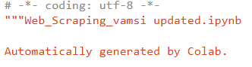
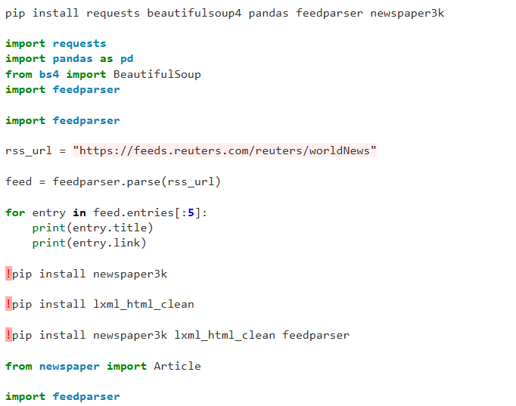

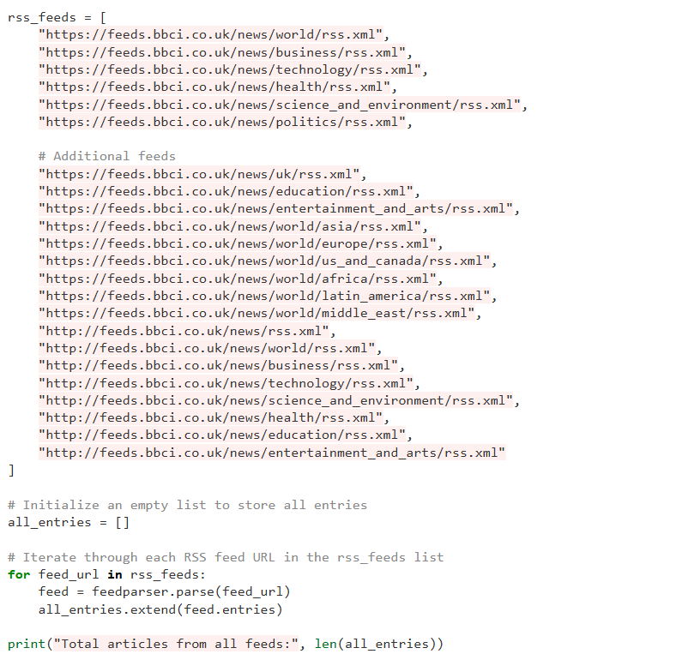
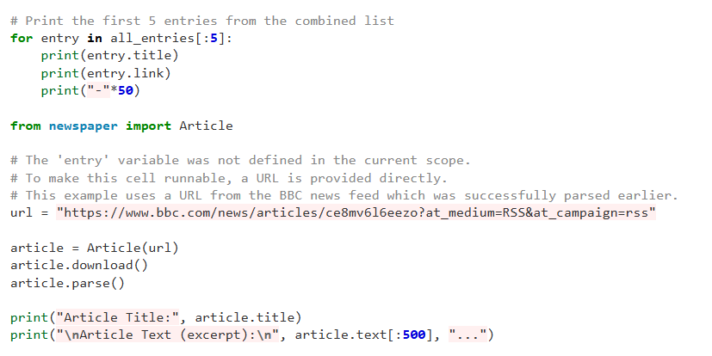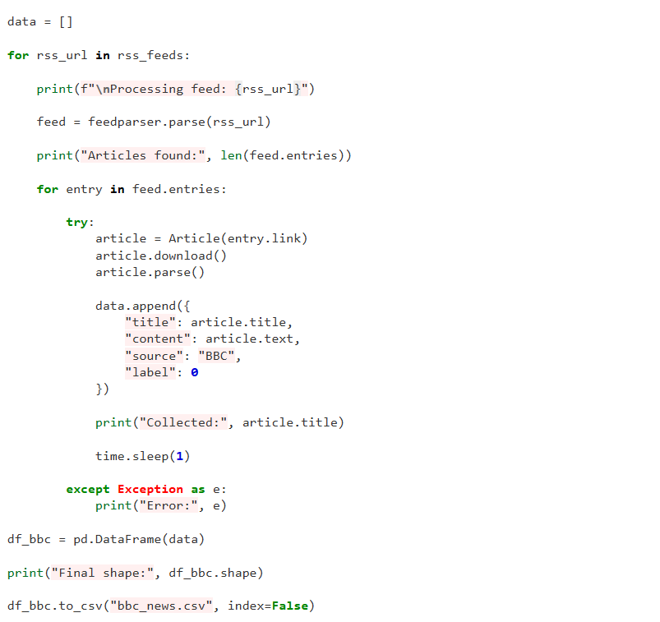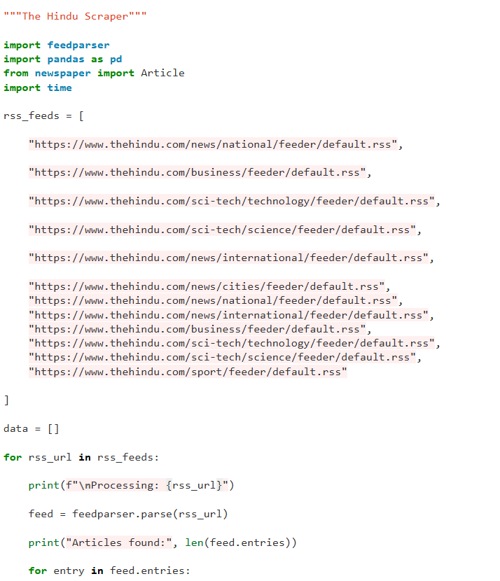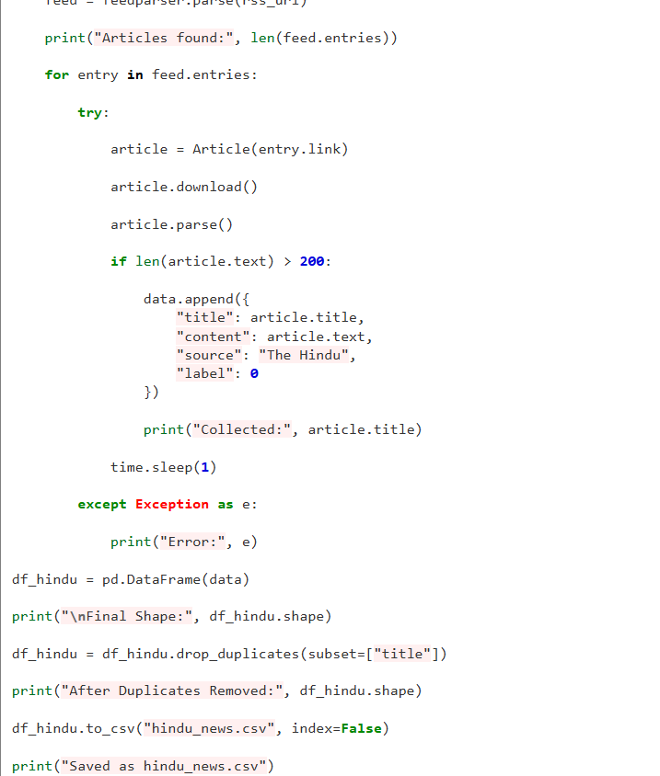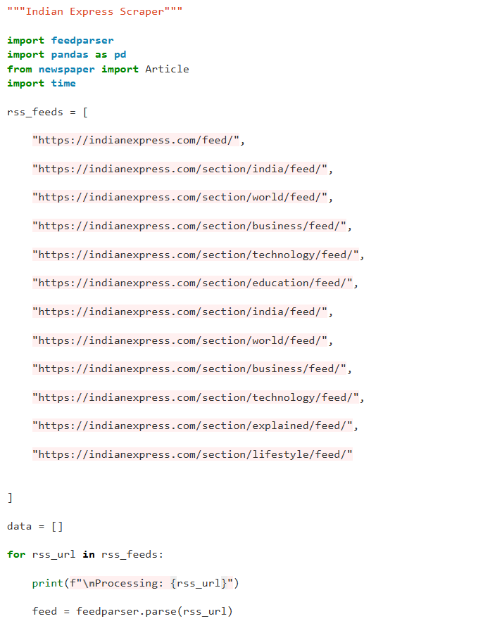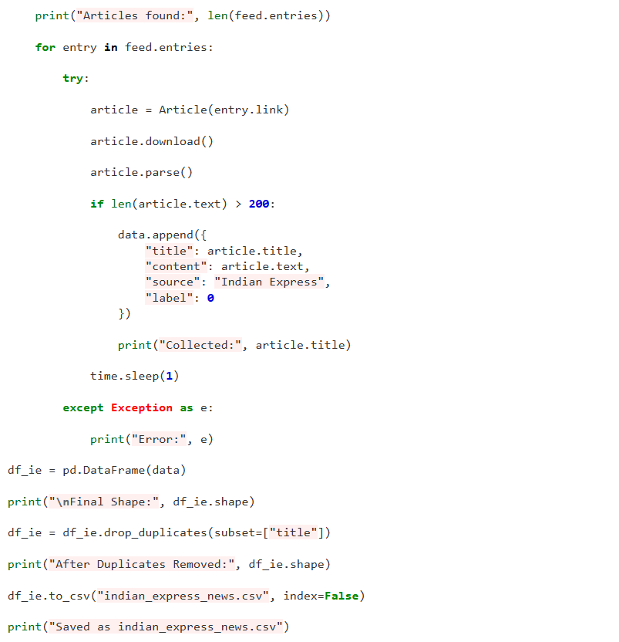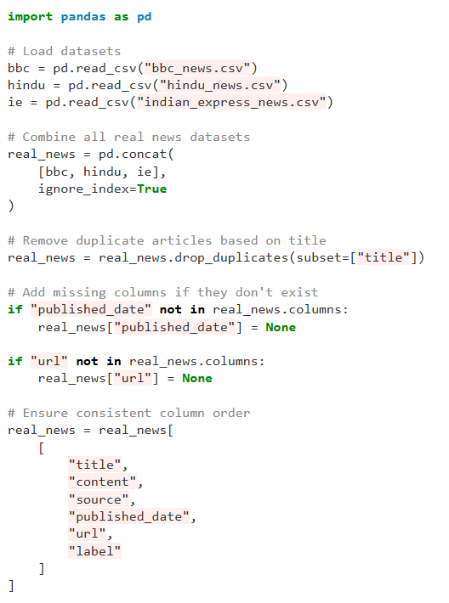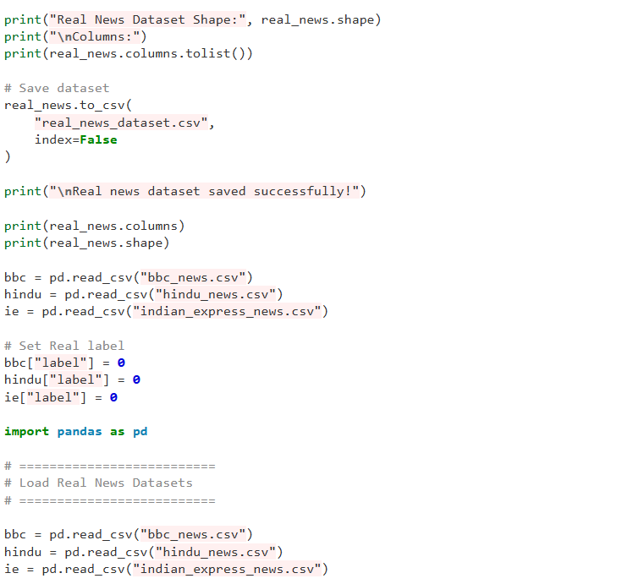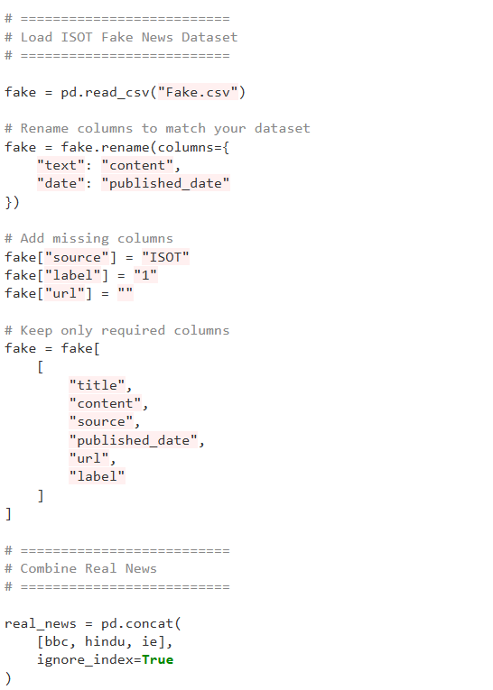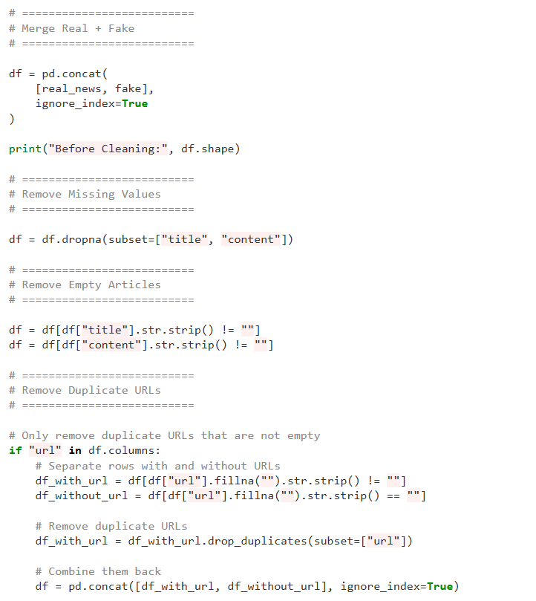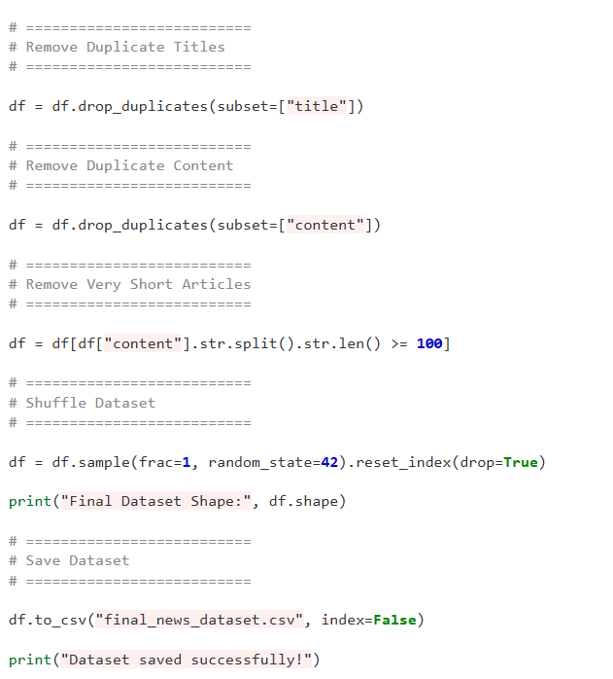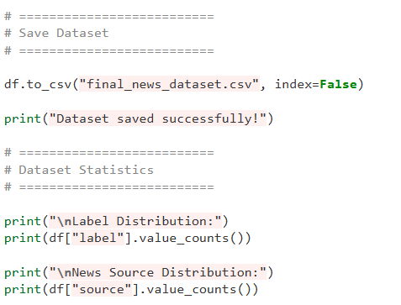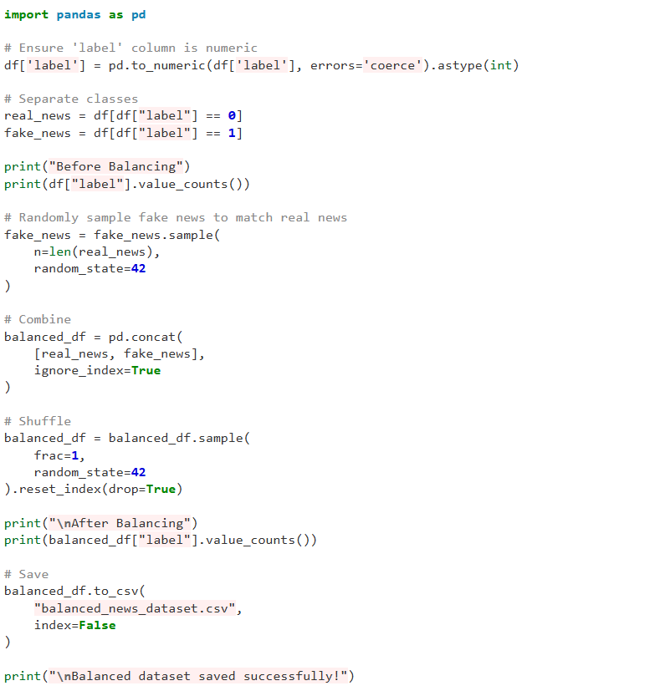

Appendix - B
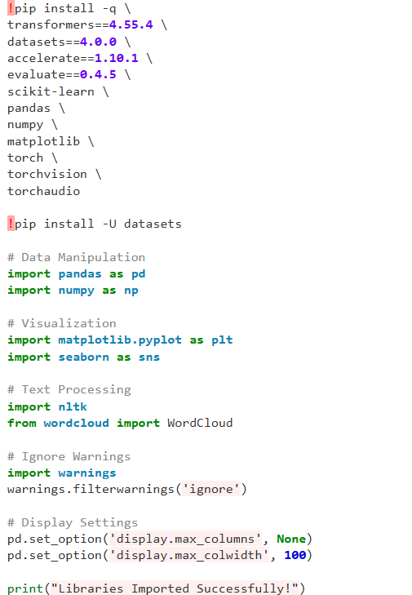
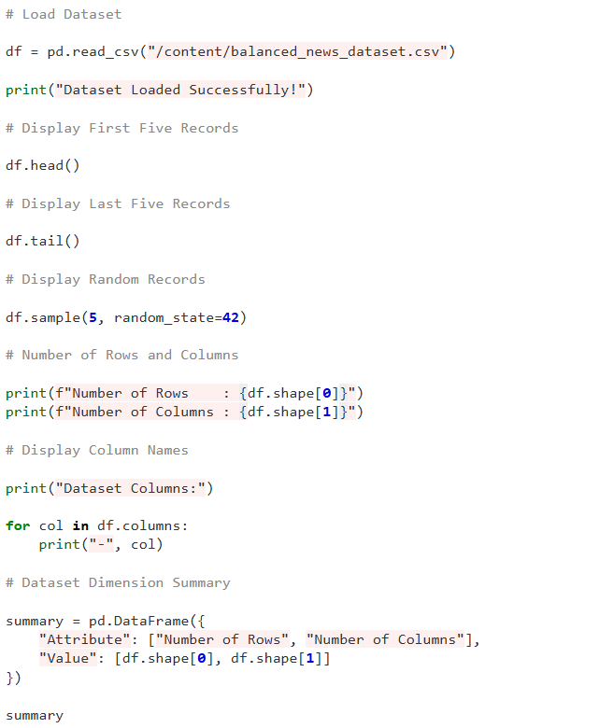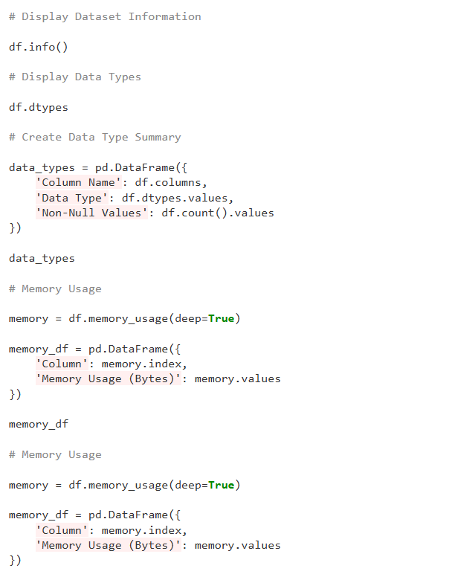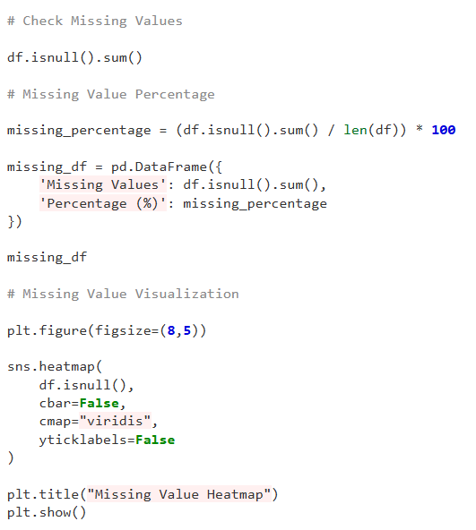
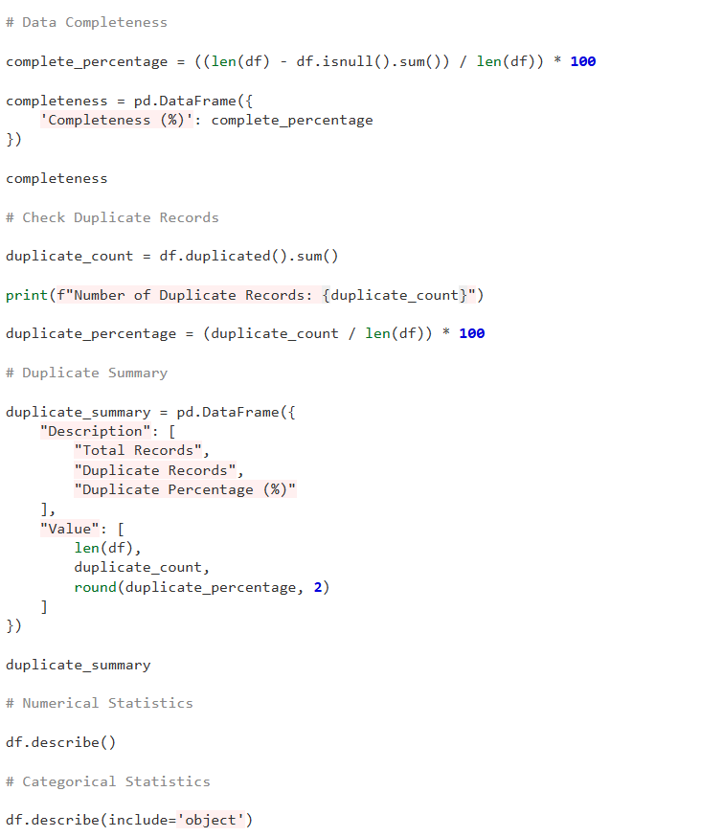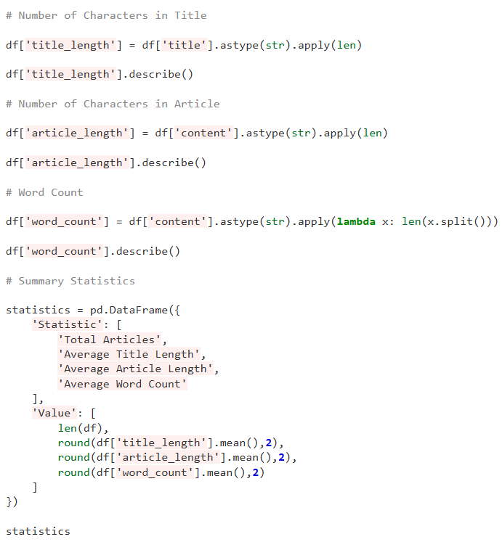
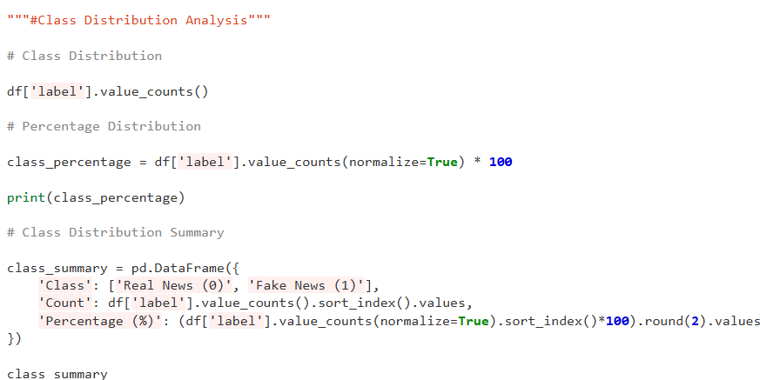
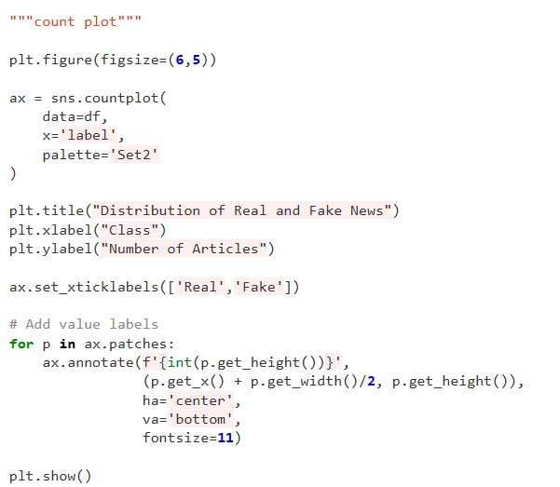

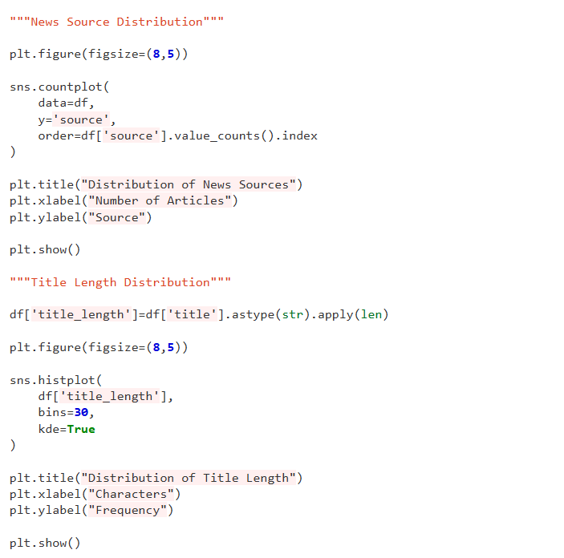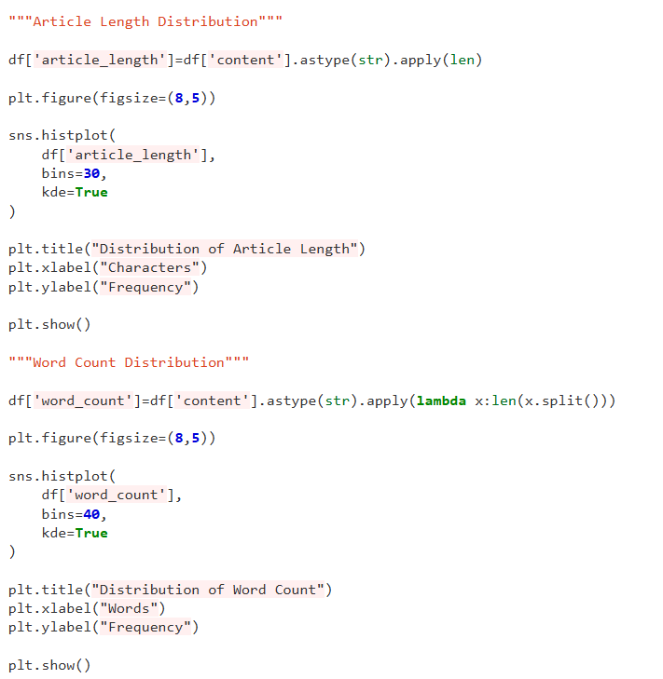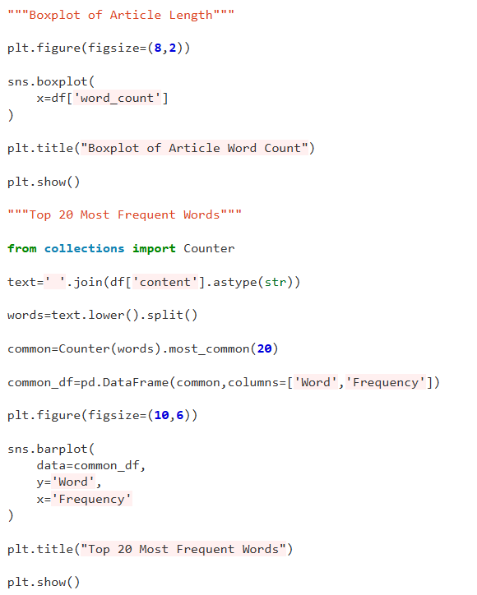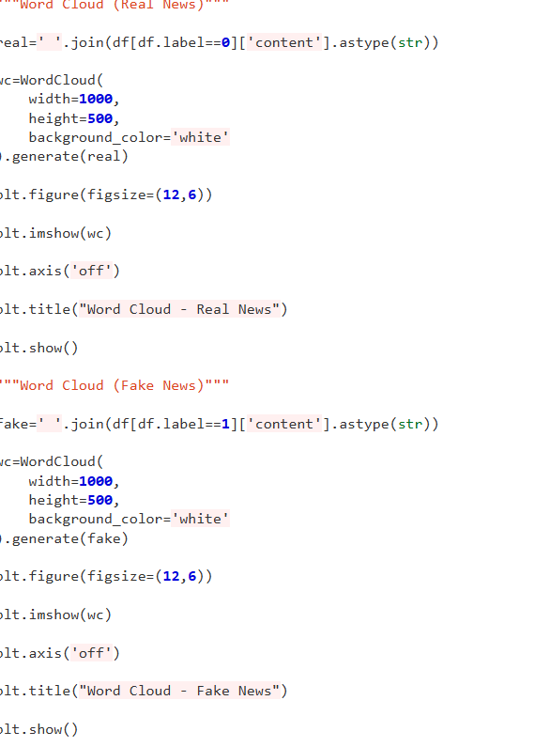
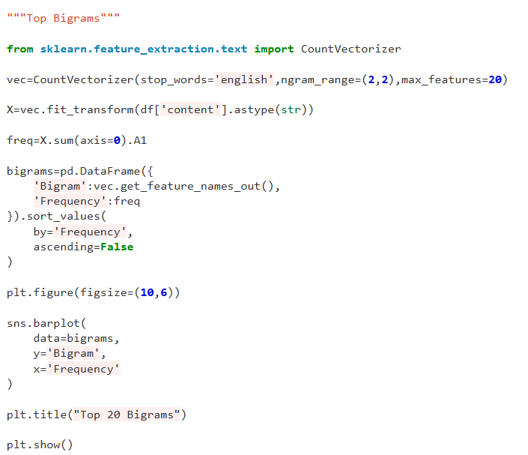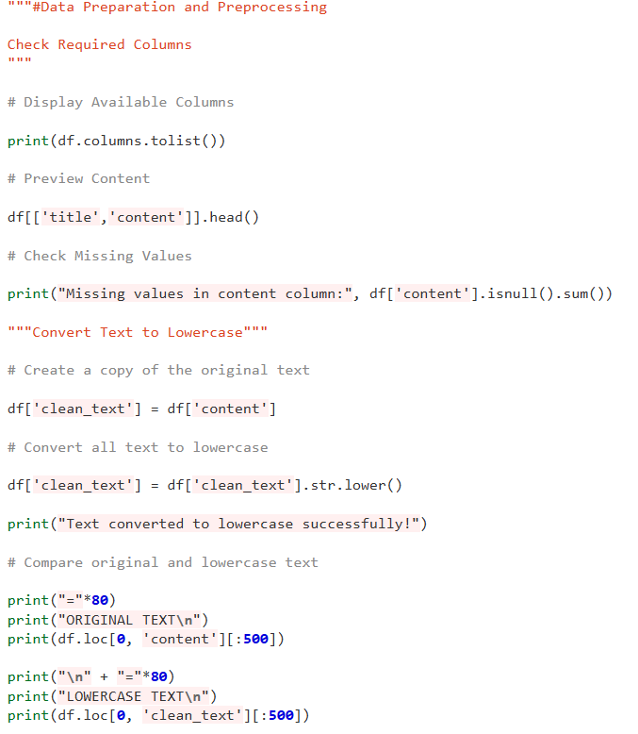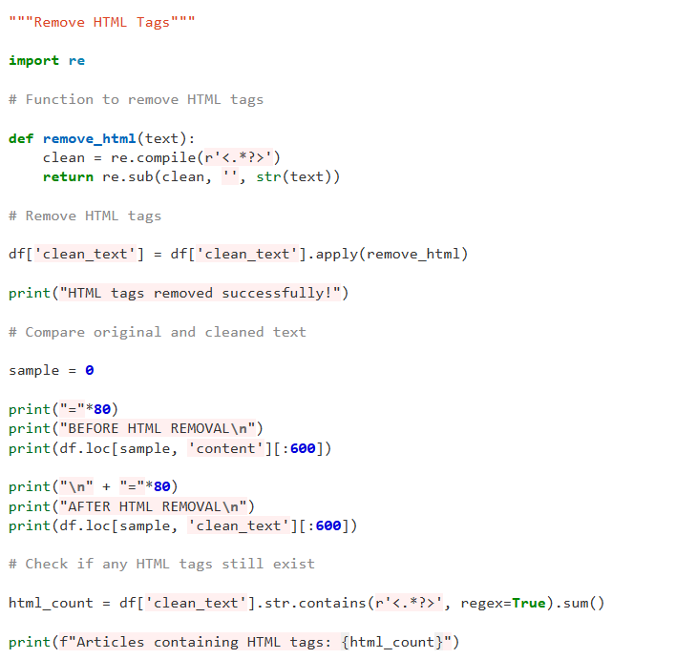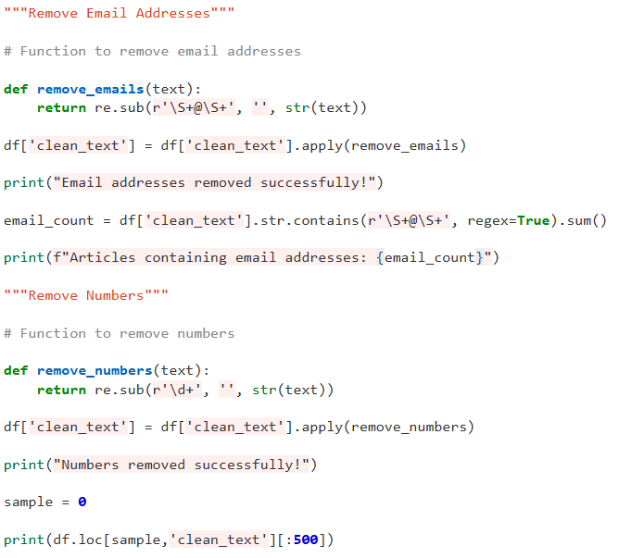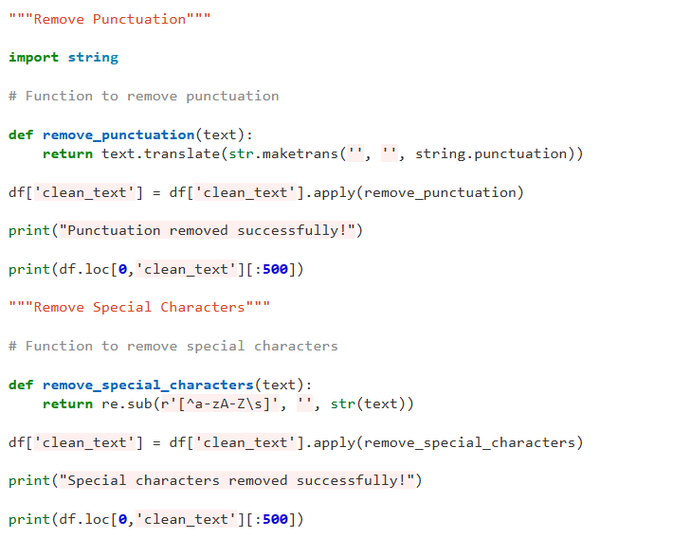
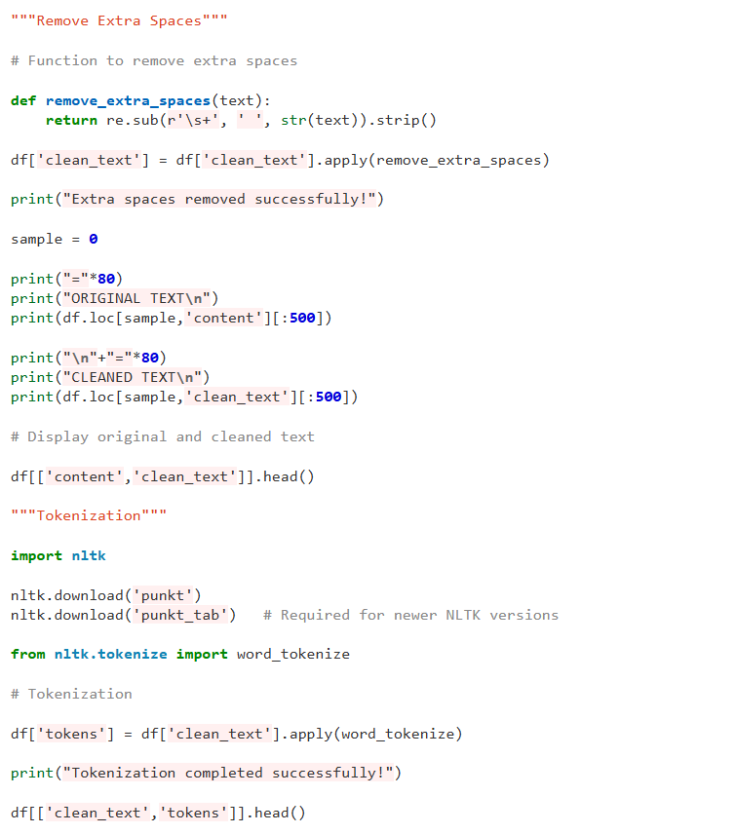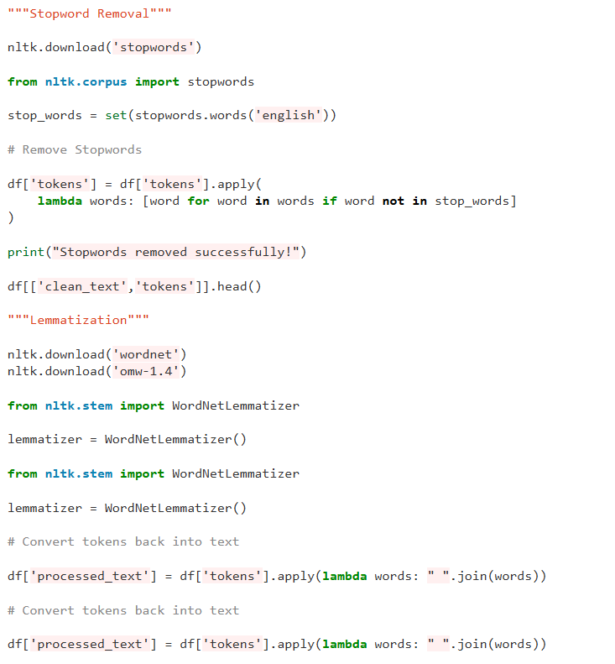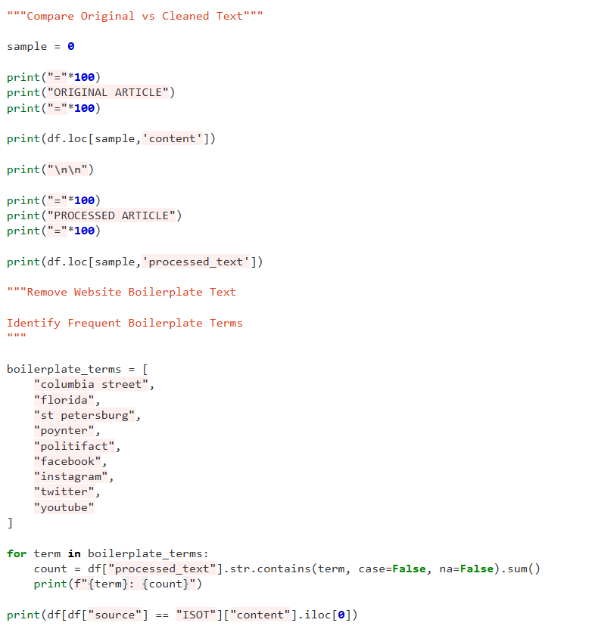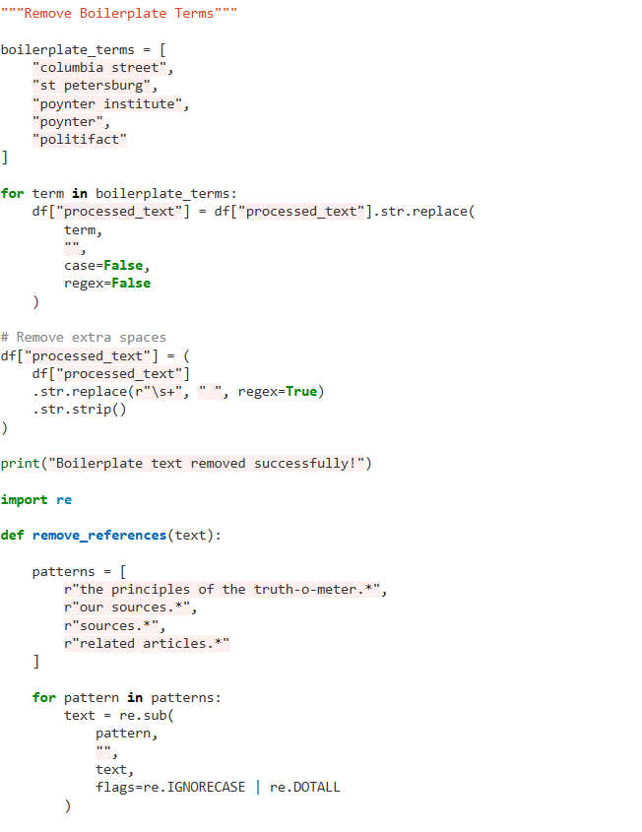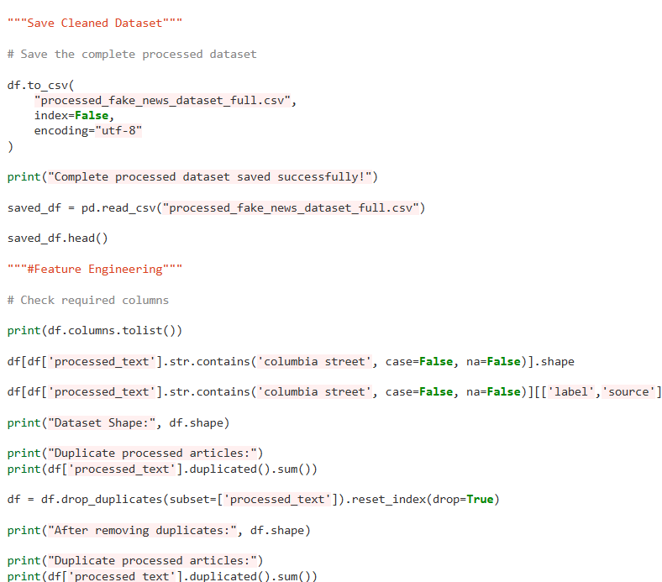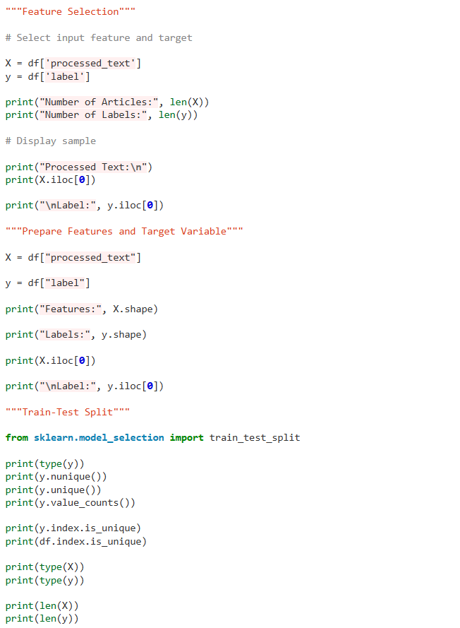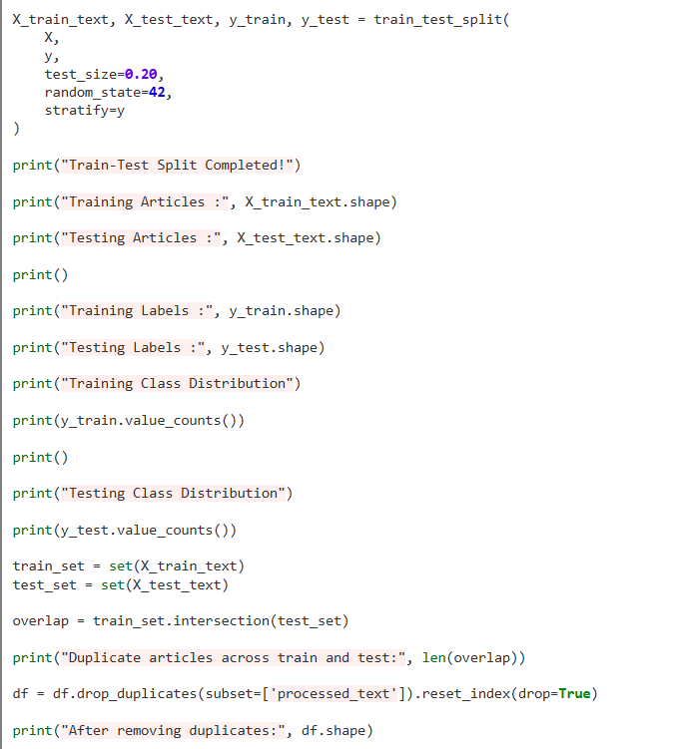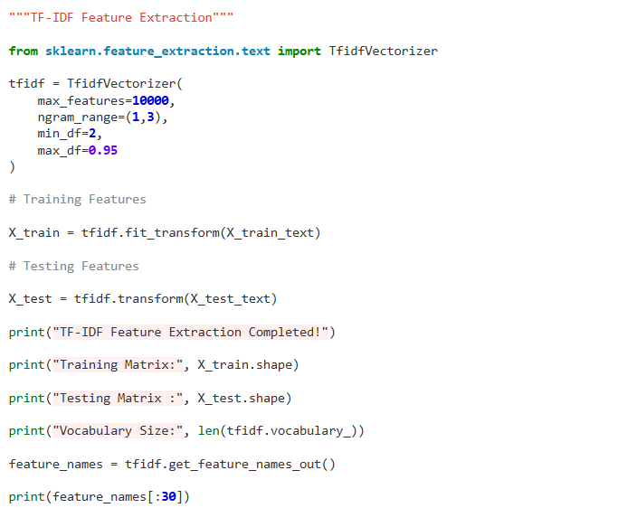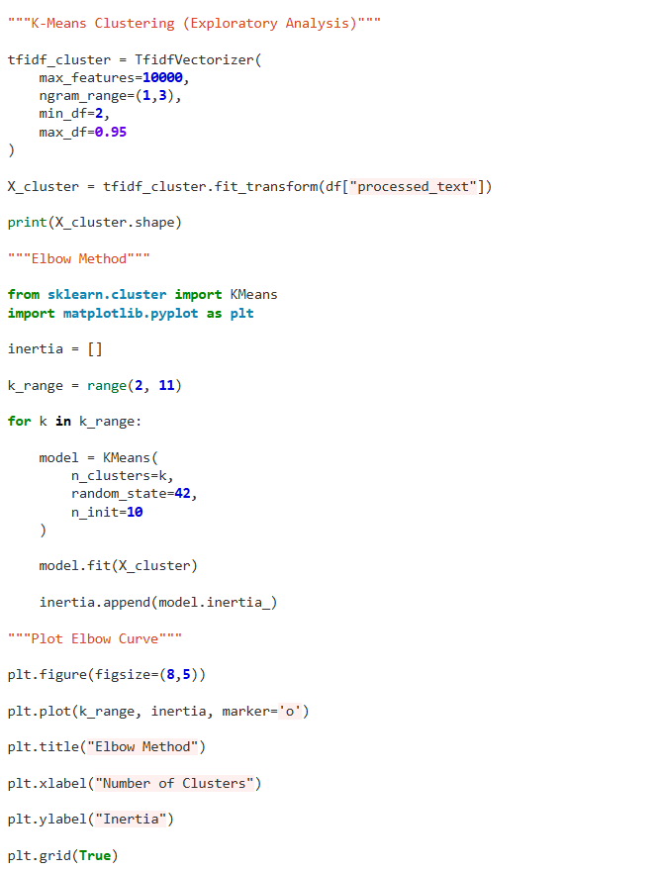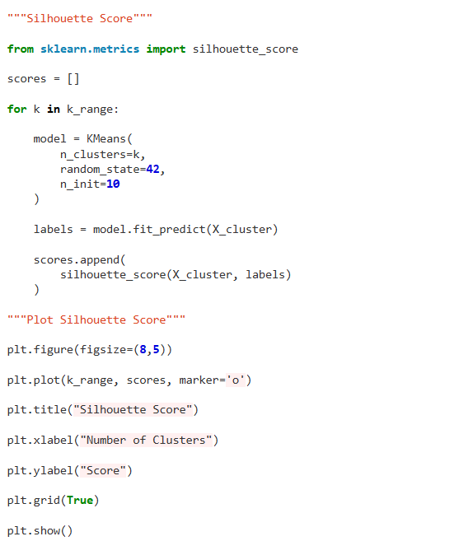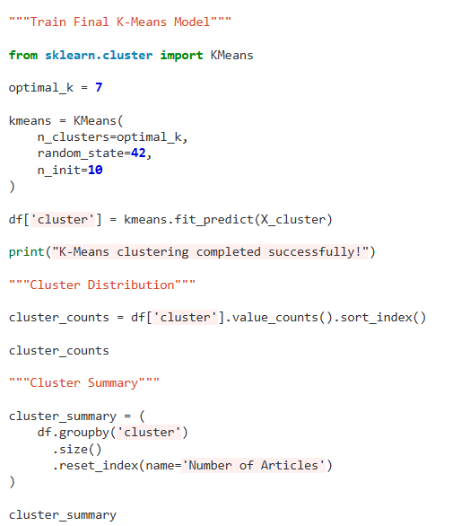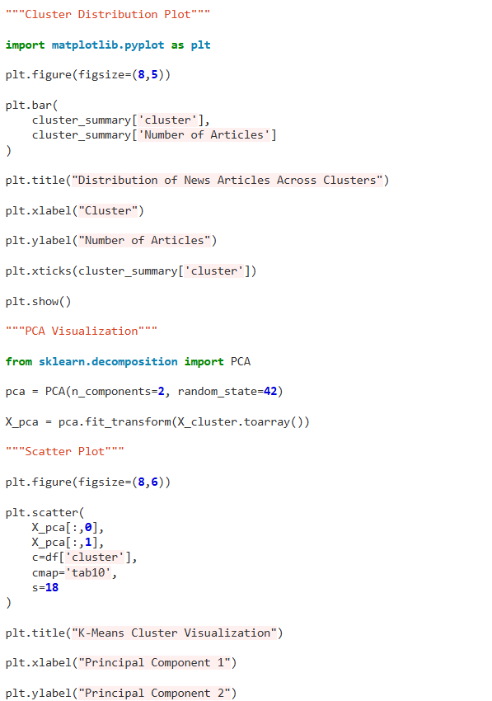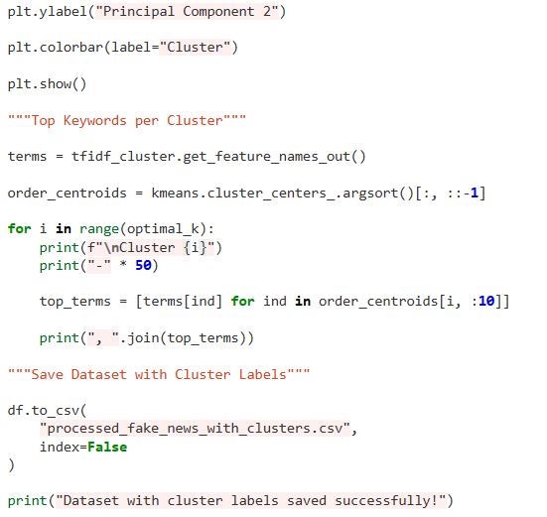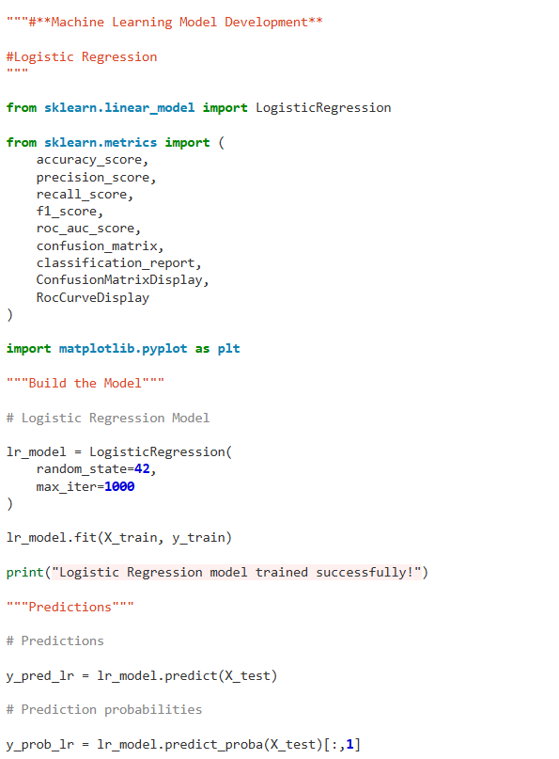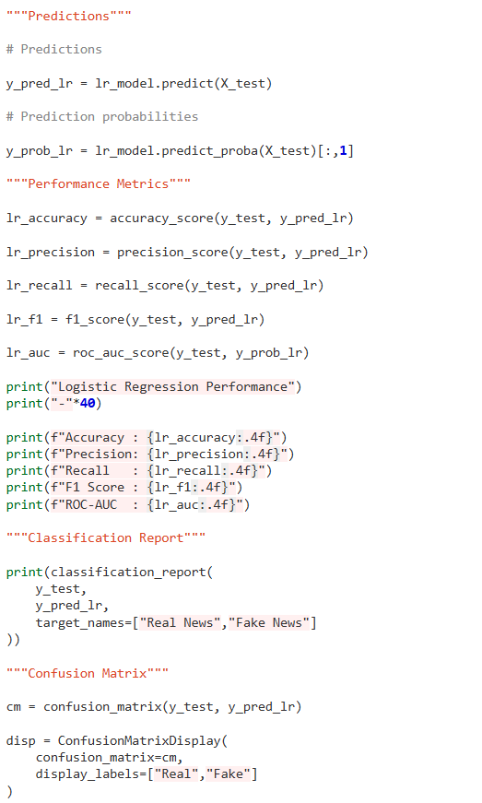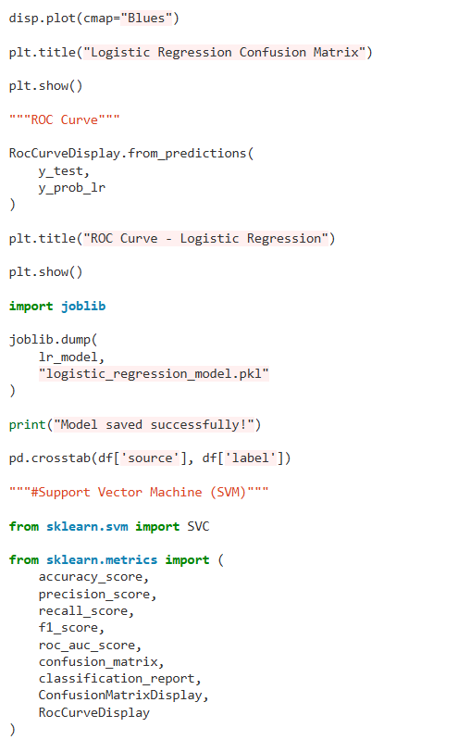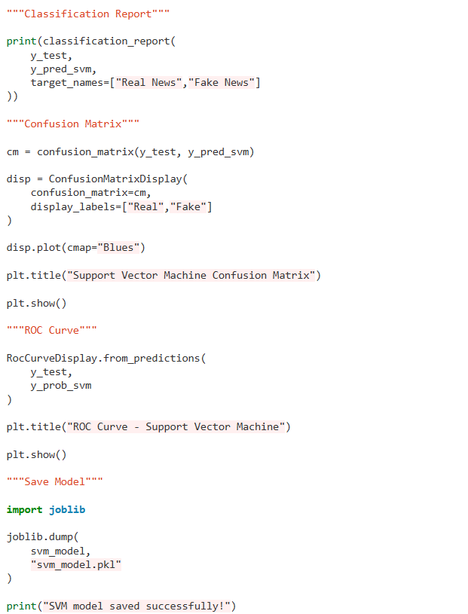
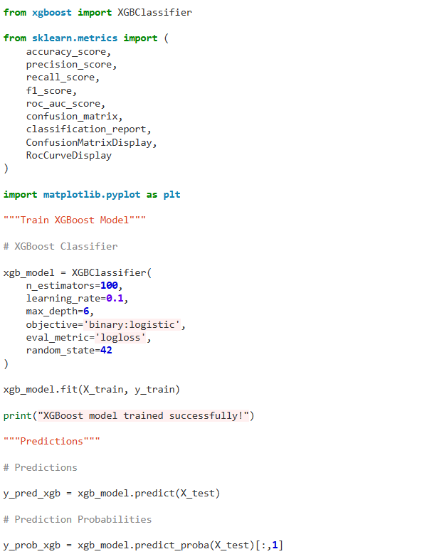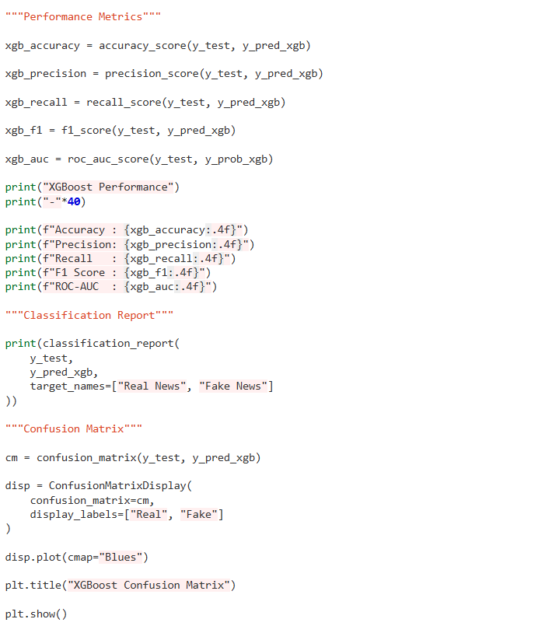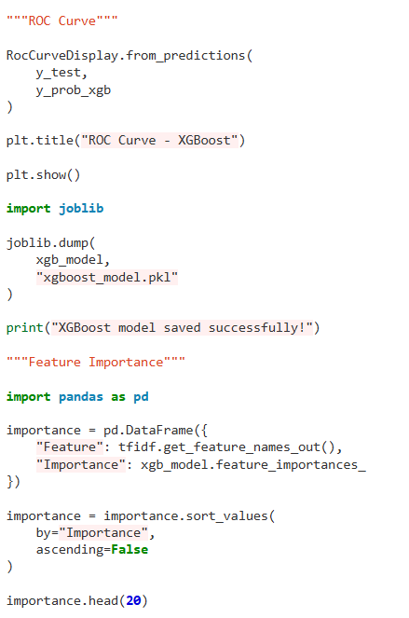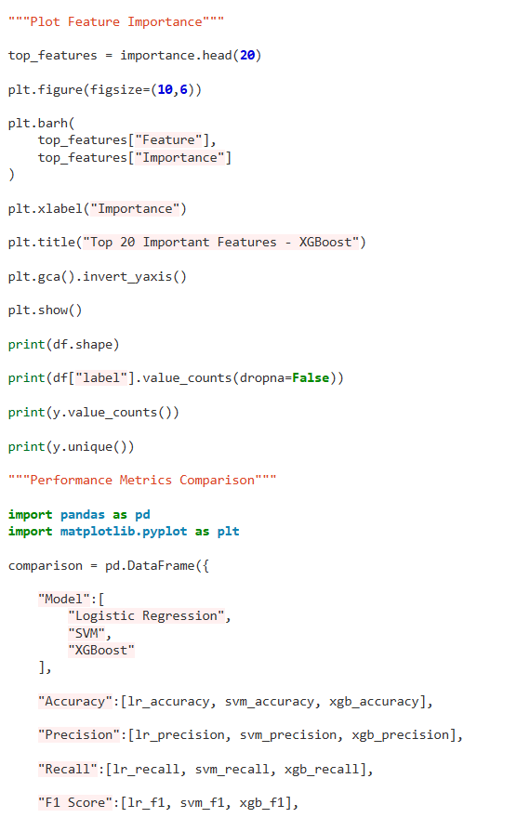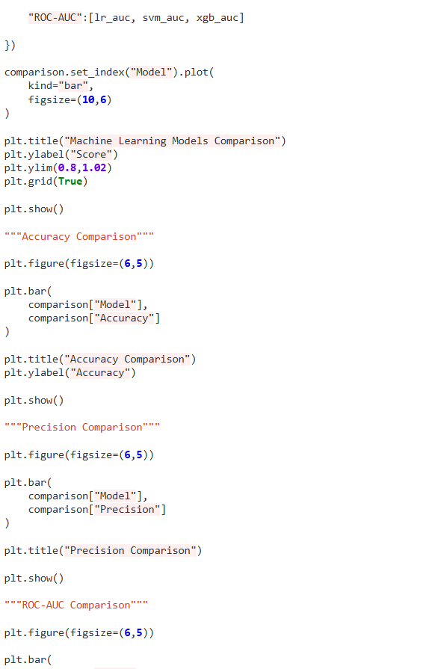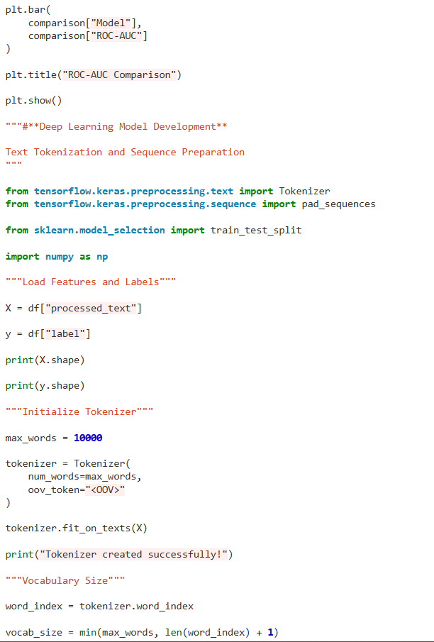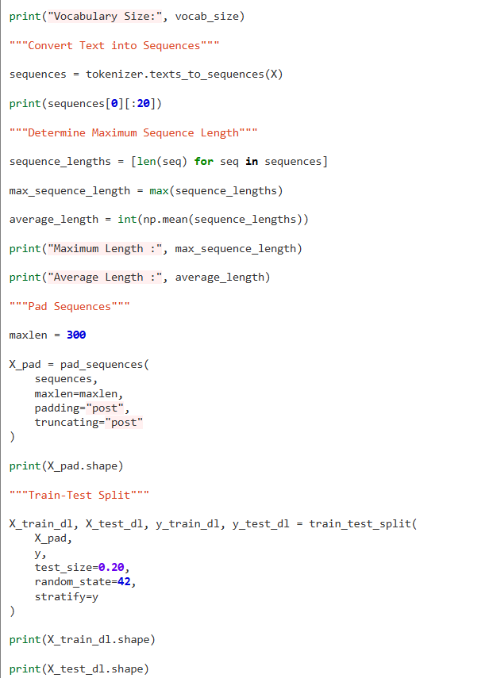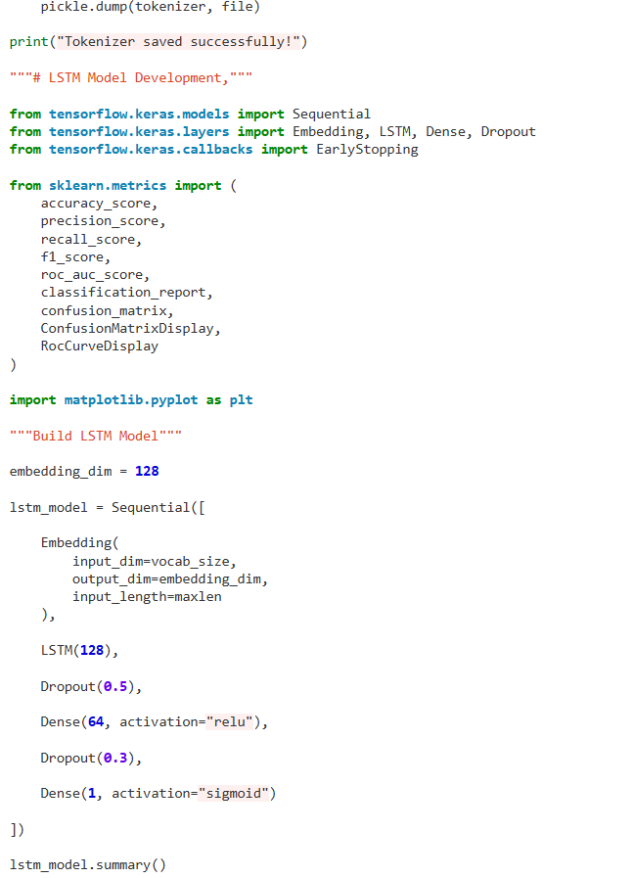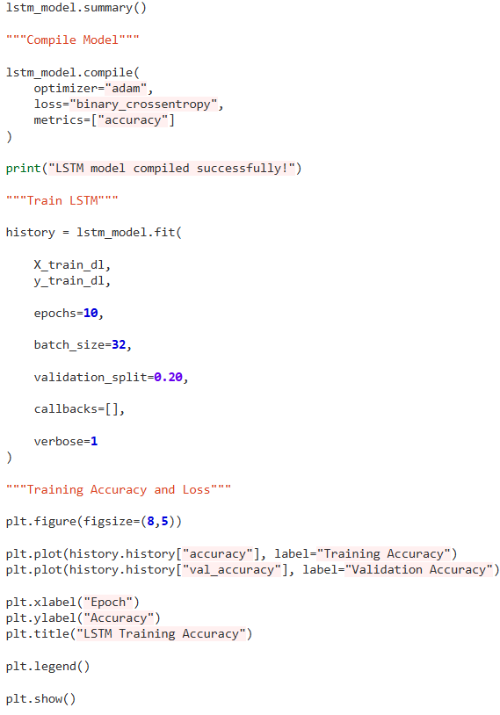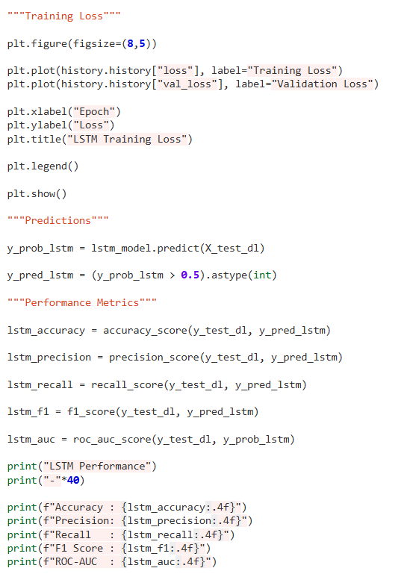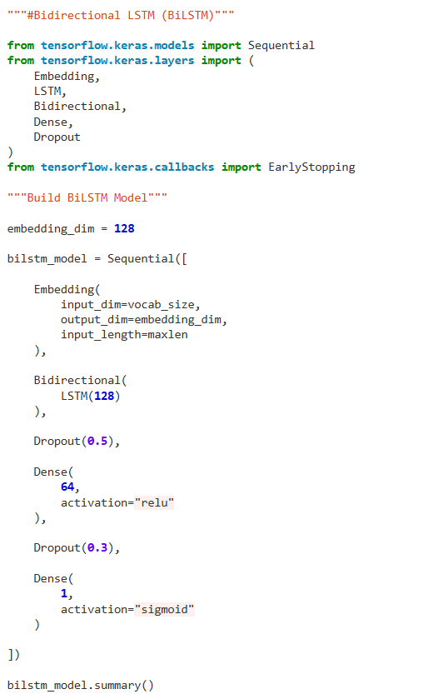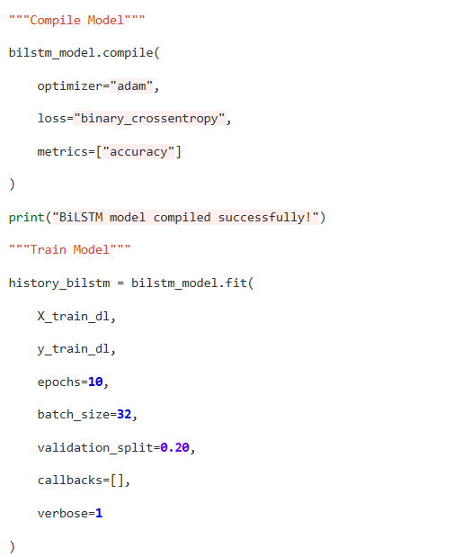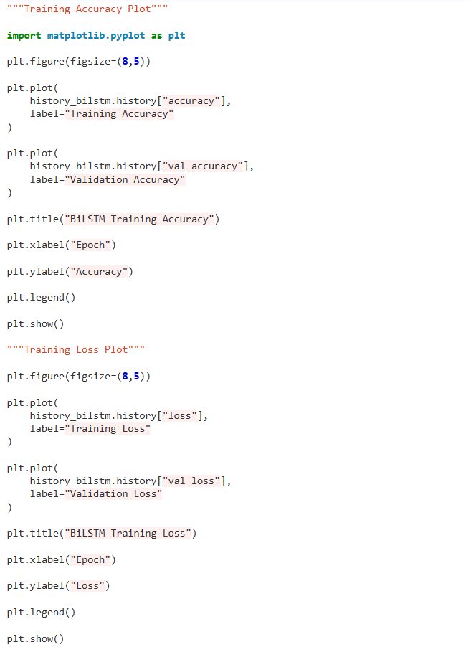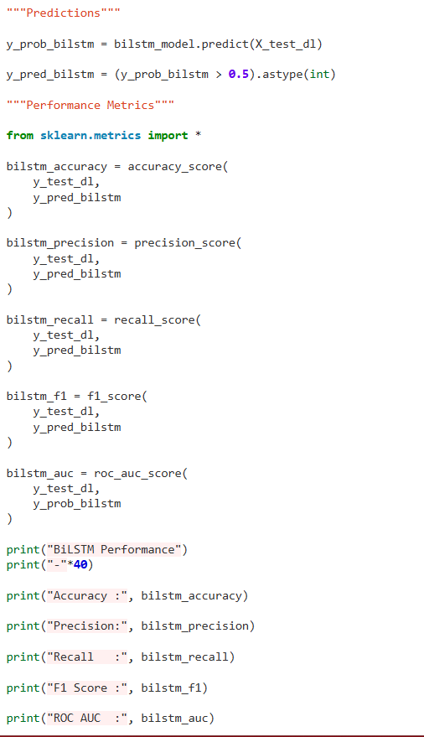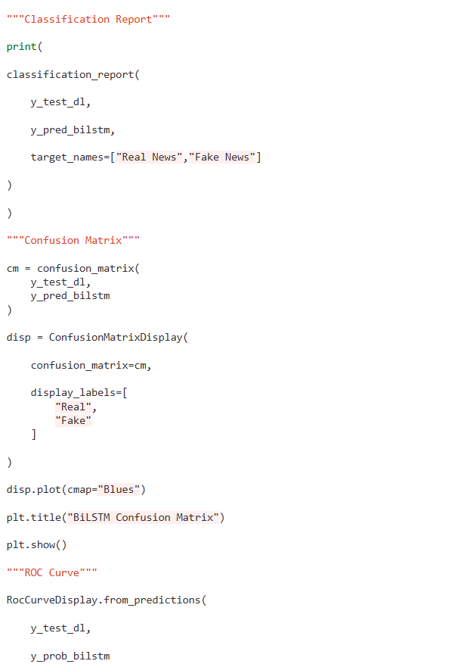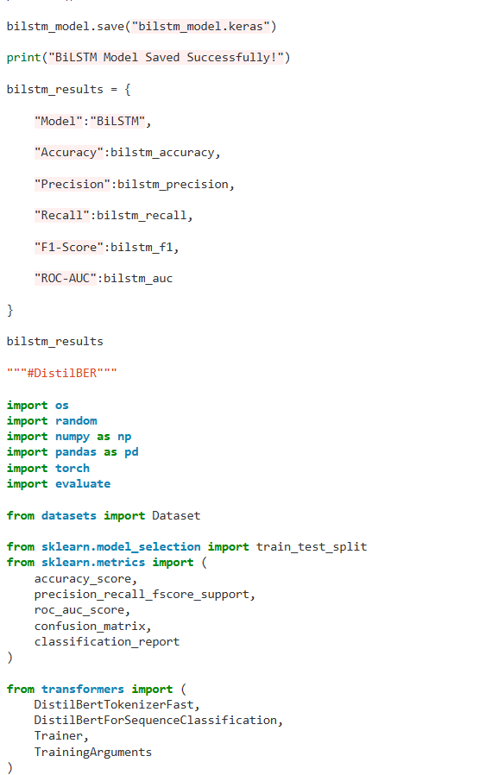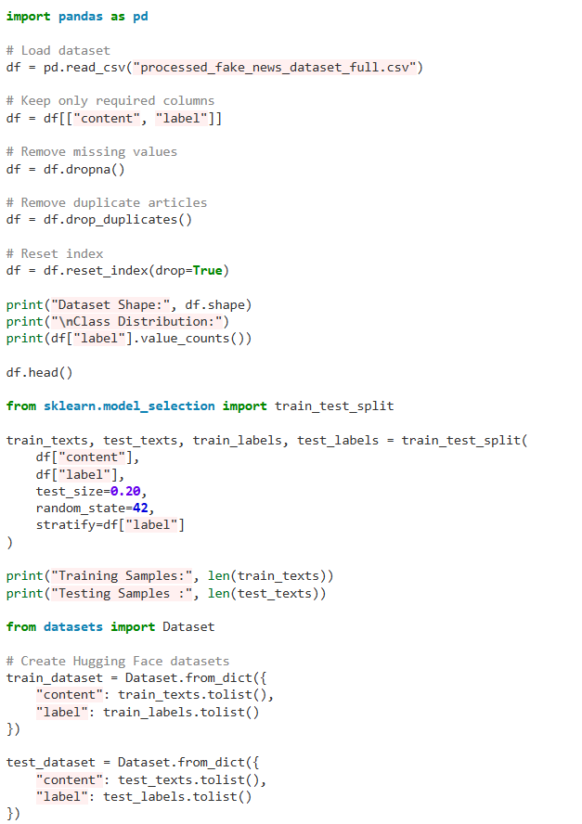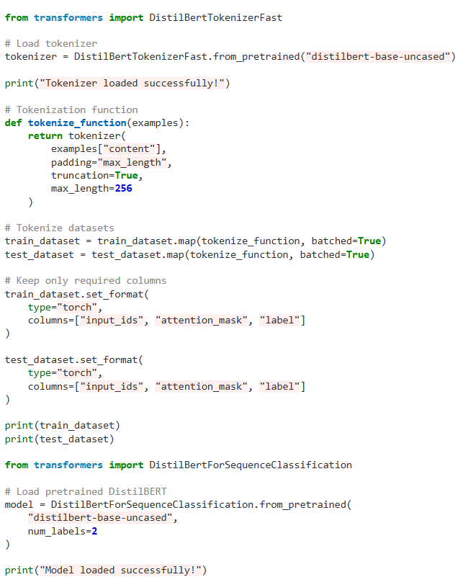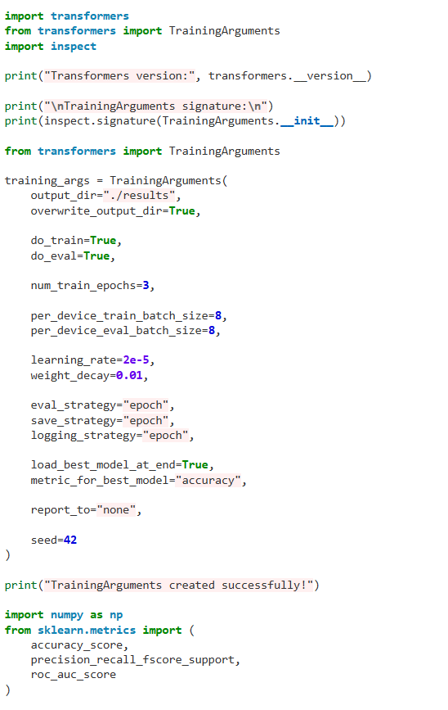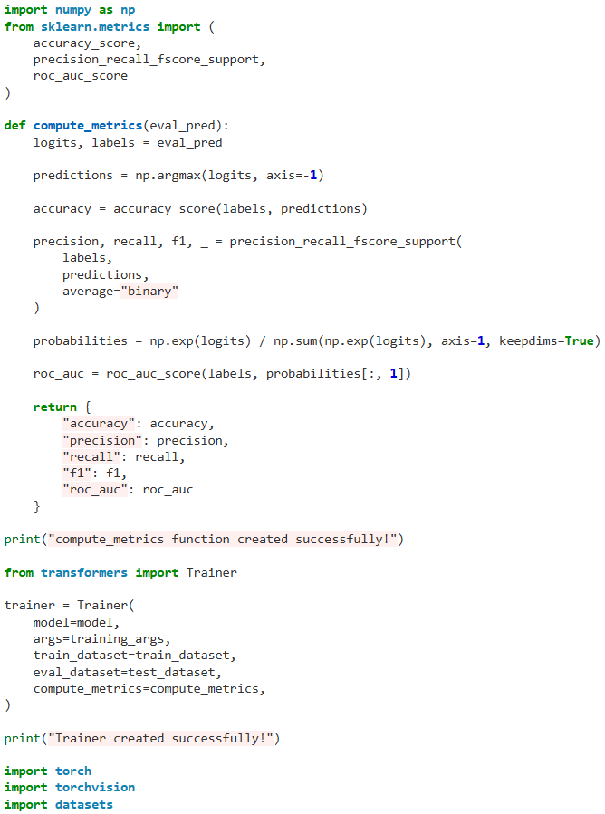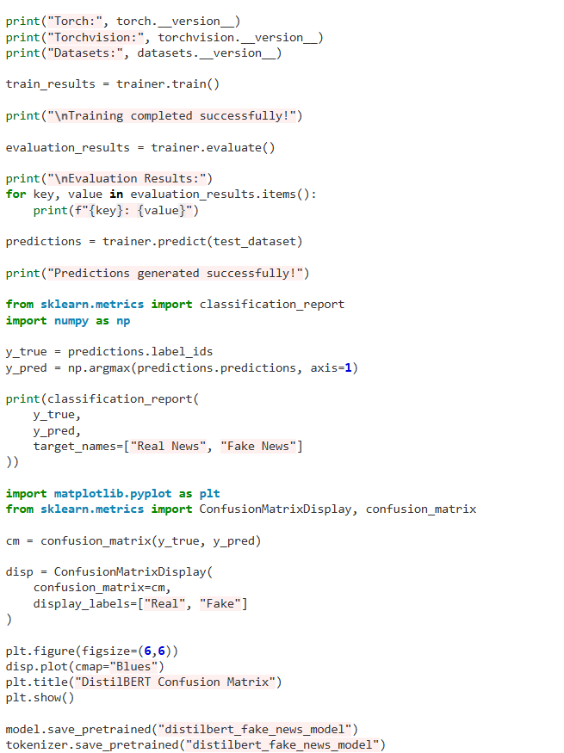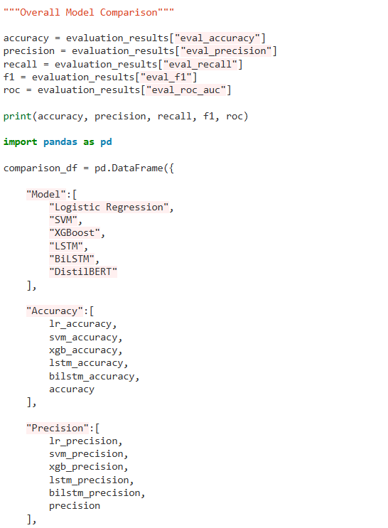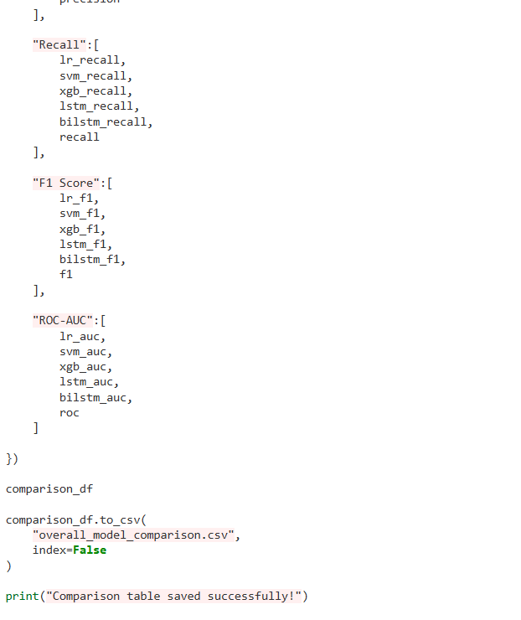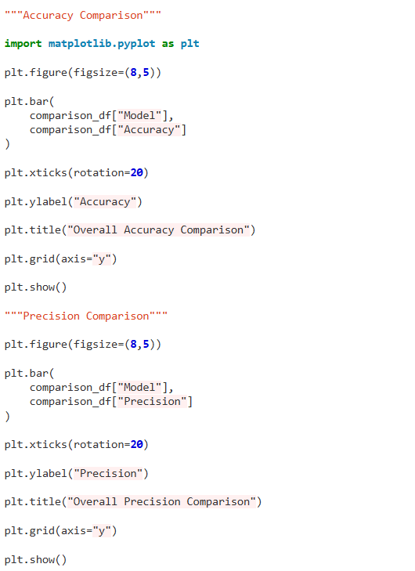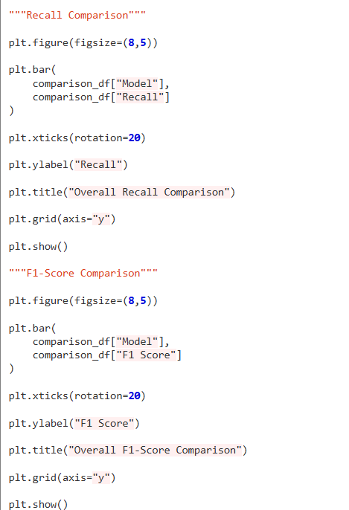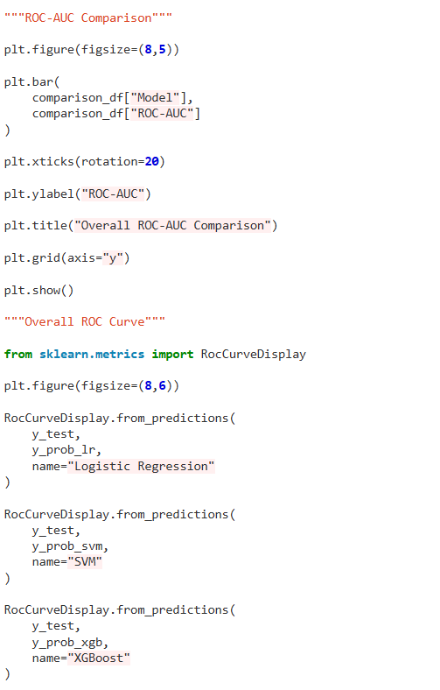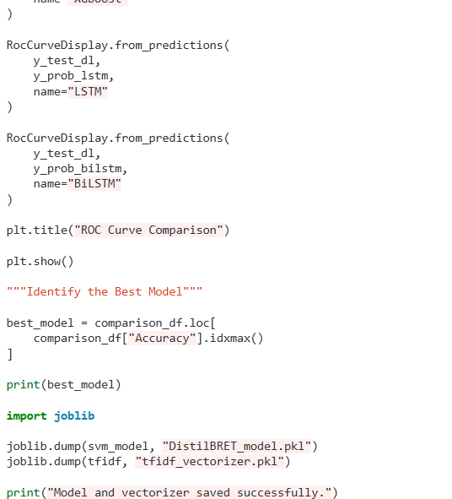

Appendix -C
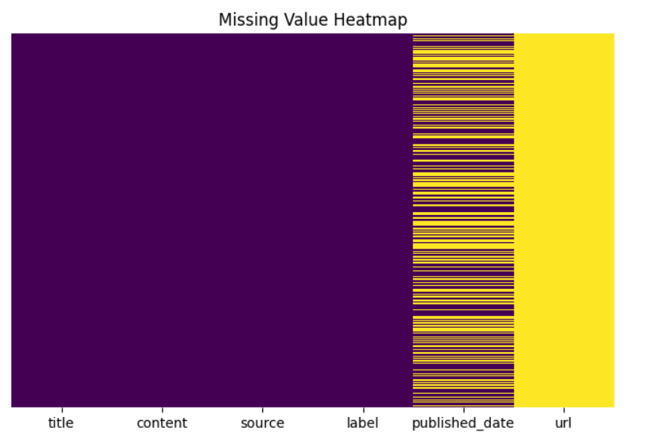

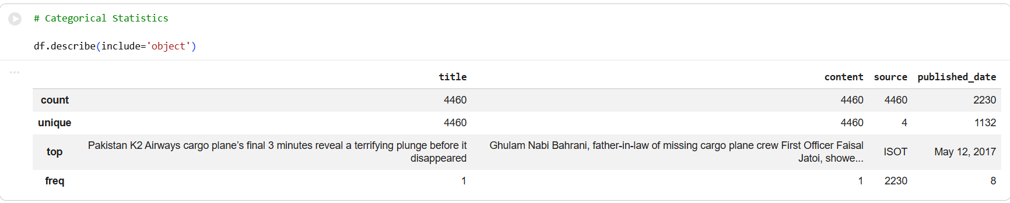

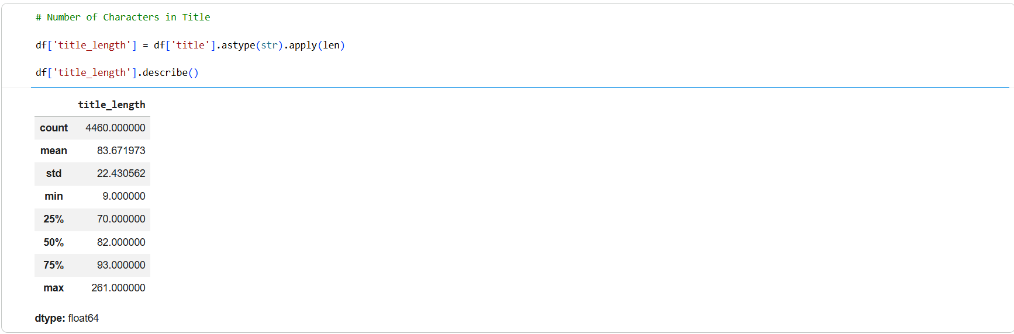

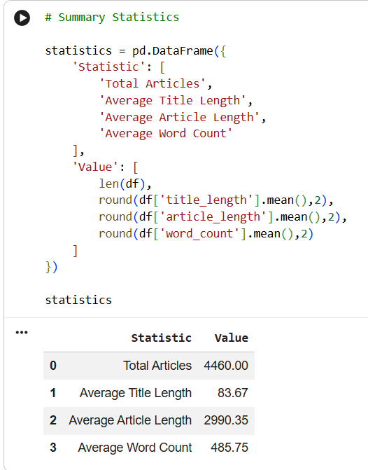
EDA plots
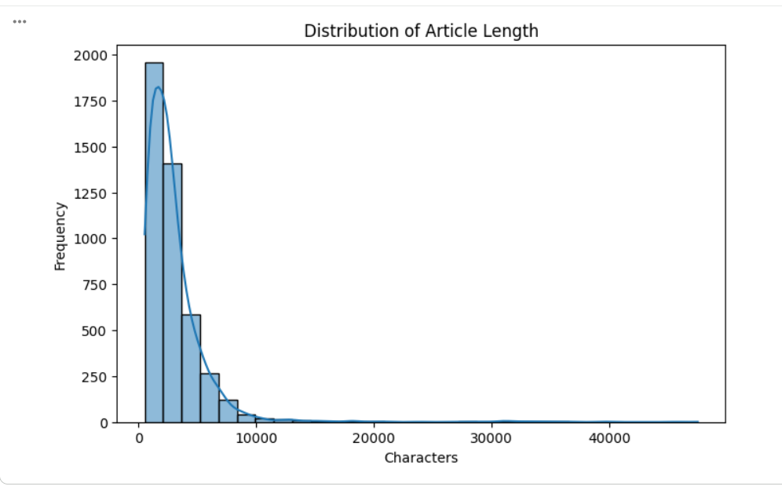
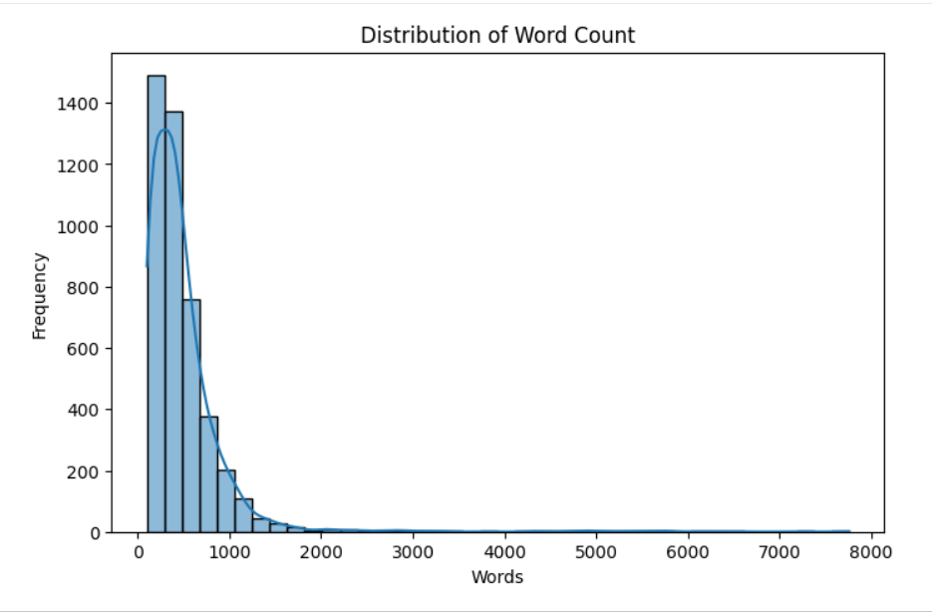
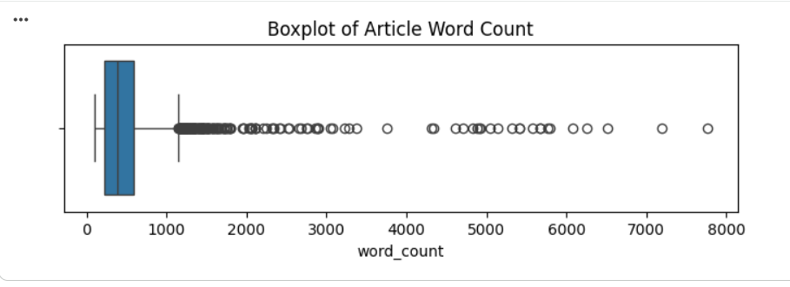
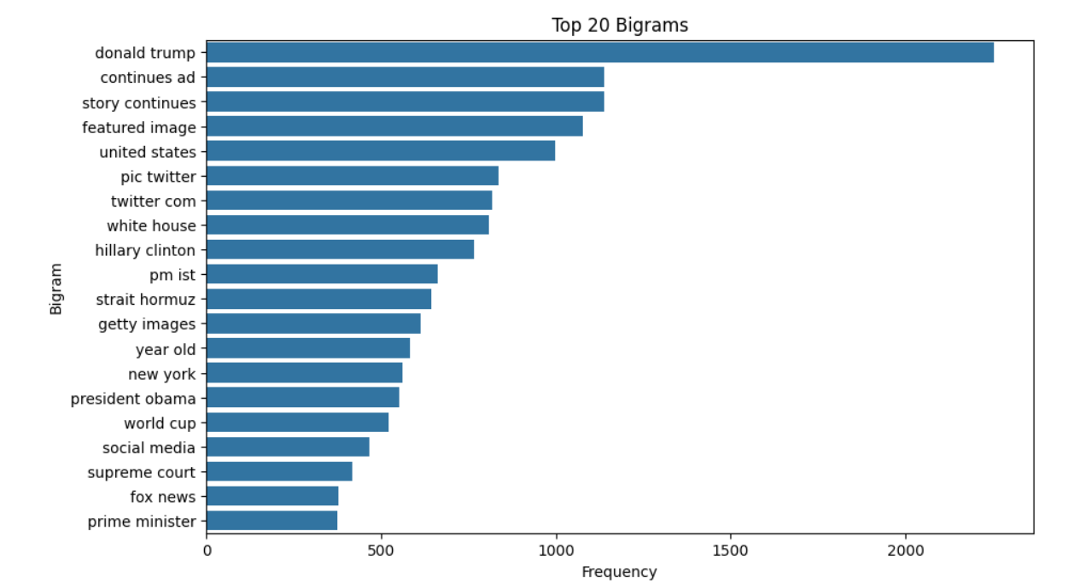
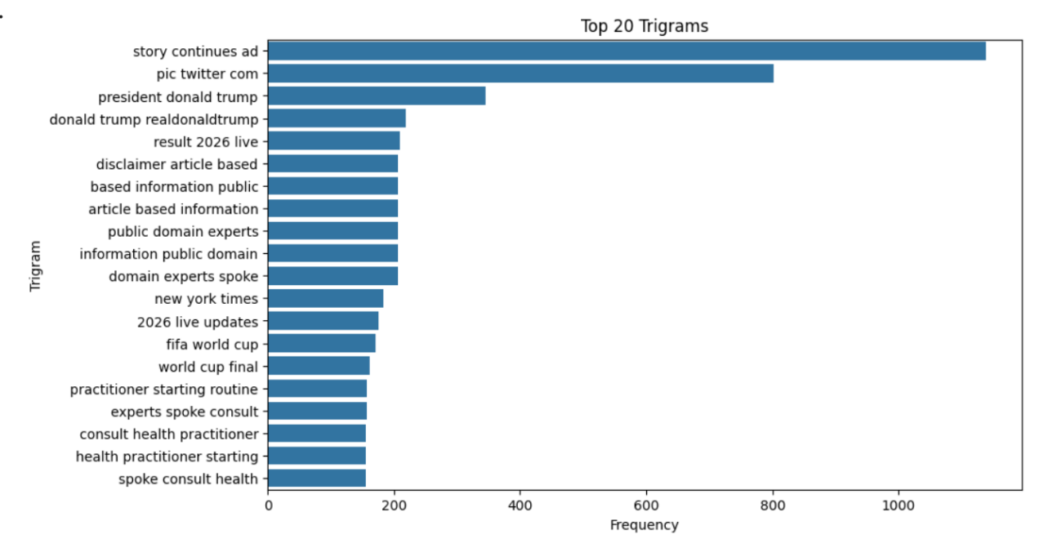

Data preprocessing plots
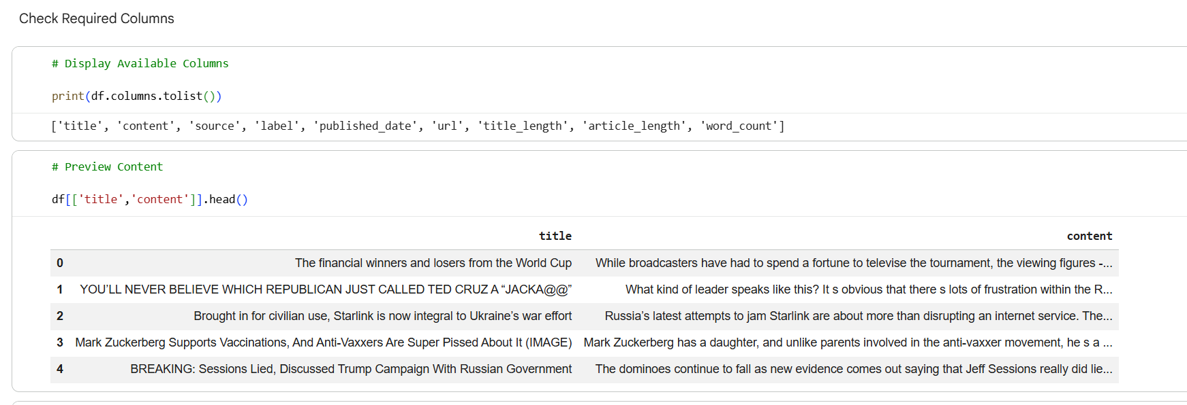
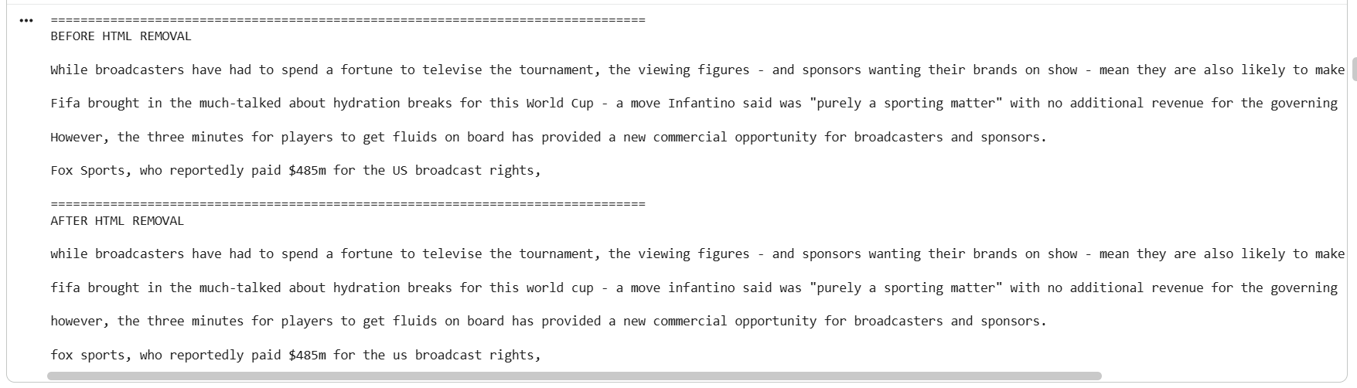
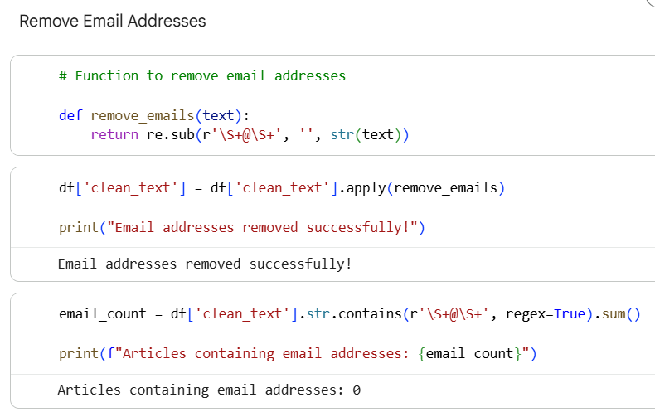
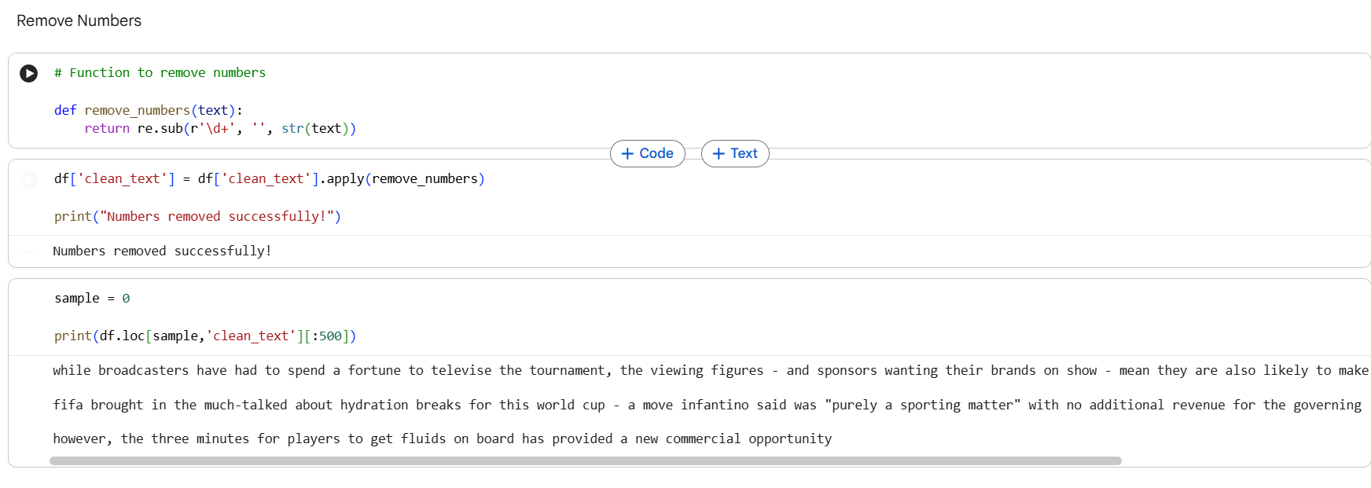
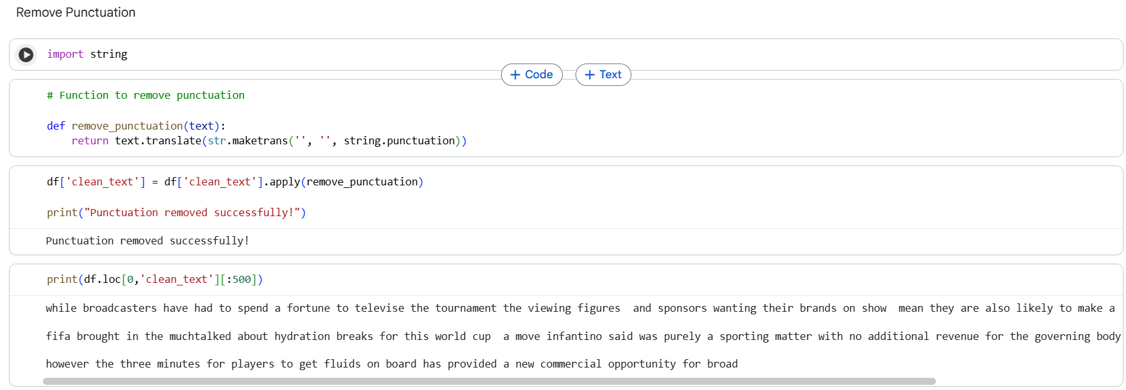
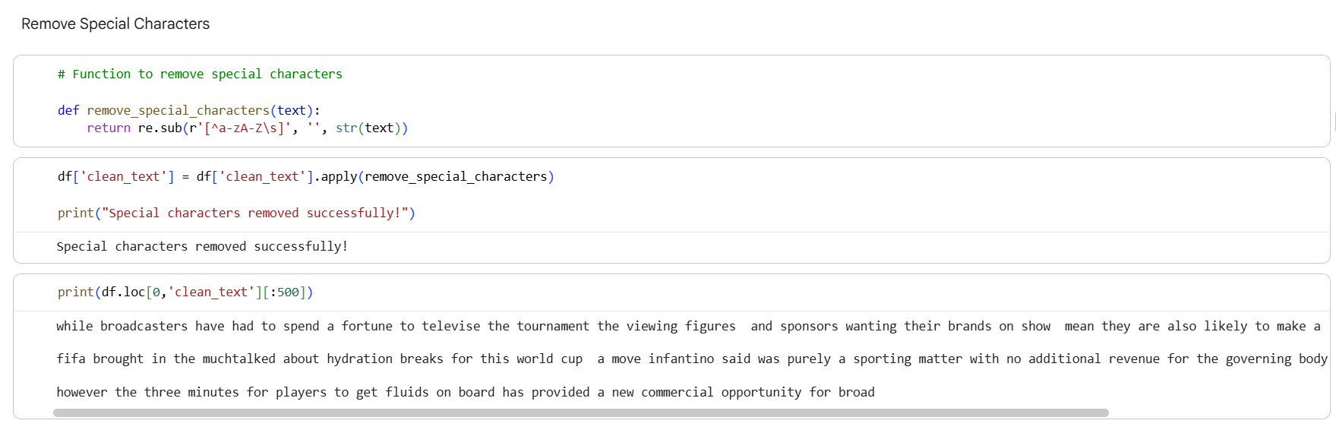
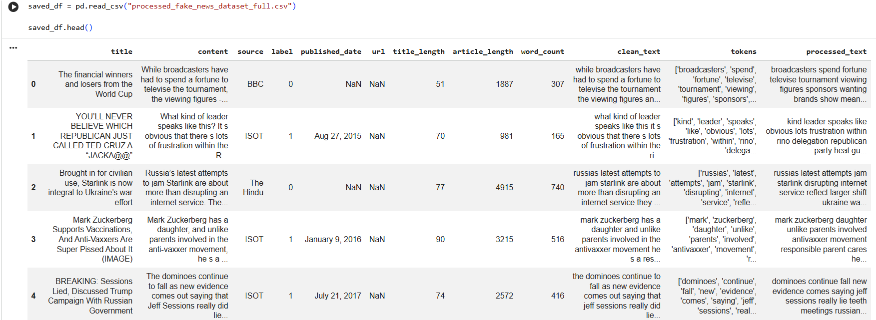

Feature engineering
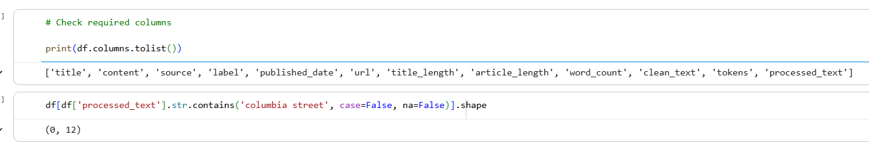
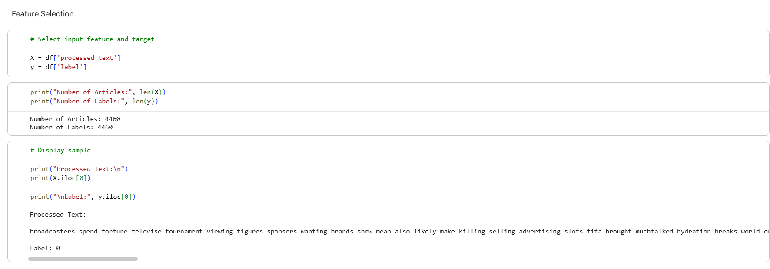
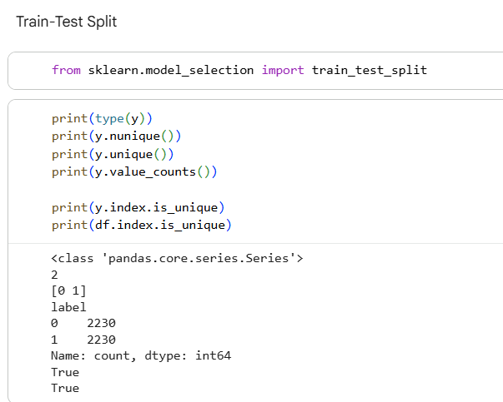
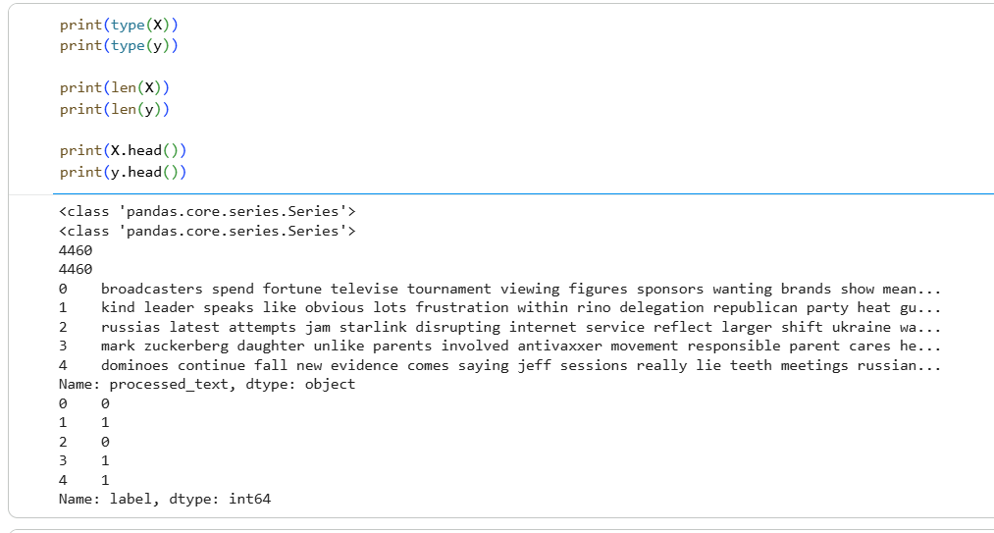
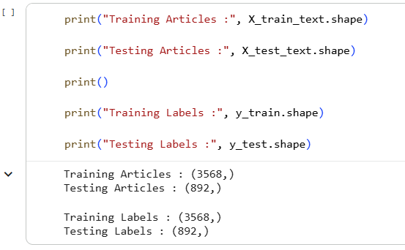
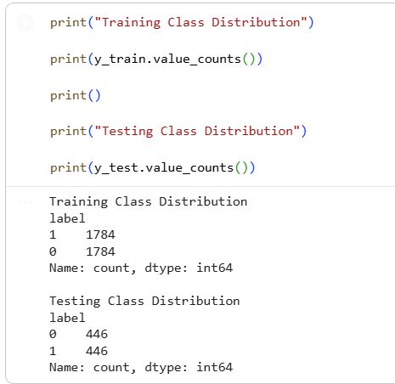
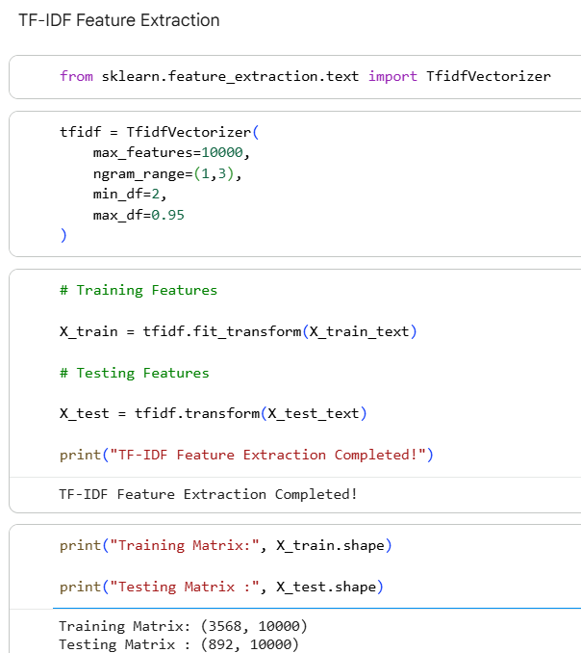
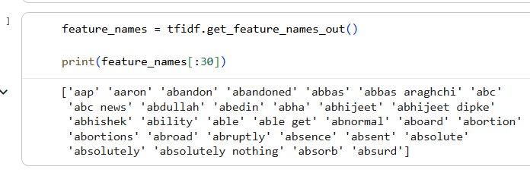
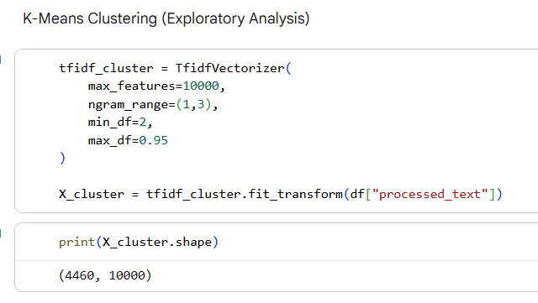
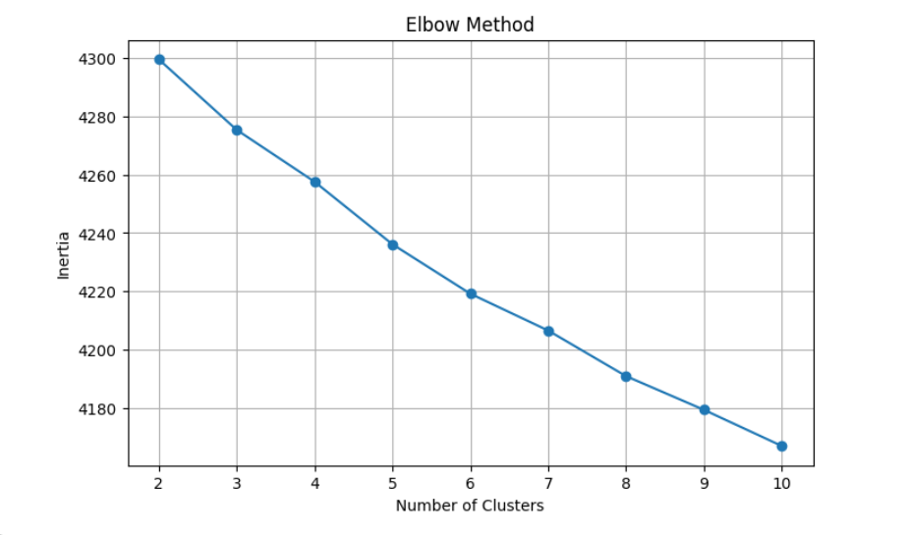
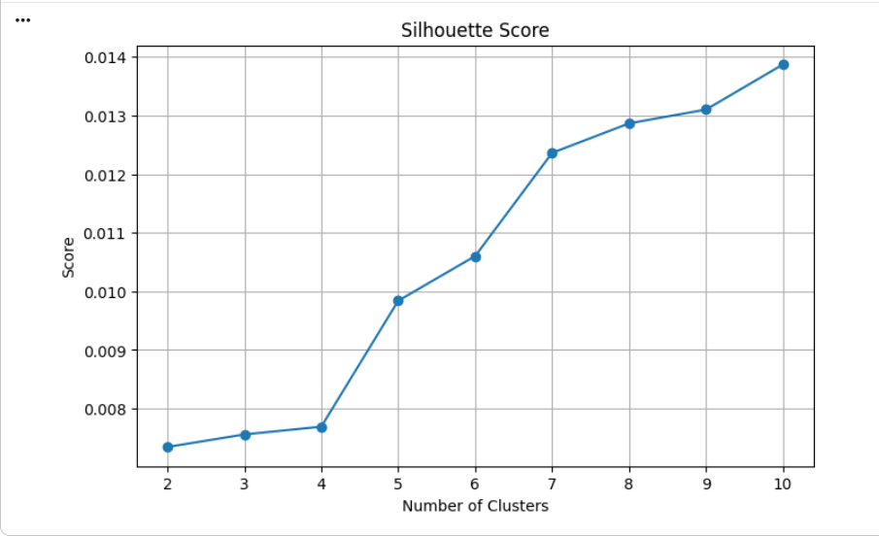
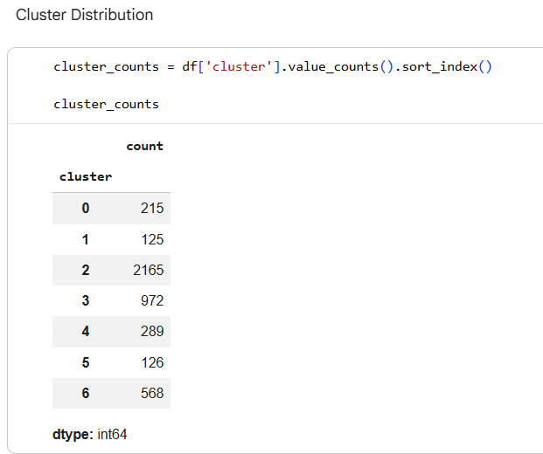
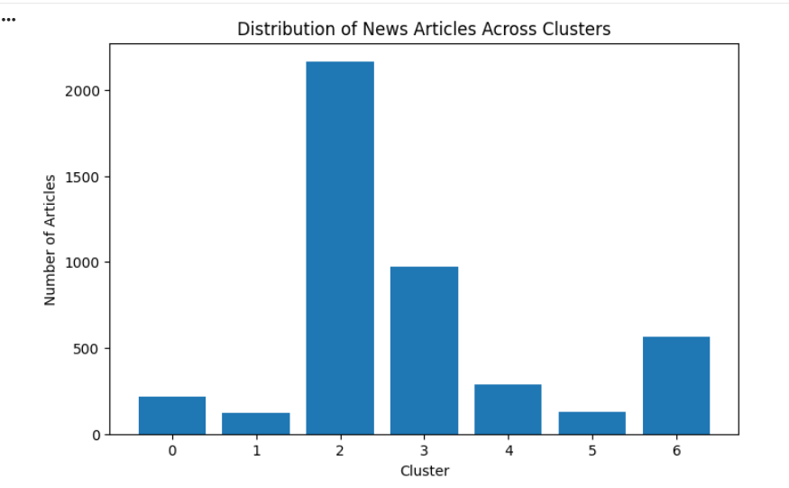
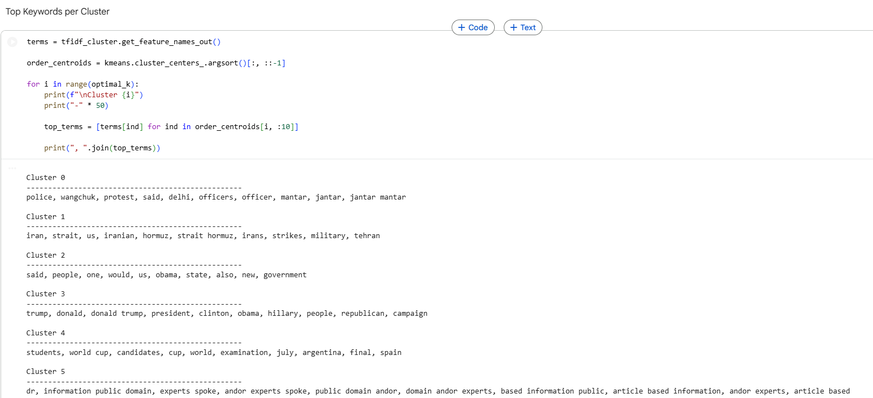

Machine Learning Model Development
Logistic regression
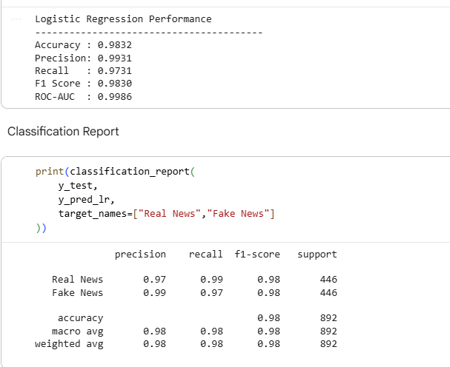

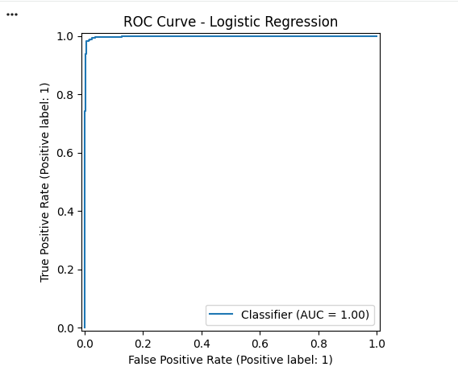

Support Vector Machine (SVM)
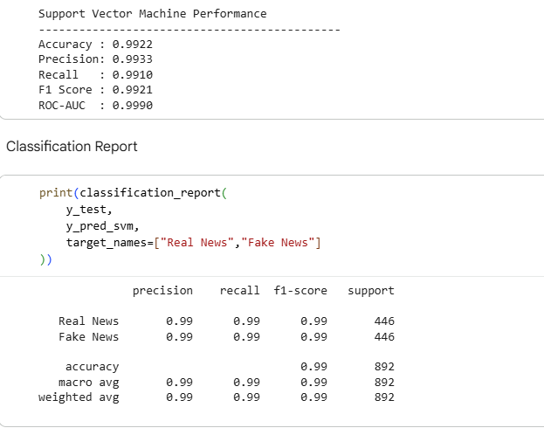
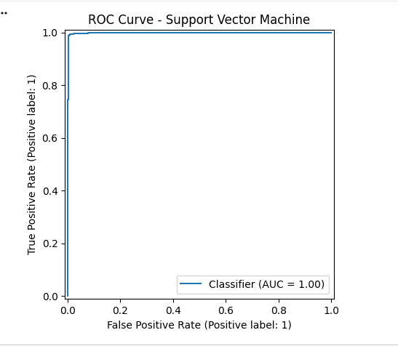

XGBoost
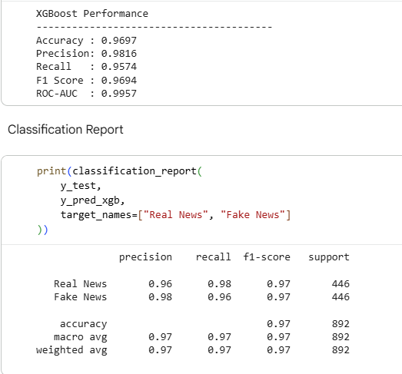
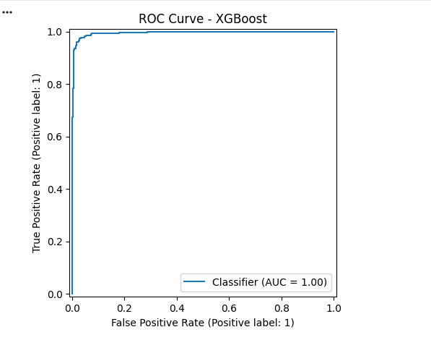
Deep Learning Model Development
LSTM Model Development
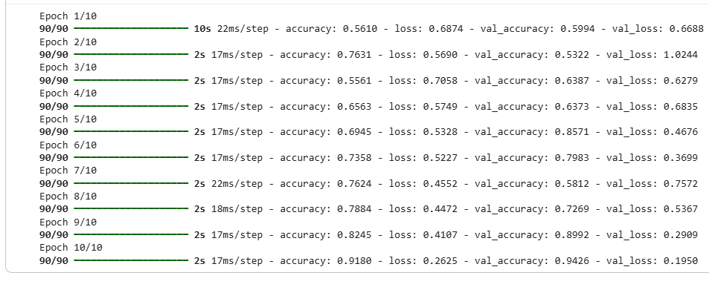
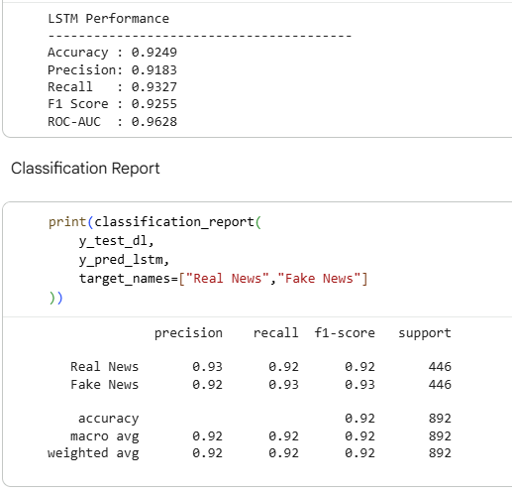
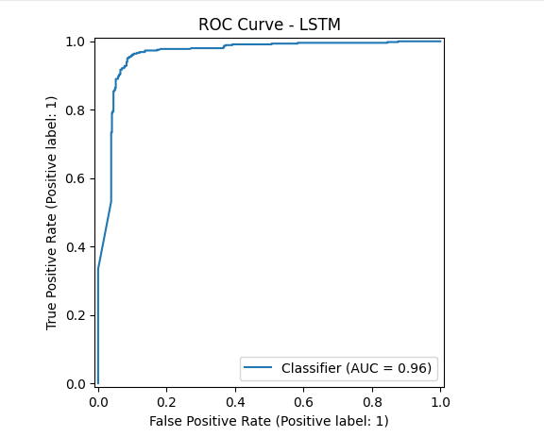
Bidirectional LSTM (BiLSTM)
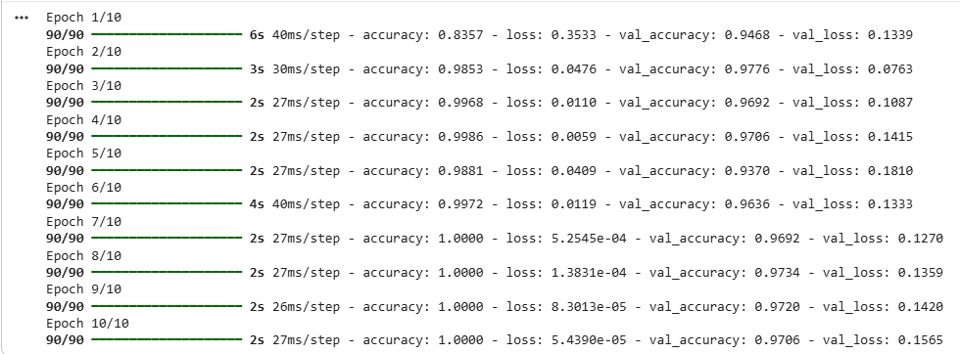
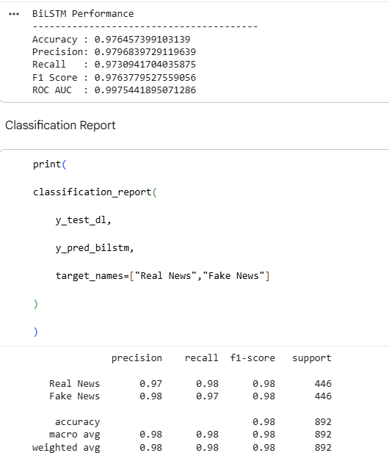
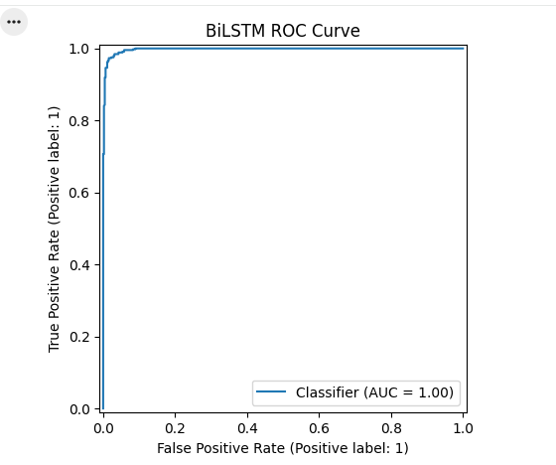
DistilBER
